DESIGN AND DEVELOPMENT OF A CENTRIFUGAL CASTING MACHINE

AND INVESTMENT CASTING PROCESS FOR HSRW

A Thesis

Submitted to the

Technology and Bionics Faculty

of

Hochschule Rhein-Waal

by

Aaron J. Hinkle

22113

In partial fulfillment of the

requirements for the degree

of

Bachelor of Science in Mechanical Engineering

October 20th 2020

Hochschule Rhein-Waal

Kleve, Nordrhein-Westfalen

Table of Contents

LIST OF TABLES 5

LIST OF FIGURES 6

ABSTRACT 9

Chapter 1. DESCRIPTION 10

Background and History 10

Literature Review 10

Relevance to HSRW 12

Chapter 2. OBJECTIVES 13

Machine Specifications 13

Desires and Constraints 13

Basic Idea 13

Timeline 15

Casting Process 16

Chapter 3. METHODOLOGY 17

Chapter 4. FUNCTIONAL DESIGN 19

Rotation Speed 19

Angular Acceleration and Spin Duration 20

Chapter 5. CONCEPTUAL DESIGN 23

Morphological Box 23

Chapter 6. DETAILED DESIGN 26

Component Hierarchy 26

Functional Hierarchy 27

Casting Arm Sub-Assemblies 27

Flask Cradle Assembly 27

Slider Assembly 28

Pin joint and Slider Bar Assembly 28

Full-Articulated Arm Assembly 29

Counterweight Arm Assembly 29

Full Casting Arm Assembly 29

Motor and Machine Base Assembly 30

Enclosure 31

Full Assembly of Casting Machine 32

Motor Selection 34

Check of axial shaft load 35

Check of radial shaft load 35

Chapter 7. STRUCTURAL ANALYSIS 36

Articulated Arm Assembly 36

Pre-tension loads for bolts 36

Deformation of plates at pretension 37

Tensile stress in slider bars 40

Pin Joint Calculations 42

Clevis Pin 43

Clevis and blade 44

Casting Arm Assembly 45

Counterweight arm 46

Parallel key connection 47

Bolt for retaining counterweight 48

Chapter 8. FABRICATION PLAN FOR UNIQUE COMPONENTS 49

Flask Cradle Assembly 49

Flask Cradle 49

Cradle Base 49

Slider Assembly 50

Retainer for Crucible 50

Slider 50

Slider Spacer 50

Crucible Grip Stick 51

Grip Stick Knob 51

Pin Joint and Slider Bar Assembly 51

Slider Bars 51

Pin Joint 52

Counterweight Arm Assembly 52

Counterweight Arm 52

Counterweight 52

Spacer for Counterweight 53

Motor and Machine Base Assembly 53

Bracket for Connection to Gearbox 53

Top Piece 53

Vertical Post 54

Legs 54

Foot 54

Corner Bracket 55

Flat Bracket 55

Spacer 55

Base Plate 55

Chapter 9. CONSTRUCTION 56

Fabrication of Unique Components 57

Flask Cradle 57

Cradle Base 58

Retainer for Crucible 58

Slider 59

Slider Spacer 60

Crucible Grip Stick 60

Grip Stick Knob 60

Slider Bars 61

Pin Joint 61

Counterweight Arm 62

Counterweight 62

Spacer for Counterweight 63

Bracket for Connection to Gearbox 63

Top Piece 64

Vertical Post 64

Legs 65

Foot 65

Corner Bracket 65

Flat Bracket 66

Spacer 66

Base Plate 66

Enclosure 67

Final Assembly 68

Chapter 10. DISCUSSION 70

Was the Spec met? 70

Limitations of the Design 71

Relevance to HSRW 71

Going Forward 72

References 74

APPENDIX A i

Investment Casting Process and Procedure i

SAFE OPERATING PROCEDURE xiii

APPENDIX B I

Motor Dimensioning I

Motor Product Overview II

Gearbox Dimensioning – Technical Information III

Gearbox Product Overview V

SRS UK Classic Investment Powder Safety Data Sheet VI

Cristobalite Hazardous Substance Fact Sheet VIII

APPENDIX C a

CAD Model accompanying this document a

# LIST OF TABLES

|  |  |  |
| --- | --- | --- |
| **No.** | **Description** | **Page** |
| 1.1 | Example sources of folk wisdom and what not to do | 11 |
| 2.1 | Proposed Gantt chart for the project | 15 |
| 4.1 | Surface tensions, densities and critical flow velocities for common jewelry materials | 19 |
| 6.1 | Bill of materials for machine base assembly | 31 |
| 6.2 | Bill of materials for enclosure assembly | 32 |
| 7.1 | Maximum loads and minimum pretension calculations for bolts in slide assembly | 36 |
| 7.2 | Plate deformation calculations for bolts in slide assembly | 37 |
| 7.3 | Settling losses and minimum assembly force calculations for bolts in slide assembly | 38 |
| 7.4 | Operational load calculations for bolted connection between flask cradle and cradle base | 40 |
| 7.5 | Properties of clevis pin for pin joint analysis | 43 |
| 7.6 | Analysis of clevis pin for pin joint | 43 |
| 7.7 | Analysis of clevis for pin joint | 44 |
| 7.8 | Analysis of blade for pin joint | 45 |
| 7.9 | Properties of shaft hub connection for analysis | 47 |
| 7.10 | Analysis of parallel key connection hub | 47 |
| 7.11 | Operational load calculations for the bolt that retains the counterweight | 48 |

# LIST OF FIGURES

|  |  |  |
| --- | --- | --- |
| **No.** | **Description** | **Page** |
| 2.1 | Schematic (top view) of a centrifugal casting machine and its components | 14 |
| 2.2 | Schematic representation of casting in a centrifugal machine using a torch | 14 |
| 4.1 | Typical cooling curve for a pure metal. The molten material must entirely fill the mold before solidification begins and the spinning process cannot end until solidification is sufficiently completed. | 21 |
| 6.1 | Component hierarchy diagram showing parts and materials for final design | 26 |
| 6.2 | Functional hierarchy diagram showing normal operating functions and operator controlled functions | 27 |
| 6.3 | Isometric views of exploded and assembled flask cradle assembly with bill of materials | 27 |
| 6.4 | Isometric views of exploded and assembled slider assembly with bill of materials | 28 |
| 6.5 | Isometric views of exploded and assembled pin joint assembly with bill of materials | 28 |
| 6.6 | Isometric views of assembled articulated arm with and without crucible and casting flask | 29 |
| 6.7 | Isometric views of exploded and assembled counterweight assembly with bill of materials | 29 |
| 6.8 | Isometric view of full assembled casting arm, shown without crucible or casting flask | 29 |
| 6.9 | Select cardinal views of assembled motor and machine base assembly | 30 |
| 6.10 | Detail and isometric view of motor and machine base assembly showing gearbox and motor placement | 30 |
| 6.11 | Open and closed isometric views of enclosure showing components | 31 |
| 6.12 | Top and right section view of full assembly of entire centrifugal casting machine | 32 |
| 6.13 | Isometric view of 3D rendering of final CAD model | 33 |
| 6.14 | Isometric section view of 3D rendering of final CAD model | 34 |
| 6.15 | DB56D036030–A – Brushless DC Motor and relevant technical data | 35 |
| 6.16 | GP56–S1–7–SR – High-Torque Planetary Gearbox and relevant technical data | 35 |
| 7.1 | Schematic of slide assembly showing components and forces relevant for calculations | 36 |
| 7.2 | Calculation of substituting cylinder $A_{sub}$ for the clamped plates | 37 |
| 7.3 | Resiliencies and dimensions of the screws in the slide assembly | 38 |
| 7.4 | Free body diagram of bolted joint and sum of moments about the assumed rotation point | 40 |
| 7.5 | Free-body, shear force and bending moment diagrams, and relevant input parameters for Bernoulli-Euler beam theory for slider bars | 41 |
| 7.6 | Schematic of casting arm showing components of, and forces applied to, pin joint | 42 |
| 7.7 | Free body diagram of casting arm with relevant dimensions | 42 |
| 7.8 | Free-body, shear force and bending moment diagrams for $⊘$ 10 mm clevis pin | 43 |
| 7.9 | Schematic of casting arm assembly showing components and forces relevant for calculations | 45 |
| 7.10 | Free-body, shear force and bending moment diagrams for counterweight arm | 46 |
| 7.11 | Detail view of parallel key connection | 47 |
| 7.12 | Detail of counterweight and retaining bolt showing operational forces | 48 |
| 8.1 | Design and plan for flask cradle | 49 |
| 8.2 | Design and plan for cradle base | 49 |
| 8.3 | Design and plan for retainer for crucible | 50 |
| 8.4 | Design and plan for slider | 50 |
| 8.5 | Design and plan for slider spacer | 50 |
| 8.6 | Design and plan for crucible grip stick | 51 |
| 8.7 | Design and plan for grip stick knob | 51 |
| 8.8 | Design and plan for slider bars | 51 |
| 8.9 | Design and plan for pin joint | 52 |
| 8.10 | Design and plan for counterweight arm | 52 |
| 8.11 | Design and plan for counterweight | 52 |
| 8.12 | Design and plan for spacer for counterweight | 53 |
| 8.13 | Design and plan for bracket for connection to gearbox | 53 |
| 8.14 | Design and plan for top piece | 53 |
| 8.15 | Design and plan for vertical post | 54 |
| 8.16 | Design and plan for legs | 54 |
| 8.17 | Design and plan for foot | 54 |
| 8.18 | Design and plan for corner bracket | 55 |
| 8.19 | Design and plan for flat bracket | 55 |
| 8.20 | Design and plan for spacer | 55 |
| 8.21 | Design and plan for base plate | 55 |
| 9.1 | Photos of finished flask cradle | 57 |
| 9.2 | Photos of flask cradle as a work in process. Starting material with the plan and boring the steps on the lathe | 57 |
| 9.3 | Photos of finished cradle base | 58 |
| 9.4 | Photos of finished retainer for crucible | 58 |
| 9.5 | Photos of finished slider | 59 |
| 9.6 | Photos showing slider leaning back on slider bars when crucible is in place | 59 |
| 9.7 | Photo of finished slider spacer | 60 |
| 9.8 | Photos of finished crucible grip stick and modified crucible | 60 |
| 9.9 | Photos of finished grip stick knob | 60 |
| 9.10 | Photo of finished slider bars | 61 |
| 9.11 | Photos of finished pin joint | 61 |
| 9.12 | Photos of finished counterweight arm | 62 |
| 9.13 | Photos of finished counterweight | 62 |
| 9.14 | Photo of casting arm balanced on 1.5 mm sheet steel in the bench vice | 63 |
| 9.15 | Photos of finished bracket for connection to gearbox | 63 |
| 9.16 | Photos of finished top piece | 64 |
| 9.17 | Photos of finished vertical post | 64 |
| 9.18 | Before and after photos of finish removal and cleanup of machine base assembly parts | 64 |
| 9.19 | Photo of finished legs | 65 |
| 9.20 | Photo of finished foot | 65 |
| 9.21 | Photo of finished corner brackets | 65 |
| 9.22 | Photo of finished flat brackets | 66 |
| 9.23 | Photo of finished spacers | 66 |
| 9.24 | Photos of finished base plate | 66 |
| 9.25­­­ | Photos of enclosure plates before and after sanding | 67 |
| 9.26­­­ | Photos of the paint and degreaser that was used and the rusty spots after the paint dried | 68 |
| 9.27 | Photos of assembled casting arm and machine base | 68 |
| 9.28 | Photo of fully assembled casting machine | 69 |
| 9.29 | Photo of fully assembled casting machine with enclosure lid open | 69 |

# ABSTRACT

**Introduction**

The Enspire Lab at HSRW has grown steadily for years. Presently, the lab is fairly well equipped for doing large projects, especially from steel or aluminum, and with the addition of the recently set-up CNC machine, the new 3D printer, and the imminent arrival of a new laser cutter, the lab is equipped to provide students access to a number of manufacturing methods and options. However, there isn’t much equipment available for doing small projects with high degrees of accuracy, and one manufacturing method that is still conspicuously missing, is casting. The purpose of this thesis was to provide that option and the expertise that goes along with it.

**Problem**

Create a centrifugal casting machine that meets or exceeds the industry standards set by commercially available machines. Additionally, create a robust safe operating procedure manual that outlines the investment casting process as it specifically applies to the Enspire lab and HSRW.

**Procedure**

Research was done to evaluate existing commercially available centrifugal casting machines. This included research about material selections, design decisions and consumer validation. Analyzing pros and cons of different designs allowed the best options to be chosen as well as allowing for improvement on existing designs. After the research phase, computer simulation was used to design the machine. This was followed by fabrication and construction in the Enspire Lab.

**Results**

The casting machine is completed and should be functional. The fabrication and assembly went according to spec, but due to delays from COVID19, it is still missing a power supply and the electronic controller for the motor and micro-switch is still being programmed and fine-tuned. The investment casting procedure has been completed, but the process has yet to be tested since the machine is not yet operational and there is no burnout kiln yet available.

**Conclusions**

Although still untested, this thesis has provided future generations of HSRW students with an introduction to investment casting as well as access to proper, safe equipment for doing it. Due to time delays, some of the more technical objectives such as finite element analysis and condition monitoring were not possible, but the practical objectives for the machine have been met. The parts are all made to specifications; the fit and finish is acceptable; and the intended dynamics of the machine are functional.

# Chapter 1. DESCRIPTION

## Background and History

Centrifugal casting is used as a means of casting small batches of relatively small parts at very high resolution. Simple gravity pouring is insufficient for jewelry-type investment molds. This possibility is precluded by the combination of unvented molds and the desire to reproduce intricate detail together with the comparatively small volume of molten material and the consequent low hydrostatic head and low thermal capacity of the metal. Thus, some form of casting machine is used to cast the metal into the mold [Gainsbury, P. E]. One commonly used option is known as centrifugal casting.

Centrifugal casting is a means of casting small detailed parts or jewelry. A balanced, horizontally oriented, arm is driven around a vertical axis by an electric motor or torsional spring. A single-use mold and a ceramic crucible for melting the raw material are arranged together on one extremity of the arm and heated with a torch. When the raw material is molten, the arm is released, and the centrifugal force from the spin forces the liquid metal into the mold [Sias, F. R., Jr.].

The mold is made using a technique that has been practiced for thousands of years known as investment casting or lost-wax casting. Dating back to beeswax patterns from 3000 BC, it is one of the oldest known metal forming techniques. Moving the molten material into the mold by means of centrifugal force is a relatively recent development. There are patents from the early 1800s for horizontally rotating casting machines that used centrifugal forces to cast pipes (also called spin-casting), but the vertical casting process, such as that on which this thesis project is focused, did not emerge until almost 100 years later in the dental industry where highly accurate, repeatable castings of small components was necessary. Since World War II, substantial progress in the process has been made, particularly in the art world (metal-craft and jewelry-making). However, most of that progress has come as a result of material science. High technology waxes, refractory materials and specialized alloys have made the process almost infinitely customizable; while the centrifugal casting process and the machines used to achieve it remain much the same as 120 years ago.

## Literature Review

Similar resolution advantages may be obtained with alternatives like pressure casting or vacuum casting and each technology has its loyal patrons [Gainsbury, P. E]. However, the centrifugal casting process is straightforward and the machines are relatively simple to construct and operate.

Investment casting is the most widely used technique for producing jewelry so it is important that a casting machine used for jewelry investment casting should meet the efficiency and quality standards expected of manufacturing equipment. Centrifugal casting is a well-established process, so the machine will need to accommodate certain standard components such as melting crucibles and flasks for the molds [Sias, F. R., Jr.]. Investment flasks are generally stainless steel cylinders, sold in sets, with diameters from two to four inches, in half-inch increments. The melting crucibles used for centrifugal casting are generally a clay-infused silica material designed to fit one of two standard retaining systems (based on two popular casting machines, Neycraft and Kerr). Neycraft crucibles fit in Kerr machines, but the inverse is not true. Since the Neycraft design is more widely applicable, and thus easier to acquire, it has been chosen as the standard for this project as well.

The most significant differentiating feature between centrifugal casting machines is the choice between a rigid rotating arm and an articulated rotating arm. The articulated arm requires additional manufacturing steps, but it offers the advantage of ensuring that the forces are always applied in the appropriate direction (moving molten material into the mold cavity). The rotation begins from rest so initially the acceleration of the crucible and mold is purely in the tangential direction. The jointed connection in the arm allows the crucible and mold to swivel freely as the direction of the acceleration changes from purely tangential to purely normal [Sias, F. R., Jr.]. Consequently, the arm can be driven at much higher torques because jerk and jounce do not have to be considered. This means the molten material spends less time in the crucible, which is desirable for maintaining melting temperatures during casting. Rigid arms must be accelerated slowly to prevent molten material from spilling over the side of the crucible. For this reason, most commercially available centrifugal casting machines have articulated rotating arms.

This project also required a fair amount of research outside the realm of scholarly articles and textbooks. Various jewelry-making forums and YouTube channels were consulted both for practical knowledge about the casting process as well as discussion about the successes and failures of other commercially available centrifugal casting machines and a host of “homemade” alternatives that are not commercially available. These sources provided a great look at what not to do, but they also offered insight into the practical use of these machines. Table 1.1 includes several examples of such sources.

*Table 1.1: Example sources of folk wisdom and what not to do*

|  |
| --- |
| <https://www.youtube.com/channel/UC3u2Bnwf-959Wako0Dk93TA>  Supply retailer that provides tons of expert support about everything involving making jewelry. This channel features several videos about investment casting and centrifugal casting, including high-speed videos of the dynamics. |
| <https://www.youtube.com/channel/UC3VmPL7Gq4bGEYVOZ9aGB5g>  Substantial practical knowledge about mold making, investment casting and finishing can be found on this channel. |
| <https://www.youtube.com/watch?v=4HTuYa1BxEE>  Simple video of centrifugal casting in a casting machine with a rotating tub design |
| <https://www.youtube.com/watch?v=j-I0l5Rh0wg>  Simple video of centrifugal casting in a casting machine with an open top enclosure |
| <https://www.youtube.com/watch?v=58psqQQz7rc>  Overview of the pro’s and con’s of centrifugal casting as well as dispelling some common myths |
| <https://www.instructables.com/Lost-Wax-Casting/>  Instructions for investment casting, with pictures, and a useful comments thread. |
| <https://www.toytowngermany.com/forum/topic/226202-where-to-purchase-jewelry-making-materials/>  Useful forum about jewelry casting and finding suppliers specifically in Germany |
| <https://www.superbmelt.com/jewelry-casting-line-solution/>  Great source of information about casting metal and advice for equipment selection. |
| <https://orchid.ganoksin.com/t/centrifugal-casting-problem/17417/13>  Good discussion about the Neycraft casting machine including pros and con’s from users. |
| <https://www.cooksongold.com/forum/showthread.php?t=5933>  Folk wisdom about DIY centrifugal casting systems |
| <https://www.youtube.com/watch?v=9ZeLn7BT3qc>  How NOT to bring this idea to industrial scale. This is definitely not the German way. |

## Relevance to HSRW

Because the process only requires an arm spinning with sufficient centrifugal force, numerous machines are commercially available spanning a wide range of prices and offering a variety of features for different applications. This thesis project will focus on designing and developing a centrifugal casting machine optimized for casting jewelry and other small parts made of soft metals. This will be applicable to a variety of student projects in the HSRW Enspire lab. The workshop is already suited to making large components with low tolerances, but is in need of equipment and processes that offer precision. Hopefully, this machine will join the new CNC machine and laser cutter as a step in that direction.

# Chapter 2. OBJECTIVES

## Machine Specifications

Centrifugal casting is used as a means of casting small, high-resolution parts in small batches. This thesis is focused on designing and constructing a centrifugal casting machine as well as developing a process and procedure for investment casting in the workshop of HSRW.

### Desires and Constraints

Design and construct a centrifugal casting machine capable of:

* Casting soft metals with melting temperatures up to 1080°C
* Casting a range of materials with densities from Al (2560 kg/m3) to fine Au (19320 kg/m3)
* Casting parts with intricate detail (up to 25 $μm$)
* Being used safely by students
* 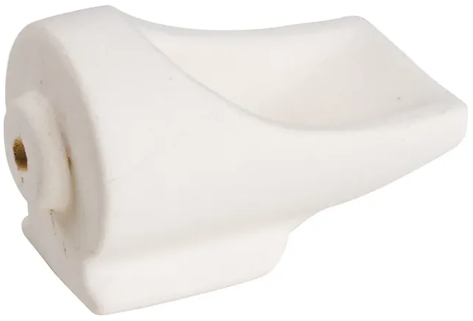Fitting standard COTS components used for centrifugal casting

Casting Crucible[1]

Neycraft Standard

Suitable for melting temperatures up to 1371°C

Weight: 266.5 g

Capacity: 13.2 ml (9 Oz gold or 5 Oz silver)

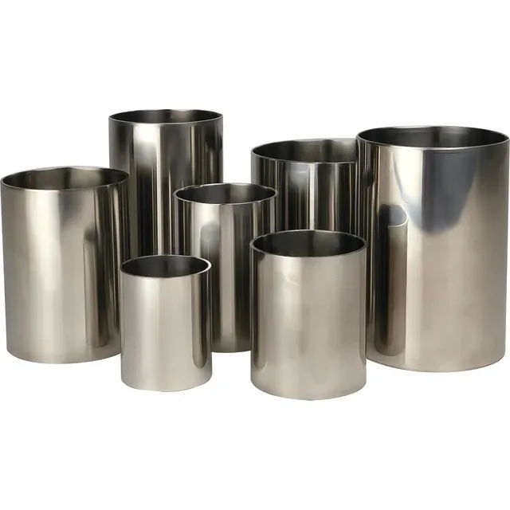

Investment Flasks[2]

Stainless steel, solid wall flasks

(2” – 4” diameters, in 1.2” increments)

76.2 mm (b) • 76.2 mm (h) • 1.63 mm (t)

50.8 mm (b) • 63.5 mm (h) • 1.63 mm (t)

### Basic Idea

A balanced, horizontally oriented, arm is driven around a vertical axis by an electric motor or torsional spring. A single-use mold and a ceramic crucible for melting the raw material are arranged together on one extremity of the arm and heated. When the raw material is molten, the arm is released, and the centrifugal force from the spin forces the liquid metal into the mold. The components and material flow during casting can be seen in figures 2.1 and ­­­2.2.

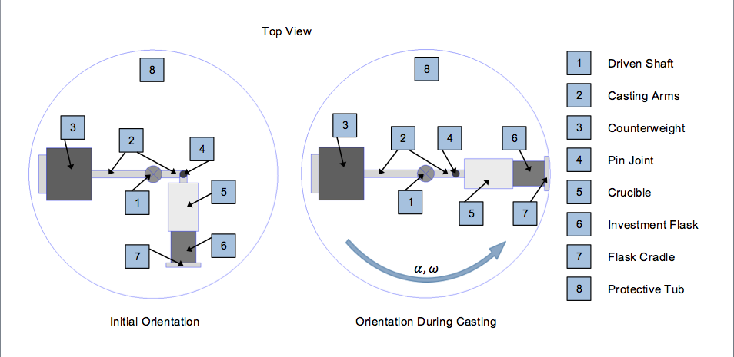

*Figure 2.1: Schematic (top view) of a centrifugal casting machine and its components*

### Macintosh HD:Users:hinkleaj:Desktop:Screen Shot 2020-06-18 at 12.56.44 AM.png

*Figure 2.2: Schematic representation of casting in a centrifugal machine using a torch. The axis of rotation is vertical and is to the left of the illustration, so the centrifugal force is oriented to the right, as shown.*

## Timeline

*Table 2.1: Proposed Gantt chart for the project*

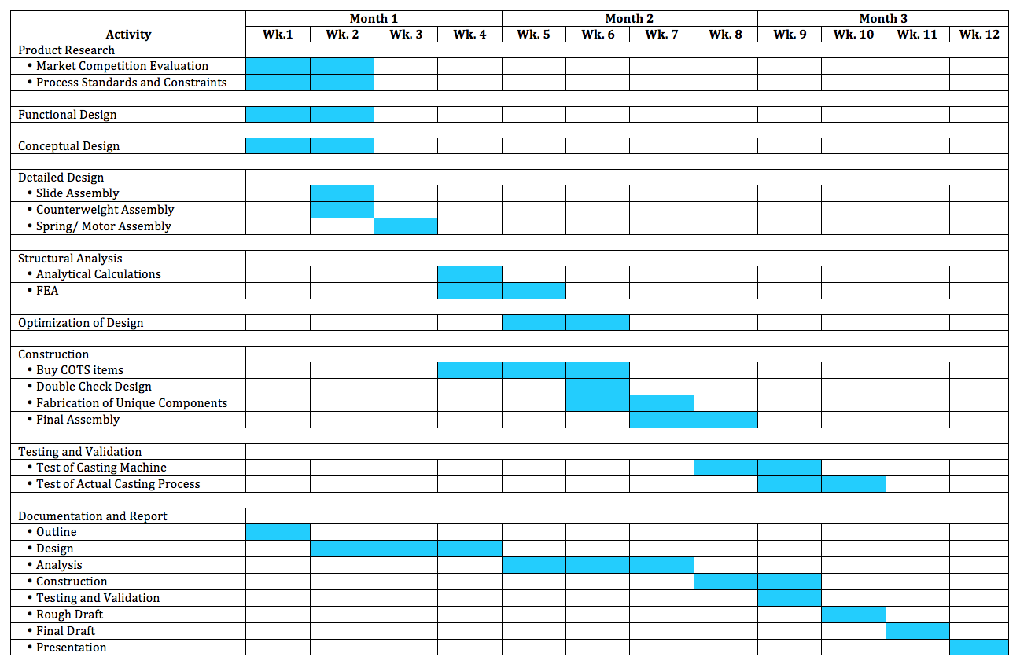

## Casting Process

Design and develop an investment casting process that:

* Is specifically applicable to the workshop at HSRW
* Is informative about the relevant variables in casting
* Is clear, easy to understand and easy to follow
* Conforms to relevant safety standards
* Can be completed concurrently with designing and building machine

# Chapter 3. METHODOLOGY

The aforementioned objectives will be achieved through a series of nearly sequential steps. Preliminary research will be done to evaluate existing centrifugal casting machines. This will involve background research of material selections, design decisions and consumer validation. Analyzing pros and cons of different designs will allow for improvement. After the research phase, computer simulation will be used to design the machine. This will be followed by fabrication, construction and testing of both the machine and the casting process in the Enspire Lab at HSRW Kleve.

I) Specifications and functional design

In this stage, the set of technical requirements to be satisfied by the machine will be chosen and the physics concerning the necessary torques and forces will be performed. The goal here is to begin developing the parameters and constraints that will define the functionality of the machine.

II) Conceptual design

This stage focuses on evaluating available options to make comprehensive design choices concerning functionality, usability and aesthetics. A morphological box will be populated with relevant sub-problems and the various conceptual solution options for those problems. From this matrix of small design decisions, should emerge the best overall combined solution.

III) Detailed design

Once the parameters have been analyzed and the overall concept for the machine has been chosen, the detailed design stage can begin. The CAD model of the casting machine will be created using Solidworks, since the 3D modeling environment is ideal for assembly simulations and shape optimization without the need for expensive and time consuming iterative prototyping. In this stage, all components needed for the machine and casting process will be designed and make-or-buy decisions will be made.

IV) Structural analysis

In this stage, the primary flow of forces will be analyzed and operational stresses will be compared to allowable stresses (according to materials and geometry) to prove the components can withstand the loads required of them, including a safety factor. Analytical stress calculations will be compared to stresses obtained by finite element analysis to ensure that the theory of the continuous system closely matches the simulation of the discrete one.

V) Optimization and Refinement

Once stress analyses have been done and COTS components have been received, the design can be optimized to ensure proper fit and efficient material usage. In this stage, the design is finalized.

VI) Fabrication and Construction

The finalization of the design prompts the creation of a fabrication plan for the unique components. In this stage, a plan for fabricating each component will be created and executed using the existing tools and equipment in the workshop at HSRW. As components are being fabricated, they will be fitted and assembled with COTS components into the final casting machine.

VII) Adaptation of Casting Process

Here, the investment casting process will be made suitable for the Enspire Lab at HSRW. Relevant safety standards will be consulted and a robust process guide will be written up for students endeavoring to use the centrifugal casting machine properly. Strict adherence to this guide will ensure safe handling and operation of all equipment used in the casting process.

VIII) Testing and Validation

Once the machine has been designed and constructed and the casting process has been formalized, the testing and validation stage can begin. Here, the machine and the casting guide will be tested to ensure that a safe and proper procedure has been laid out and to evaluate the quality of one or two casted parts.

# Chapter 4. FUNCTIONAL DESIGN

## Rotation Speed

The following analysis is done to provide some insight into the physics involved and to calculate the rotation speed that is necessary to generate sufficient centrifugal force required to meet the desired level of detail in the finished cast. This begins with calculating a critical flow velocity, as outlined by John Campbell in the Complete Casting Handbook (Campbell J.). The inertial pressure is the pressure that tends to disturb the surface during flow. This pressure is defined as $ρV^{2}/2$ with $ρ$ as the density of the molten material and *V* being the local flow velocity. By definition, the surface tension $γ$ acts to counter these disturbances at the surface of the melt, flattening it. The maximum pressure the surface tension can contain occurs when the surface is deformed into a hemisphere of radius $r$, meaning the pressure from the surface tension resisting the inertial pressure is equal to $2γ/r$. Therefore, to find the limit such that the velocity is sufficiently high to push the surface beyond the hemisphere, and thus exceed the maximum resistance from the surface tension, yields $ρV^{2}/2=2γ/r$. The critical velocity can therefore be defined as

$$V_{crit}=2{\left(\frac{γ}{r_{d}•ρ}\right)}^{\frac{1}{2}}$$

With $r_{d}$ as the desired detail radius of the cast and $V_{crit}$ as the minimum flow velocity required to penetrate mold crevices of that radius. Choose $r_{d}=25 μm$ (industry standard for fine models and jewelry) and empirical measurements for $γ$ and $ρ$.

Table 4.1: *Surface tensions, densities and critical flow velocities for common jewelry materials*

|  |  |  |  |
| --- | --- | --- | --- |
| Pure Metal | (N/m) | (kg/m3) | *V*crit (m/s) |
| Ag | 0.914 | 10490 | 3.734 |
| Al | 0.896 | 2560[3]* | 7.483 |
| Au | 1.162 | 19320 | 3.102 |
| Cu | 1.339 | 8940 | 4.895 |

Because the surface tensions are similar in numerical value, the densities dominate the calculation. The lower the density of the molten material, the higher flow velocity is required to penetrate the fine details of the mold. Since a minimum flow velocity is being calculated, the largest numerical value must be chosen to ensure proper flow of any material used in the casting machine. As such, the values for liquid aluminum will be used for the remainder of this analysis.

It can be seen from kinematics that ${V_{crit}}^{2}=2•a_{crit}•∆x$ with $∆x$ equal to the distance from the meting part of the crucible to the mold (11 cm). So,

$$a_{crit}=\frac{{V_{crit}}^{2}}{2•∆x}$$

The centrifugal force on the molten material is defined according to Newton’s second law as $F_{c}=m•a_{c}$ with $m$ as the mass of material, and the centrifugal acceleration $a_{c}=r•ω^{2}$ with $r$ as the distance from the molten material to the axis of rotation and $ω$ as the angular velocity. Setting the centrifugal acceleration equal to the critical acceleration gives

$$a_{crit}=\frac{{V_{crit}}^{2}}{2•∆x}=r•ω^{2}=a_{c}$$

so,

$$ω_{crit}={\left(\frac{{V_{crit}}^{2}}{2•r•∆x}\right)}^{\frac{1}{2}}=36.515 \frac{rad}{s}$$

$ω=2•π•n$ so,

$$n_{minimum}=\frac{ω_{crit}}{2•π}=348.691 RPM$$

This calculation is in line with most commercially available units (200 – 1000 RPM) and these predictions are likely to be all the more accurate for parts casted from noble metals such as gold and silver since, at least in principle, they will remain free of surface oxides and carbon films that pollute the cast (alloyed components will detract from this benefit) (Campbell J.).

## Angular Acceleration and Spin Duration

Intuitively, both of these parameters are linked to the amount of time the molten material spends in the crucible, the time it spends traveling from the crucible to the mold and the amount of time the molten material needs to solidify inside the mold. In other words, these parameters will be determined by the amount of time between the end of heating and the end of casting as well as the cooling properties for the various metals that will be casted. The fastest cooling rate will determine how quickly the molten material must move from the crucible to the mold; this will lead to the calculation of the angular acceleration. The slowest solidification rate will determine the length of time the cast must spin in the casting machine before stopping in order to ensure a fully solidified cast.

A cooling curve is a line graph that represents the change of phase of a material. For the purposes of casting, the transition of metals from liquid to solid is the focus. A typical qualitative cooling curve for a pure metal is shown in figure 4.1. Cooling curves for alloyed metals are similar but exhibit a range of solidification temperatures, instead of a constant temperature (sloped solidification line, instead of horizontal).

Local Solidification Time

Total Solidification Time

Solidification Temp

Casting Temp

Solidification Begins

Solidification Ends

Solid Cooling

Liquid Cooling

T/t = Cooling Rate

Superheat

Temperature T

Time t

*Figure 4.1: Typical cooling curve for a pure metal. The molten material must entirely fill the mold before solidification begins and the spinning process cannot end until solidification is sufficiently completed.*

A graphical analysis from the literature[4][5] of cooling curves for several relevant jewelry-casting metals showed that the material with the highest cooling rate is 18K Ni white gold. This material took 1.2 seconds to cool from casting temperature to the beginning of solidification. Assuming it takes the operator 0.8 seconds[6]* to remove the torch and initiate the casting process, this means the molten material must be entirely pushed into the mold by the machine within 0.4 seconds.

Kinematics gives $∆x=1/2•a•t^{2}$ with $∆x$ equal to the distance from the meting part of the crucible to the mold (11 cm) and $t$ being the calculated time. Since the casting process begins from rest with the articulated casting arm bent to the purely tangential direction, the acceleration experienced by the molten material will begin as tangential acceleration.

$$a_{T}=\frac{2•∆x}{t^{2}}=1.375 \frac{m}{s^{2}}$$

By definition, $a_{T}=α•r$ with $r$ as the radial distance from the pin joint to the rotation axis. Therefore, the minimum angular acceleration of the casting arm is calculated to be

$$α=\frac{a_{T}}{r}=\frac{2•∆x}{r•t^{2}}=27.5 \frac{rad}{s^{2}}$$

The slowest solidification rate of the analyzed materials was pure aluminum, which took 121 seconds to fully solidify. Since all other materials took much less time to solidify, two minutes was selected as the spin duration. $θ=α•t^{2}$, so the casting arm should reach its full angular velocity within 0.7 rotations. Once again, this seems to be in line with most commercially available units, which offer full rotation speeds within 1-2 full rotations.

# Chapter 5. CONCEPTUAL DESIGN

|  |  |  |  |  |
| --- | --- | --- | --- | --- |
| Morphological Box | | | | |
| **Sub-challenges** | **Potential Solutions +Advantages -Disadvantages**  **Chosen** | | | |
| Retaining cup / flask size | 2.5” diameter  + Easy to manufacture  - Restricted to casting small parts | 3” diameter  + Easy to manufacture  - Restricted to casting small parts or wasting investment material for small parts | Conical-shape for range of diameters  + Allows for range of flask sizes  - Makes investment process more difficult  - Complicated to manufacture | Stepped-shape for range of diameters  + Allows for several flask sizes without making investment process harder  - Stepped-shape requires additional manufacturing steps (lathe, mill) |
| Crucible standard | Kerr  + Common (easy to purchase)  - Restricted to Kerr machines | Neycraft  + Most widely used (easy to purchase and inexpensive)  - Work in Kerr and Neycraft machines | UltraFlex  - Restricted to UltraFlex machines  - Not even standard to all UltraFlex machines |  |
| Heating option | Casting torch  + Inexpensive  + Easy to operate  - Higher risk | Electrical induction  + Easy to operate  + Safer to operate  - More expensive  - Complicates system significantly (electronics and user interface required) | Electrical resistance  + Easy to operate  + Safer to operate  - More expensive  - Complicates system significantly (electronics and user interface) |  |
| Rigid or articulated arm | Rigid arm  + Easy to manufacture  - Arm must accelerate much slower to prevent material spilling over side of crucible | Articulated arm  + Allows forces to always point in the desired direction for material flow (no risk of spilling => higher torques)  - More manufacturing steps (pin joint or bearing arrangement) |  |  |
| Hinge for arm articulation | Pin joint  + Inexpensive  + Easy to manufacture  - May cause too much friction to allow arm to swing freely | Slide bearing  + Relatively inexpensive  + Easy to manufacture  + Friction should be low enough to allow arm to swing freely | Coupled rolling bearings  + Friction definitely low enough to allow arm to swing freely  - More expensive  - More difficult to design bearing arrangement  - More complicated fabrication of joint (mill, CNC, tolerance considerations, etc.) |  |
| Force generation | Manually driven  + Inexpensive  - More difficult to manufacture (- crank system with very small radius means high stresses) | Spiral flat spring  + Reasonably inexpensive  + Could potentially use replacement spring for Neycraft machine  - More difficult to design  - May not be able to meet torque requirements if steel is used for slide assembly and tub (larger inertia)  - May not be able to meet minimum spin duration requirements | Electric motor  + Can be tailored to exact force/ torque requirements  + Easy to model and design around COTS product  - More expensive  - May require electronics and user interface |  |
| Motor/Machine arrangement | Machine sits on top of motor and machine weight is axial load on motor shaft  + Easiest option to design  + Least expensive option  - Axial load may cause longevity concerns for motor  - May be more expensive | Machine sits on fixed enclosure and is driven by motor via spur gears  + No axial load on motor  - More complicated to design (housing and gear arrangement) | Machine sits on fixed enclosure and is driven by motor via belt  + No axial load on motor  - More complicated to design (belt and pulley arrangement with bearings) | Machine sits on fixed enclosure and is driven by motor via chain  + No axial load on motor  - More complicated to design (chain and sprocket arrangement with bearings) |
| Material for slide assembly | S235 Structural Steel  + Inexpensive and readily available  + Relatively easy to machine  + Can be welded easily  + High melting temperature (1480°C)  - Could corrode over time | 304 Stainless steel  + Can be welded easily  + No risk of corrosion  + High melting temperature (1400°C)  - More expensive  - More difficult to machine | Aluminum  + Inexpensive and readily available  + Easy to machine  + No risk of corrosion  - More difficult to weld (for me)  - Could corrode over time  - Low melting temperature (660°C) | Combination of whatever is available in the lab  + Cheapest option  - Will need additional treatment (oil quench or zinc sink) to prevent corrosion |
| Shape of slider bars (cross-section) | Round  - More difficult to manufacture (tapping ends or cotter pin arrangement) | Rectangular  + Easy to manufacture and assemble  - More difficult to calculate  - Will require additional hardware | I-Beam  - More difficult to manufacture (welding)  - Unnecessary because bending loads are small  - Inertia payoff is for wrong axis |  |
| Material for tub | S235 Structural Steel  + Inexpensive and readily available  + Relatively easy to machine  + Can be welded easily  + High melting temperature (1480°C)  - Could corrode over time | 304 Stainless steel  + Can be welded easily  + No risk of corrosion  + High melting temperature (1400°C)  - More expensive  - More difficult to machine | Aluminum  + Inexpensive and readily available  + Easy to machine  + No risk of corrosion  - More difficult to weld (for me)  - Low melting temperature (660°C) | Thermoset Plastic  + Lightweight (smaller inertia)  + Easy to machine  + No risk of corrosion  -+ Difficult to cast but may be easy to purchase COTS  - Brittle (less durable than metal) |
| Tub | Rotating  + Safer in the event of a catastrophic failure of the mold or crucible, since spilled molten metal can only spill onto surface with no relative motion  - More difficult to manufacture (mechanism for locking arm to tub)  - Additional rotating mass means additional torque required from spring/ motor | Stationary  + Easier to manufacture (possibly even COTS)  - Higher risk of splashing molten metal in the event of a catastrophic failure of the mold or crucible (could be solved by adding a protective lip to the inner wall) | Stationary solid upper ring around full enclosure  + Easier to manufacture  - Higher risk of splashing molten metal in the event of a catastrophic failure of the mold or crucible (could be solved by adding a protective lip to the inner wall) |  |
| Tub shape | Vertical walls  + Easy to manufacture (weld)  - Provides less safety in the event of a catastrophic failure of the mold or crucible | Concave walls  + Safer since spilled molten material would be directed downward (into tub) instead of upward  - More difficult to manufacture (cone shape) and weld |  |  |
| Tub Fabrication | Deep-drawing/ pressing  + Lowest mass/inertia option  - Difficult to manufacture  - May not have access to equipment | Welded seams  + Low mass/inertia  - Long welds, difficult to manufacture.  - Difficult to calculate  - Welding creates local brittle areas | Bolted seams  + Easy to manufacture  + Relatively easy to calculate  - Highest mass/inertia  -Requires more components | No seams  + Easiest to manufacture  + Requires fewest components  + Inertia doesn’t matter for stationary design inside enclosure |
| Enclosure  Definition:  Top  -------- Upper lip of tub  Bottom | Fully enclosed  + Provides illusion of safety even in the event of a catastrophic failure  - Most difficult to design and manufacture  - Most expensive  - May actually increase risk because of safety components interfering with casting | Open top, enclosed bottom  + Allows for easy access to crucible and flask during casting  - More difficult to design and manufacture (especially if a rotating tub is chosen)  - More expensive  - Would create possibility to get fingers between fixed enclosure and spinning tub (less safe) | Open bottom, enclosed top  + Hinged, closing top may add safety in the event of a catastrophic failure of the mold or crucible  - Even more difficult to design and manufacture (need a way to be able to release the arm from outside  - May actually increase risk because of safety components interfering with casting | Fully open  + Least expensive  + Easiest to manufacture  + Most commonly used option  - Provides less illusion of safety in the event of catastrophic failure of the mold or crucible |

# Chapter 6. DETAILED DESIGN

For the purposes of classical rational analysis, the casting machine may be divided into hierarchies by means of its component assemblies and by means of its functions.

## Component Hierarchy

*Figure 6.1: Component hierarchy diagram showing all parts and materials for final design*

## Functional Hierarchy

Enclosure

DC 0-36V 0-15A Power Supply

DB56D036030-A Brushless Motor

GP56-S1-7-SR Planetary Gearbox

Casting Arm Assembly

220V AC Electric

Power from outlet

36V DC Power

Electronic

Kill-Switch

Lid of enclosure

must close for

power to flow

3000 RPM

0.6 Nm

Heat

from torch

Pre-prepared

casting flask

375 RPM

6 Nm @ 7.5 A

Normal Operating Functions

Operator Controlled Functions

*Figure 6.2: Functional hierarchy diagram showing normal operating functions and operator controlled functions*

## Casting Arm Sub-Assemblies

### Flask Cradle Assembly

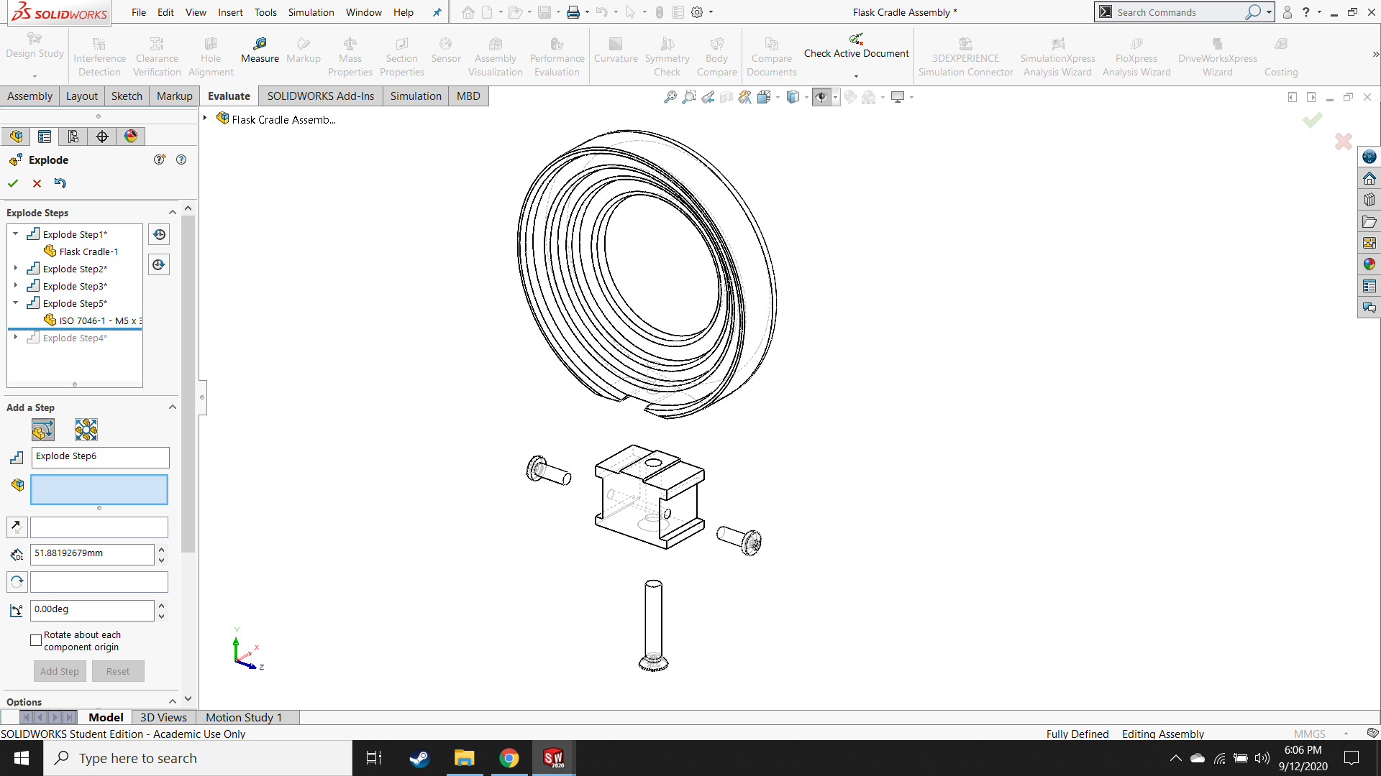

1

2

3

4

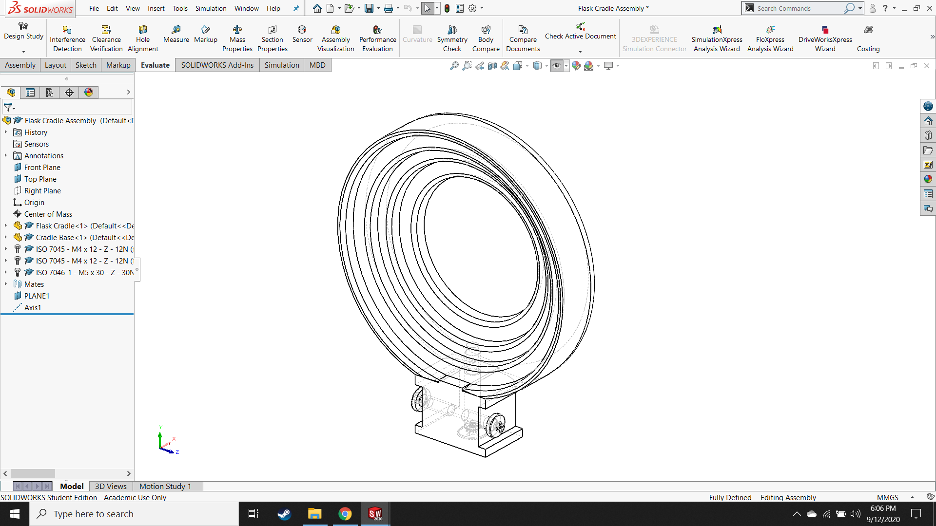

|  |  |  |  |  |
| --- | --- | --- | --- | --- |
| **#** | **Part Name** | **Qty** | **Material** | **M or B** |
| 1 | Flask Cradle | 1 | S235 Structural | Make |
| 2 | Cradle Base | 1 | S235 Structural | Make |
| 3 | ISO 7045–M4x12–Z–12N | 2 | 304 Stainless | Buy |
| 4 | ISO 7046-1–M5x30–Z–30N | 1 | 304 Stainless | Buy |

*Figure 6.3: Isometric views of exploded and assembled flask cradle assembly with bill of materials*

### Slider Assembly

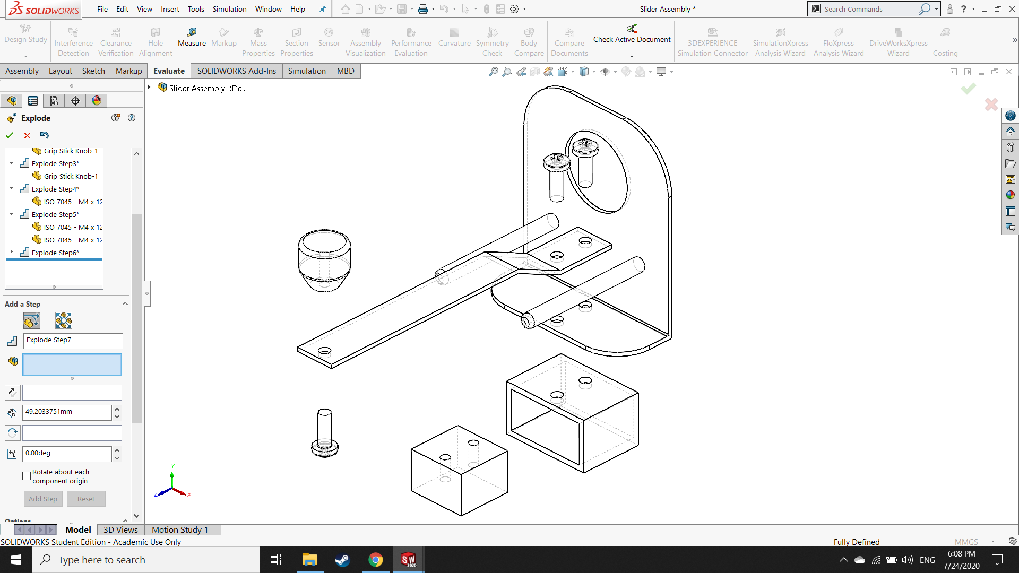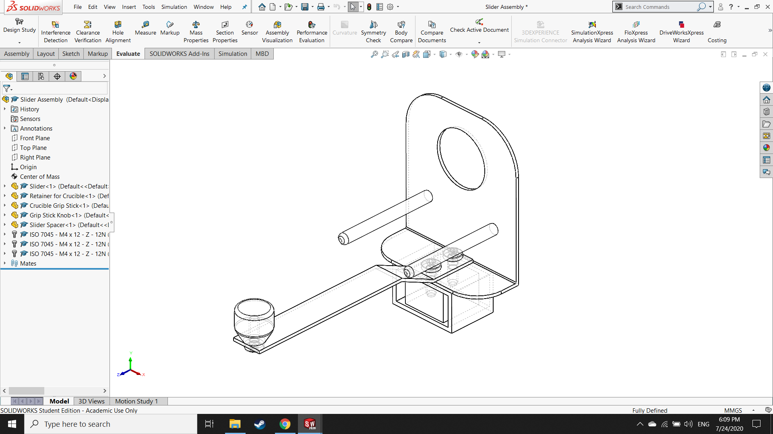

1

2

3

4

5

6

|  |  |  |  |  |
| --- | --- | --- | --- | --- |
| **#** | **Part Name** | **Qty** | **Material** | **M or B** |
| 1 | Retainer for Crucible | 1 | 304 Stainless | Make |
| 2 | Slider | 1 | S235 Structural | Make |
| 3 | Slider Spacer | 1 | S235 Structural | Make |
| 4 | Crucible Grip Stick | 1 | 304 Stainless | Make |
| 5 | Grip Stick Knob | 1 | Oak | Make |
| 6 | ISO 7045–M4x12–12N | 3 | 304 Stainless | Buy |

*Figure 6.4: Isometric views of exploded and assembled slider assembly with bill of materials*

### Pin joint and Slider Bar Assembly

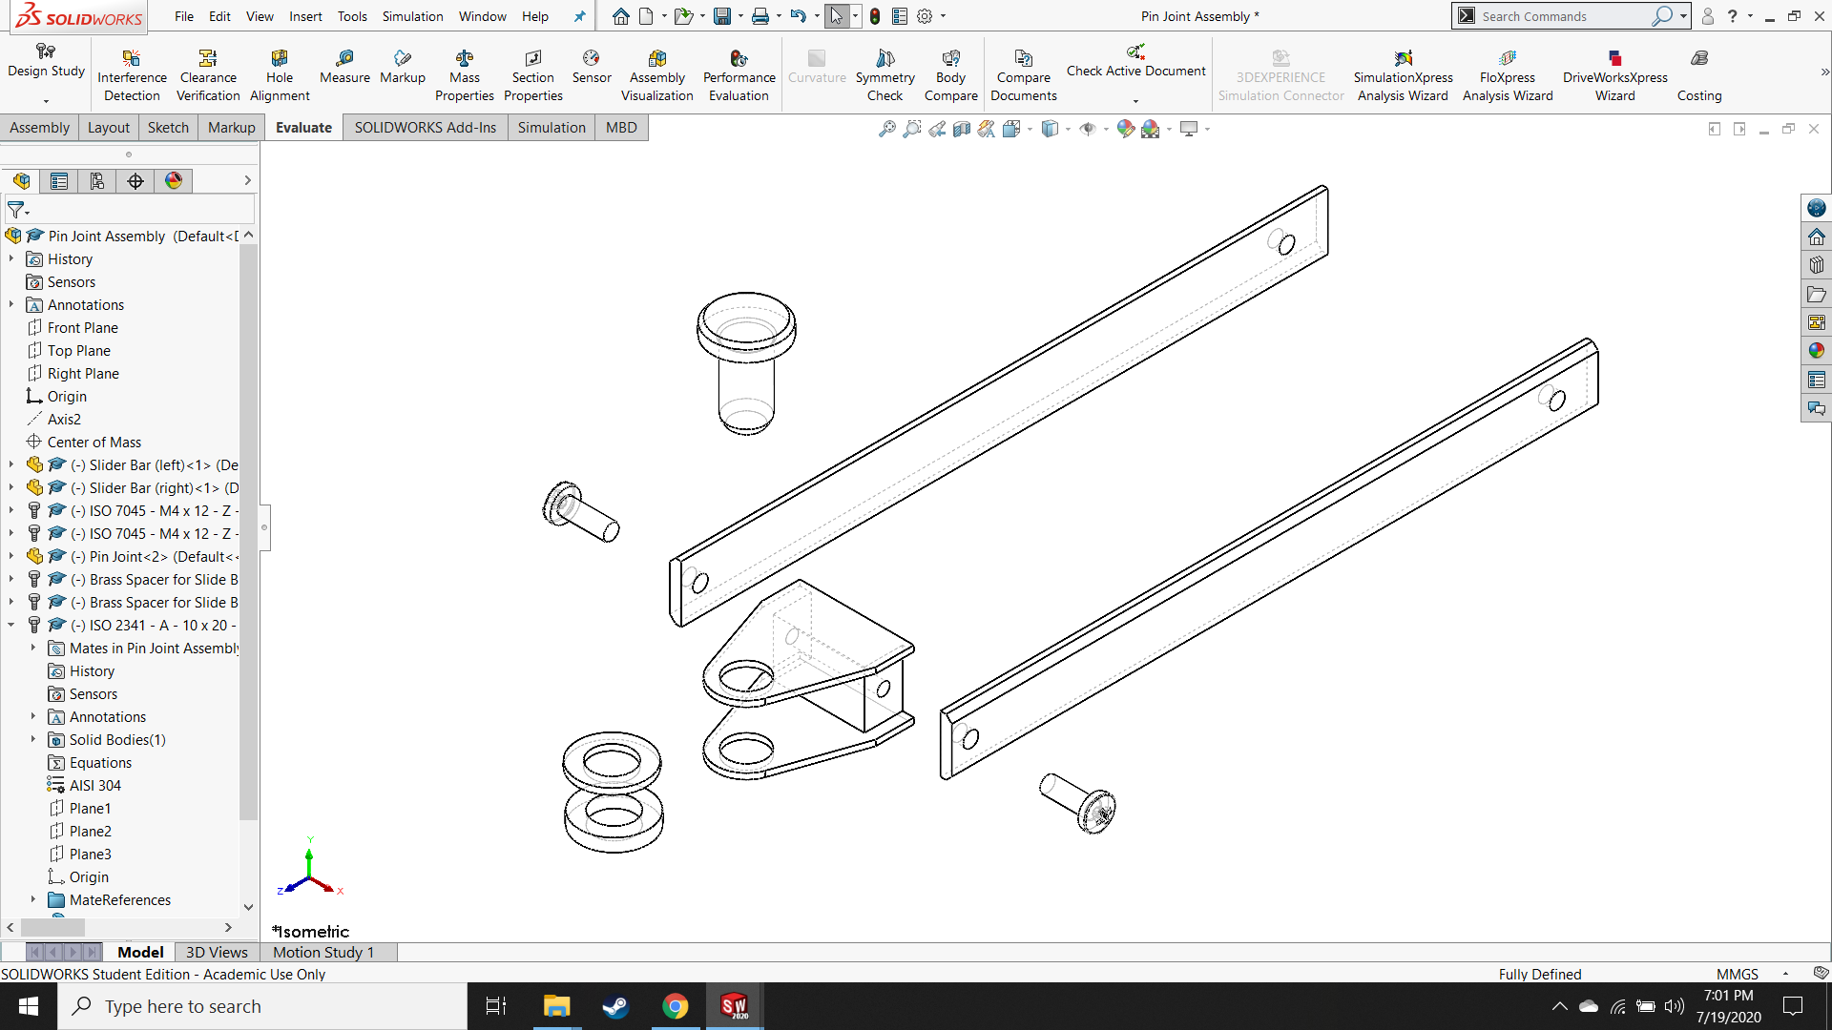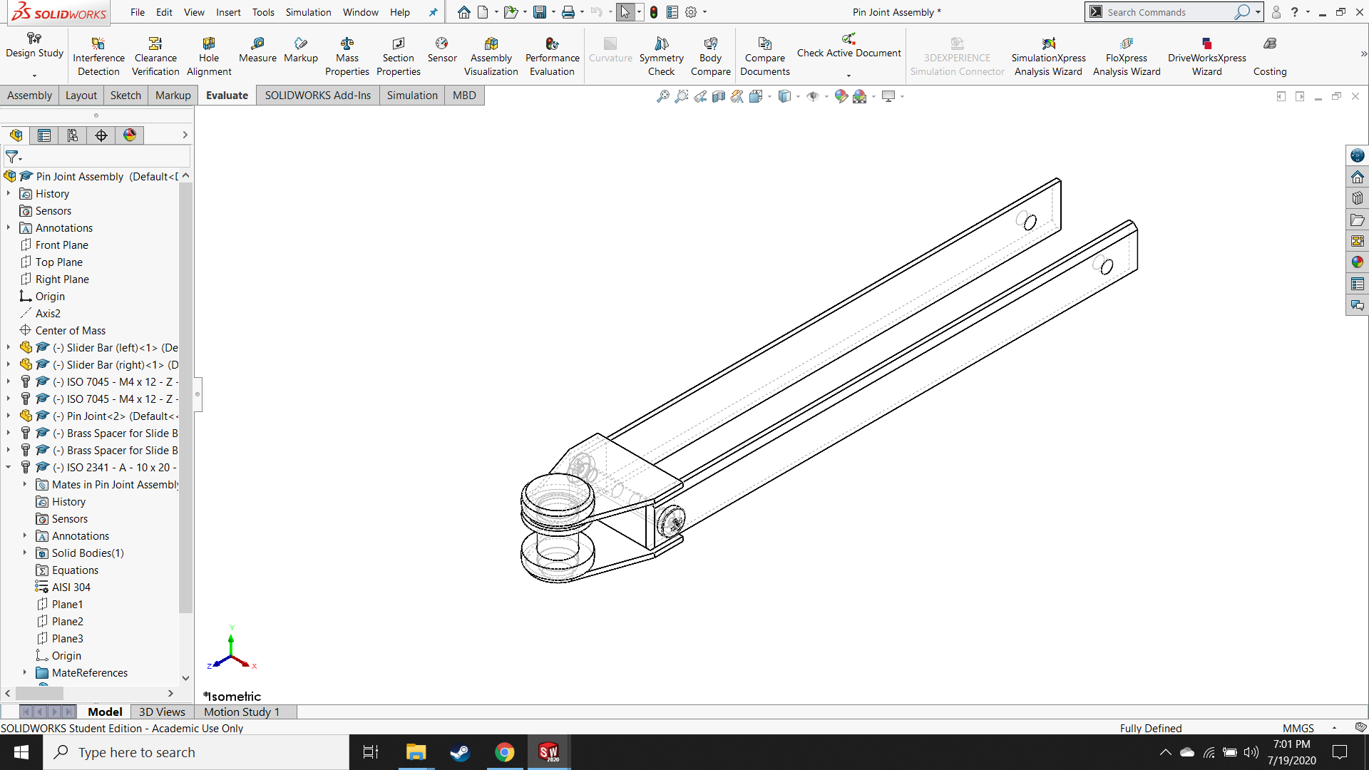

1

2

3

4

5

6

|  |  |  |  |  |
| --- | --- | --- | --- | --- |
| **#** | **Part Name** | **Qty** | **Material** | **M or B** |
| 1 | Slider Bar (Left) | 1 | 304 Stainless | Make |
| 2 | Slider Bar (Right) | 1 | 304 Stainless | Make |
| 3 | Pin Joint | 1 | S235 Structural | Make |
| 4 | ISO 2341–A–10x20 | 1 | 304 Stainless | Buy |
| 5 | ISO 7045–M4x12–Z–12N | 2 | 304 Stainless | Buy |
| 6 | Spacer for Bearing | 2 | Brass | Make |

*Figure 6.5: Isometric views of exploded and assembled pin joint assembly with bill of materials*

### Full-Articulated Arm Assembly

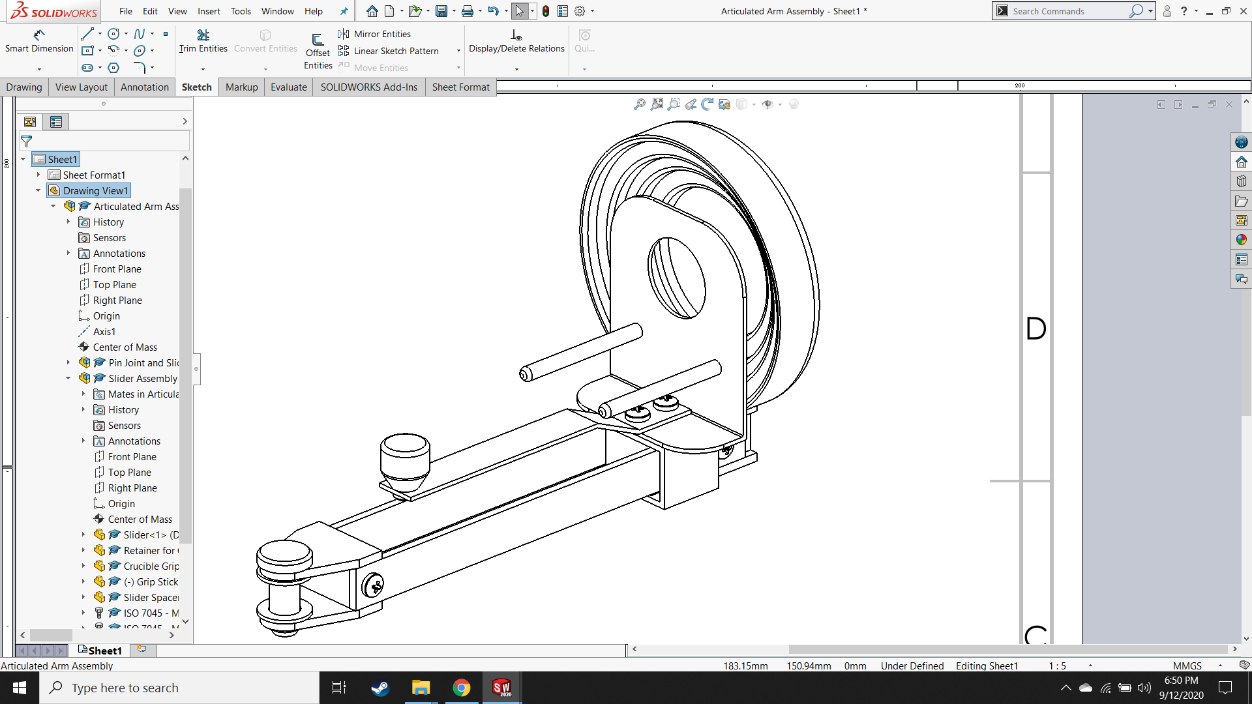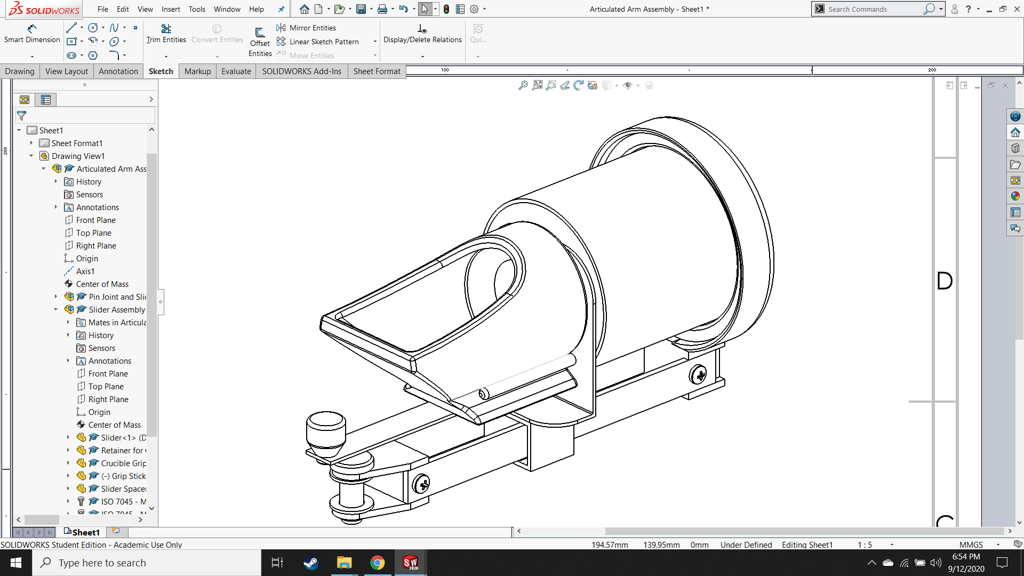

*Figure 6.6: Isometric views of assembled articulated arm, shown with (right) and without (left) crucible and casting flask*

## Counterweight Arm Assembly

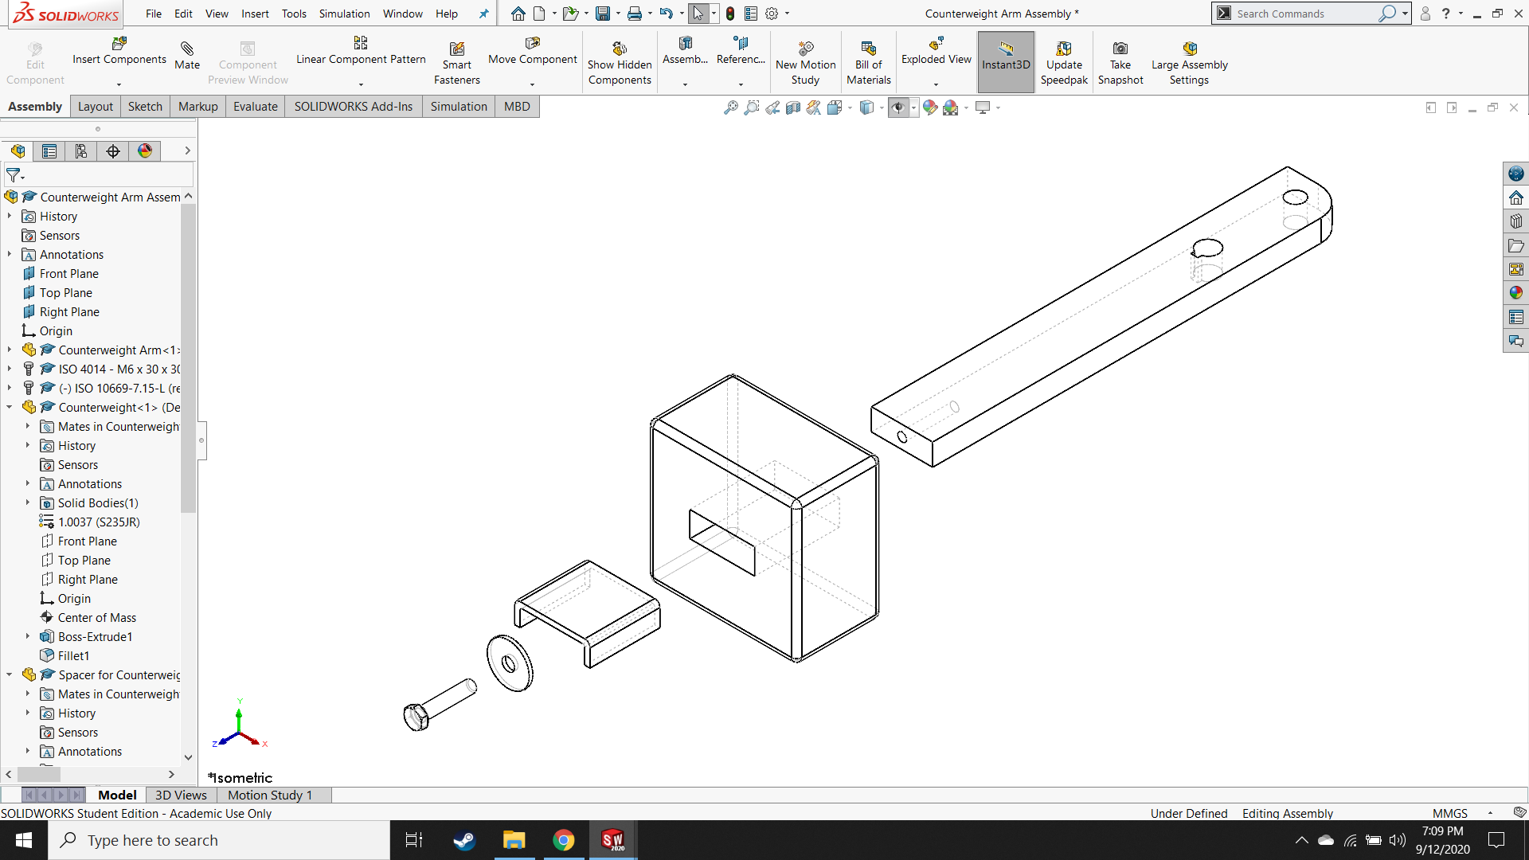

1

2

3

4

5

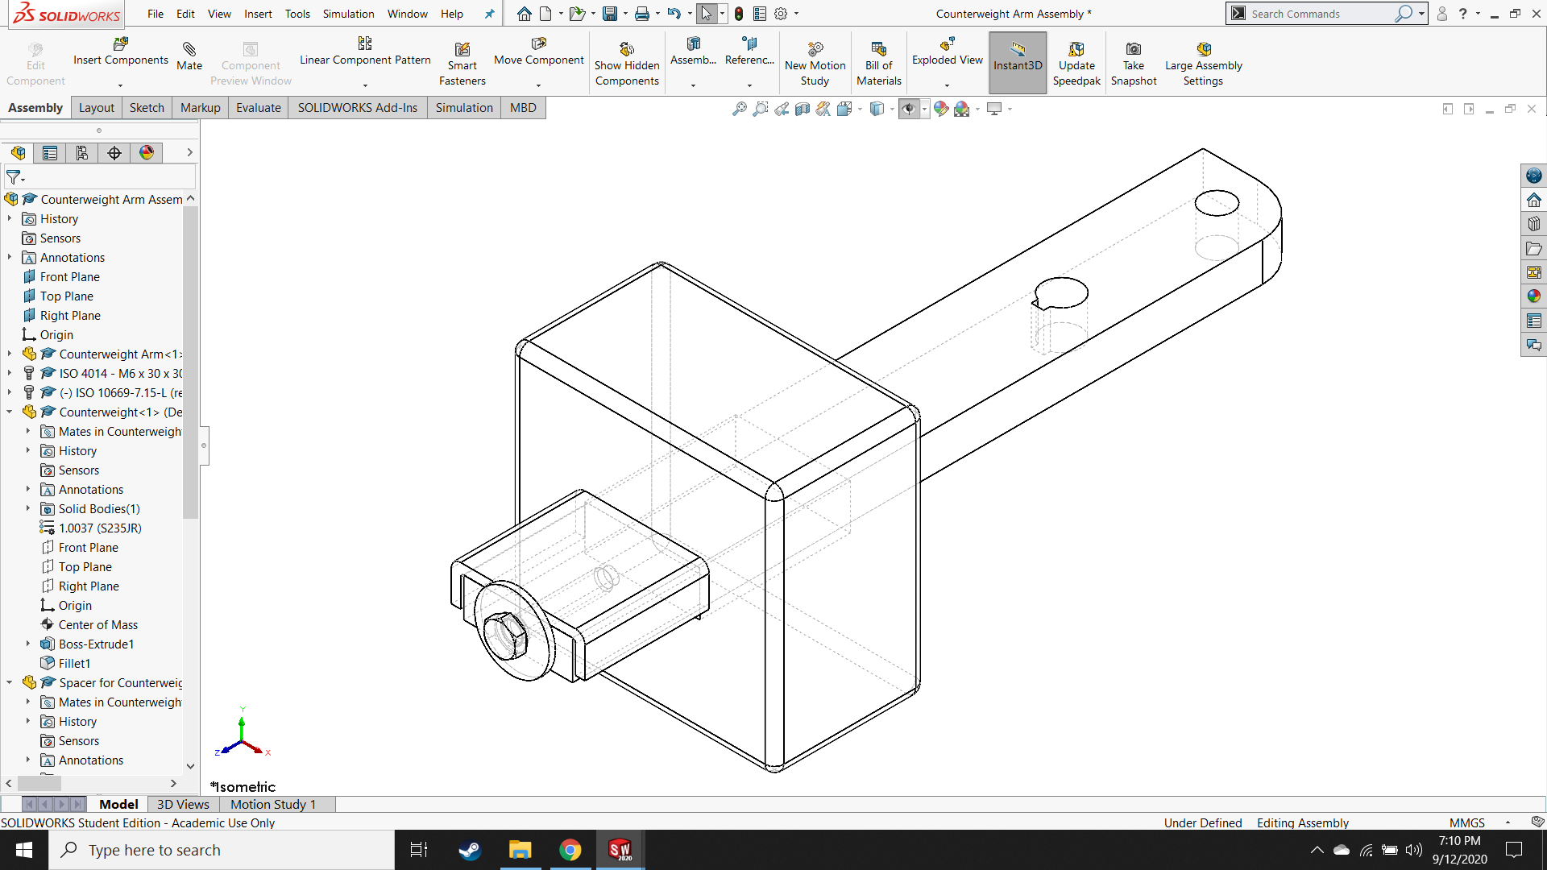

|  |  |  |  |  |
| --- | --- | --- | --- | --- |
| **#** | **Part Name** | **Qty** | **Material** | **M or B** |
| 1 | Counterweight Arm | 1 | S235 Structural | Make |
| 2 | Counterweight | 1 | S235 Structural | Make |
| 3 | ISO 4014 – M6 x 30 x 30-N | 1 | S235 Structural | Buy |
| 4 | ISO 10669-7.15-L | 1 | S235 Structural | Buy |
| 5 | Spacer for Counterweight | 1 | S235 Structural | Make |

*Figure 6.7: Isometric views of exploded and assembled counterweight assembly with bill of materials*

## Macintosh HD:Users:hinkleaj:Desktop:Thesis:Diagrams, Pics & Tables:new pics for detailed design:Screenshot (192).pngFull Casting Arm Assembly

*Figure 6.8: Isometric view of full assembled casting arm, shown without crucible or casting flask*

## Motor and Machine Base Assembly

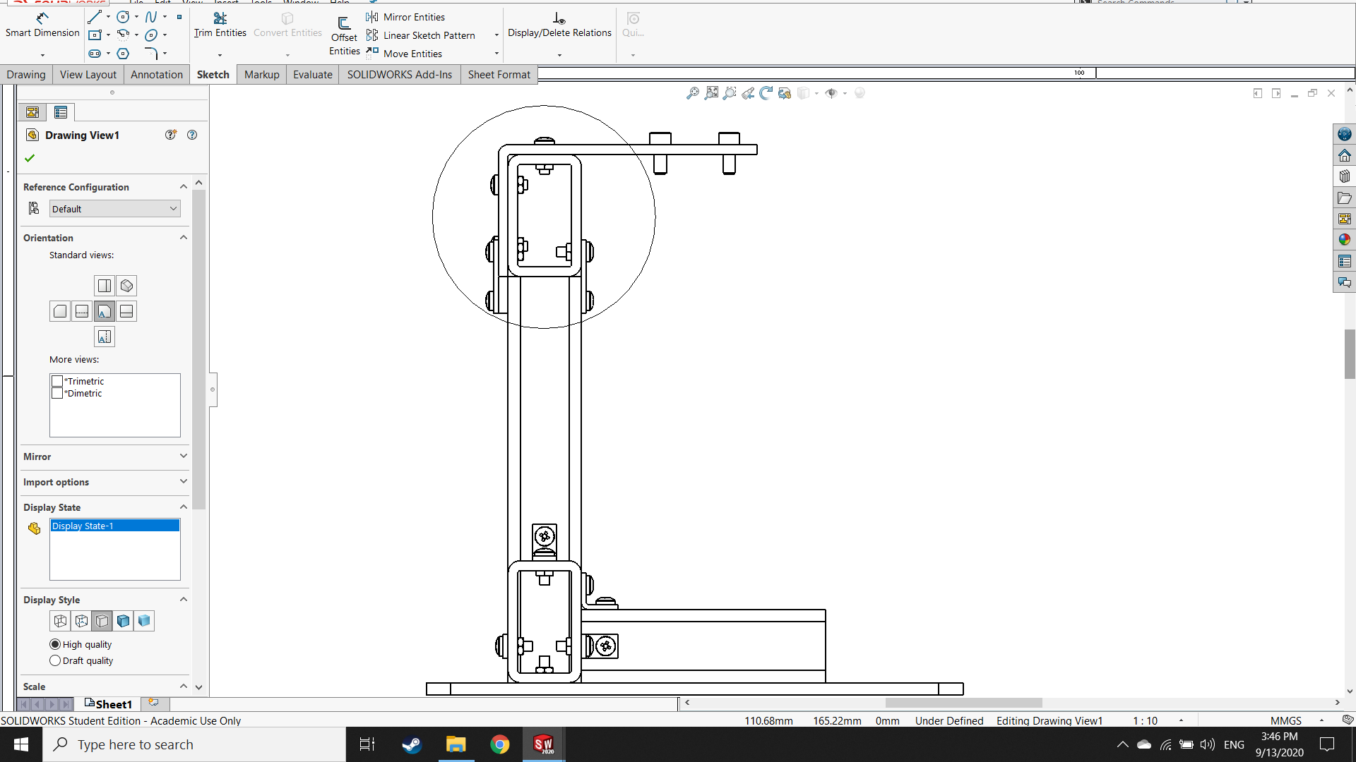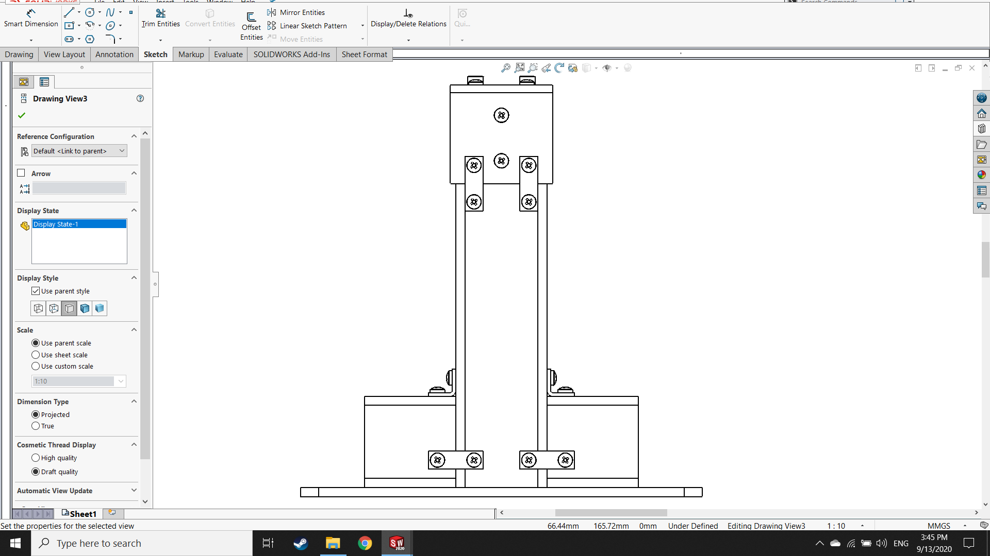

A

FRONT

LEFT

1

2

5

3

4

9

7

8

6

10

11

12

13

*Figure 6.9: Select cardinal views of assembled motor and machine base assembly*

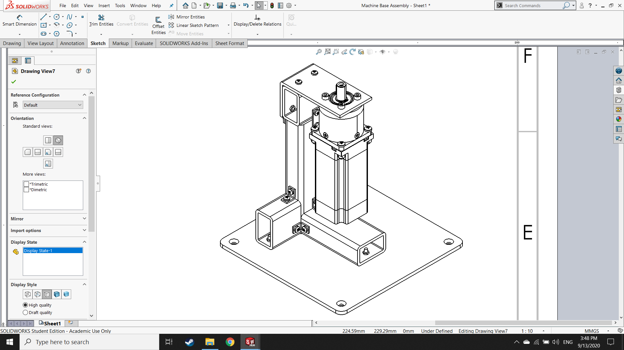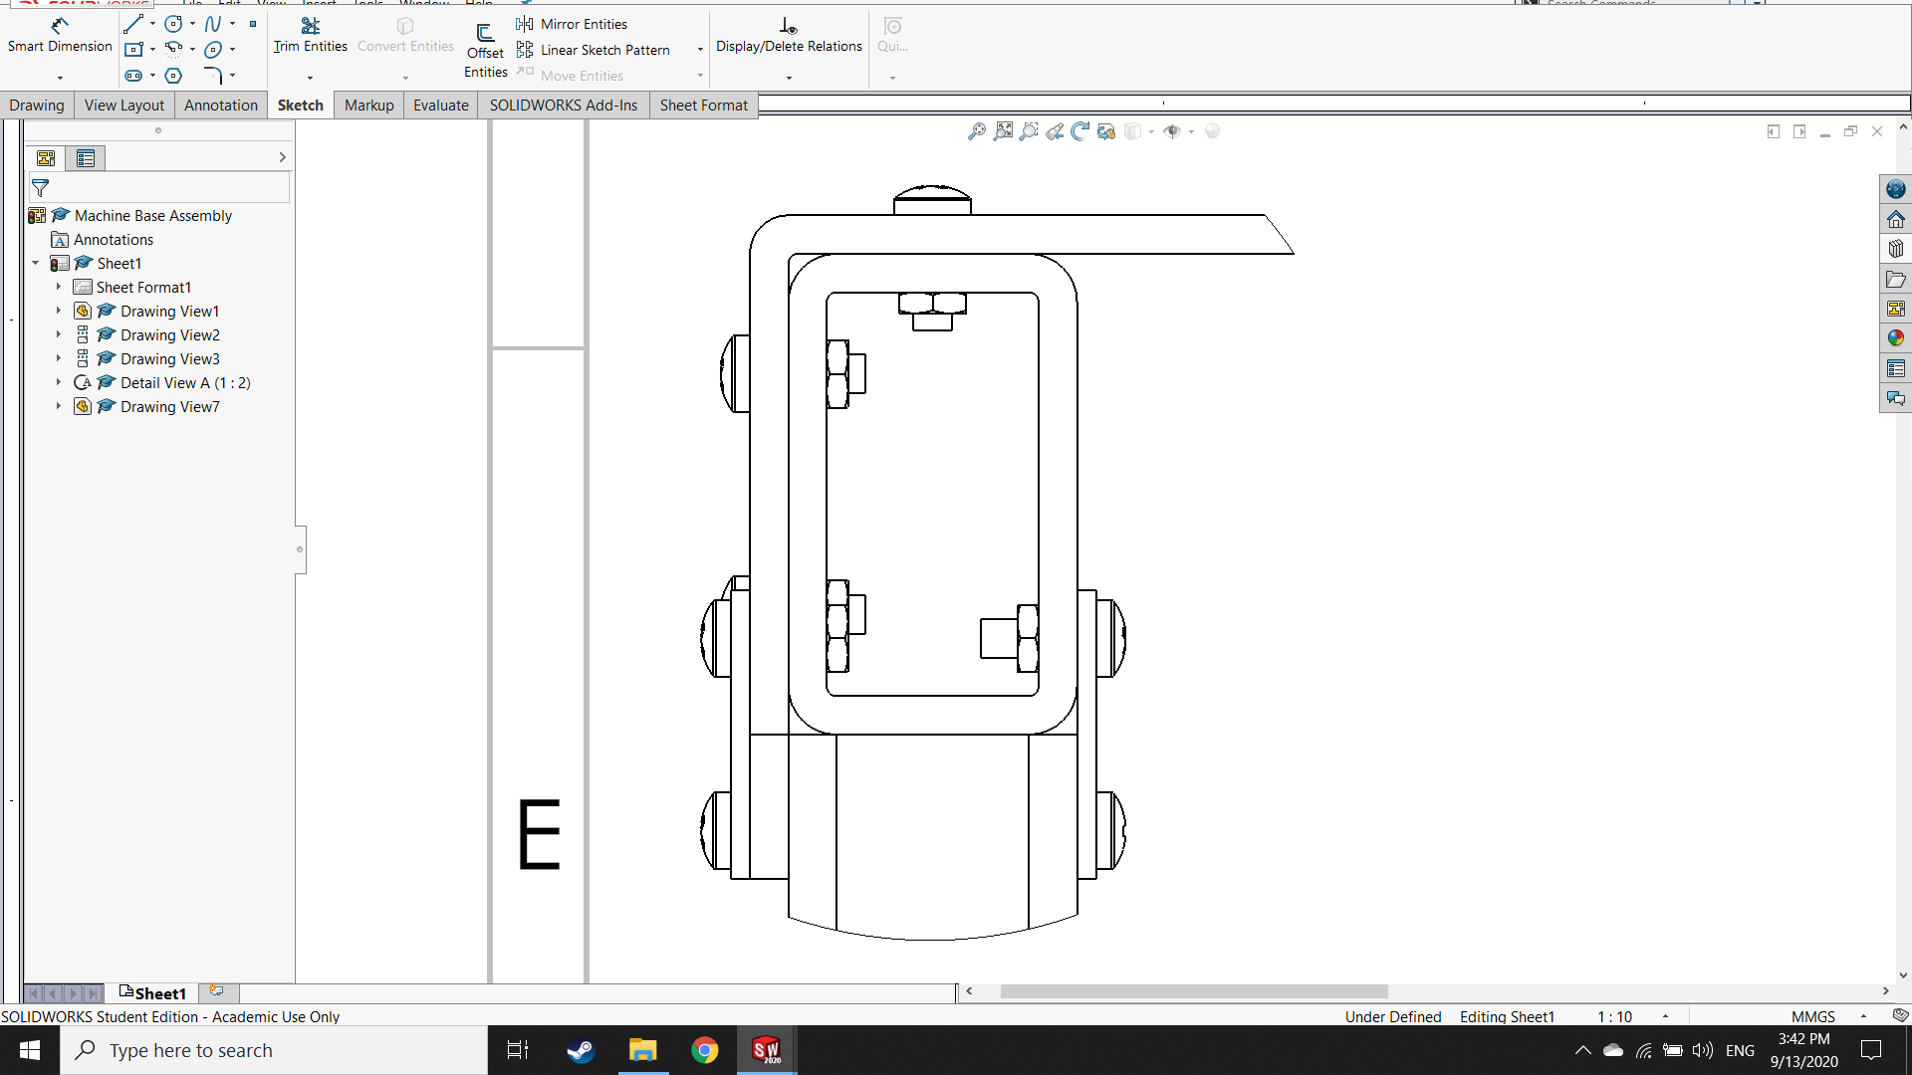

DETAIL A

14

15

*Figure 6.10: Detail A and isometric view of motor and machine base assembly showing gearbox and motor placement*

*Table 6.1: Bill of materials for machine base assembly*

|  |  |  |  |  |
| --- | --- | --- | --- | --- |
| **#** | **Part Name** | **Qty** | **Material** | **M or B** |
| 1 | Bracket for Connection to Gearbox | 1 | S235 Structural | Make |
| 2 | Flat Bracket | 5 | S235 Structural | Make |
| 3 | Corner Bracket | 5 | S235 Structural | Make |
| 4 | Legs | 2 | S235 Structural | Make |
| 5 | ISO 7045 – M4 x 12 – Z – 12N | 24 | S235 Structural | Buy |
| 6 | Spacer | 2 | S235 Structural | Make |
| 7 | ISO 7046-1 – M4 x 16 – Z – 16N | 3 | S235 Structural | Buy |
| 8 | ISO – 4035 – M4 – N | 30 | S235 Structural | Buy |
| 9 | ISO 4762 M5 x 12 – 12N | 4 | S235 Structural | Buy |
| 10 | Top Piece | 1 | S235 Structural | Make |
| 11 | Vertical Post | 1 | S235 Structural | Make |
| 12 | Foot | 1 | S235 Structural | Make |
| 13 | Base Plate | 1 | 1050A Aluminum | Make |
| 14 | GP56-1-S1-XX-SRS Planetary Gearbox | 1 | --- | Buy |
| 15 | DB56D036030-A Brushless DC Motor | 1 | --- | Buy |

## Enclosure

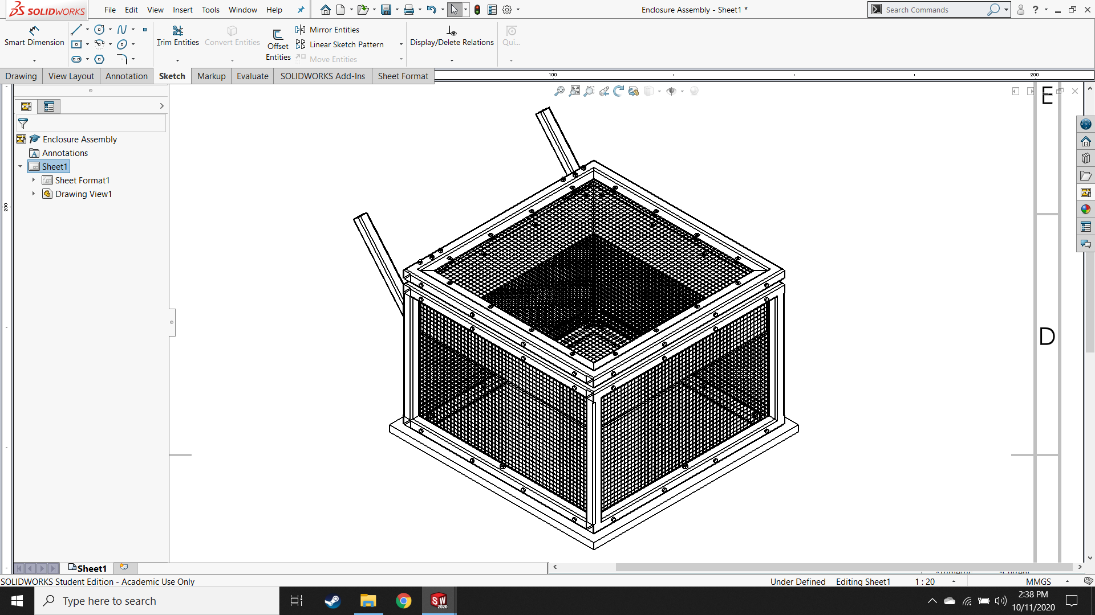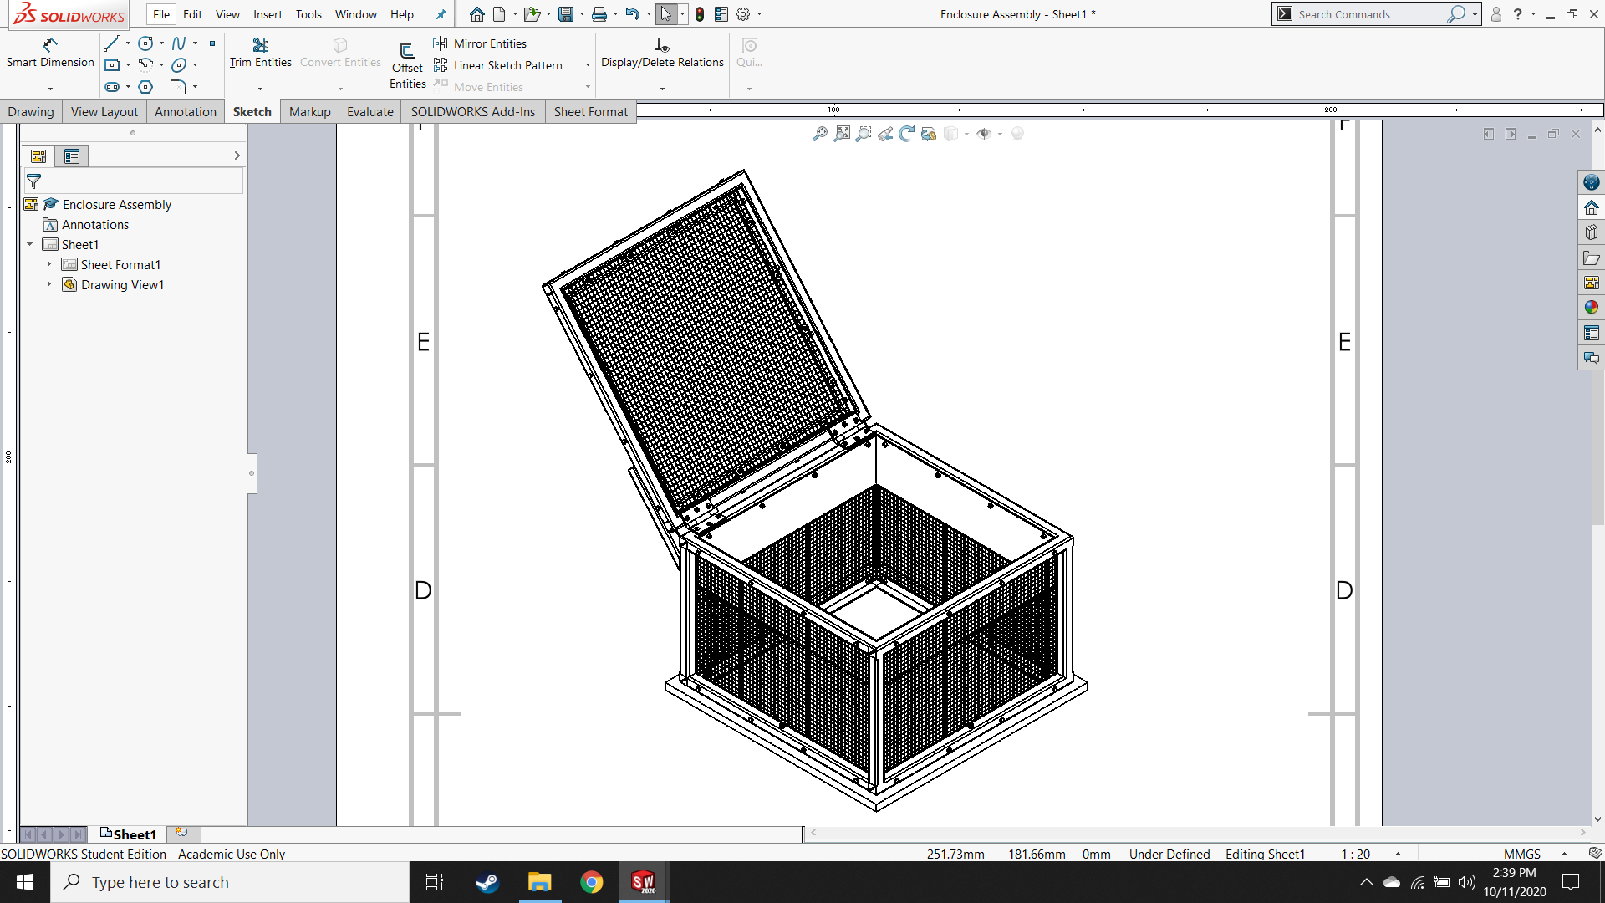

1

2

3

8

4

7

10

11

12

14

13

5

6

9

15

*Figure 6.11: Open (left) and closed (right) isometric views of enclosure showing components*

*Table 6.2: Bill of materials for enclosure assembly*

|  |  |  |  |  |
| --- | --- | --- | --- | --- |
| **#** | **Part Name** | **Qty** | **Material** | **M or B** |
| 1 | Welded Frame | 1 | S235 Structural | Make |
| 2 | Lid | 1 | S235 Structural | Make |
| 3 | Chicken Wire (5 pieces cut to inner dimensions of frame) | 5 | --- | B/M |
| 4 | ISO 7094 - 5 (large M5 washers) | 16 | S235 Structural | Buy |
| 5 | Al L-Profile (lid) | 4 | 1050A Aluminum | Make |
| 6 | 25 x 80 mm CS Hinge | 2 | S235 Structural | Buy |
| 7 | 1.5 mm Sheet | 4 | S235 Structural | Make |
| 8 | Al L-Profile (bottom) | 4 | 1050A Aluminum | Make |
| 9 | ISO 7046-1 M5 x 35 – Z – 35N (CS bolt for hinges) | 12 | S235 Structural | Buy |
| 10 | ISO – 4032 – M5 – D – N (M5 nuts) | 74 | S235 Structural | Buy |
| 11 | ISO 7046-1 M5 x 8 – Z – 8N (CS bolt for lid) | 16 | S235 Structural | Buy |
| 12 | ISO 4014 M5 x 35 x 35-N (35mm M5 hex bolt) | 48 | S235 Structural | Buy |
| 13 | ISO 7046-1 M6 x 50 – Z – 50N (CS for frame to base) | 4 | S235 Structural | Buy |
| 14 | ISO – 4034 – M6 – N (M6 nuts) | 4 | S235 Structural | Buy |
| 15 | Base Board | 1 | ¾ Inch Plywood | Make |

## Full Assembly of Casting Machine

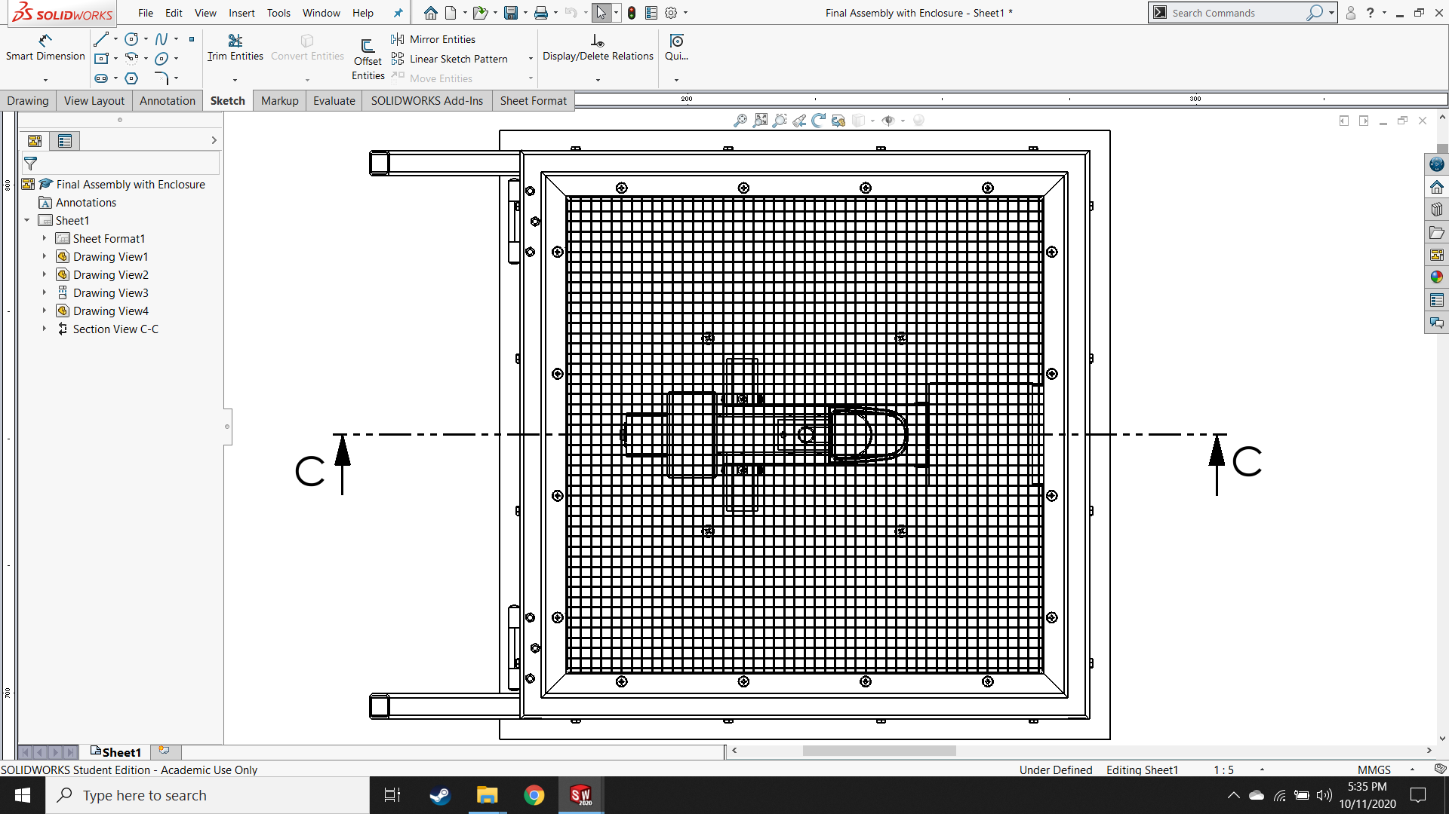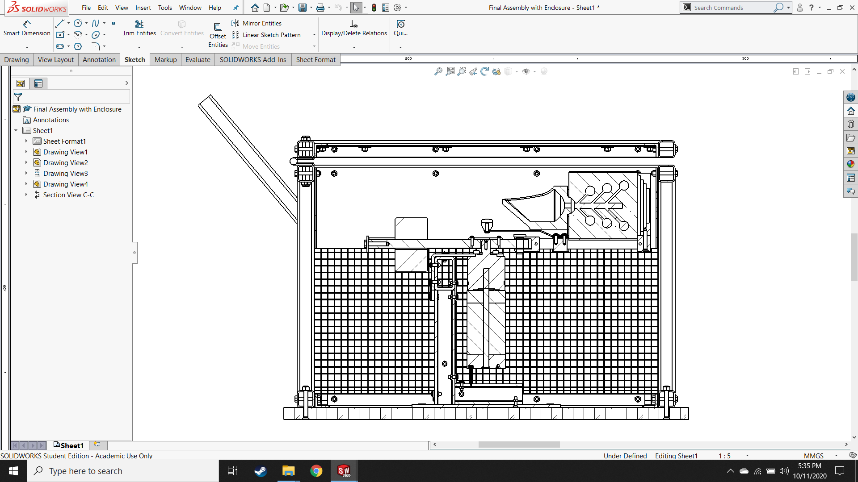

*Figure 6.12: Top and right section view of full assembly of entire centrifugal casting machine, shown with crucible and flask assembly*

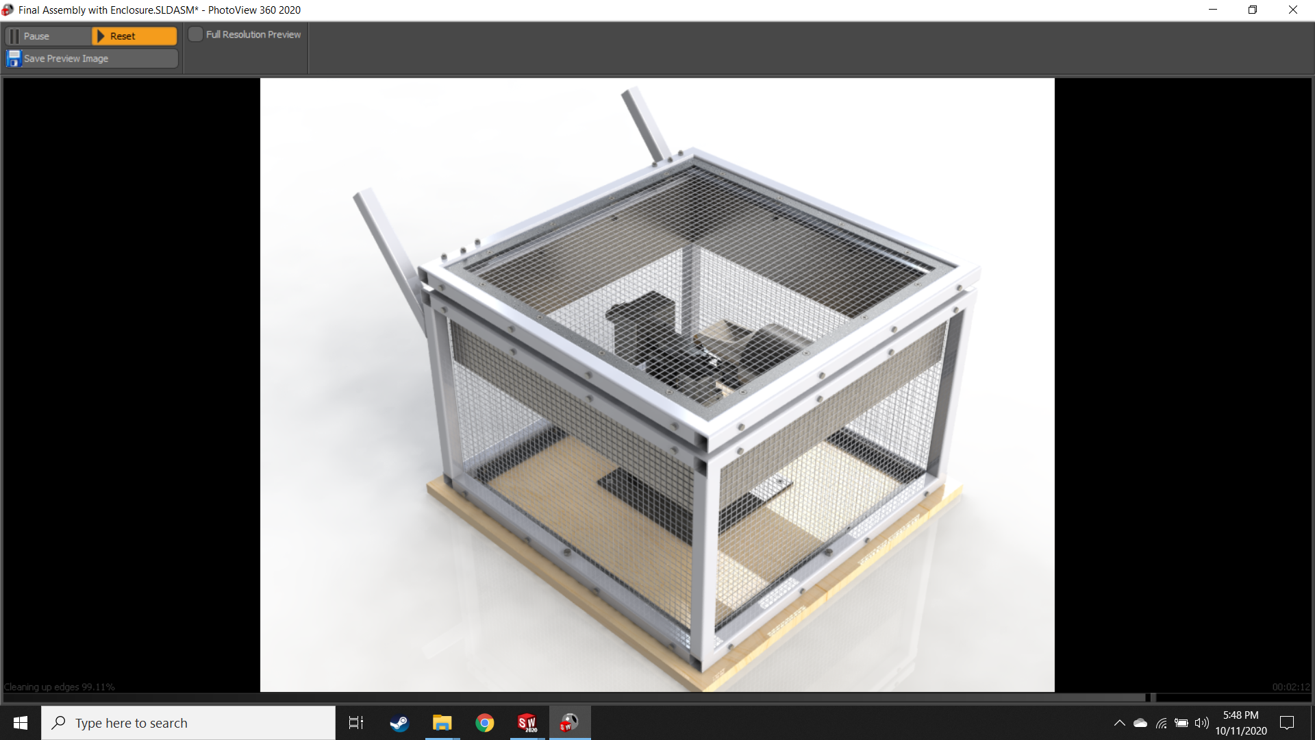

*Figure 6.13: Isometric view of 3D rendering of final CAD model*

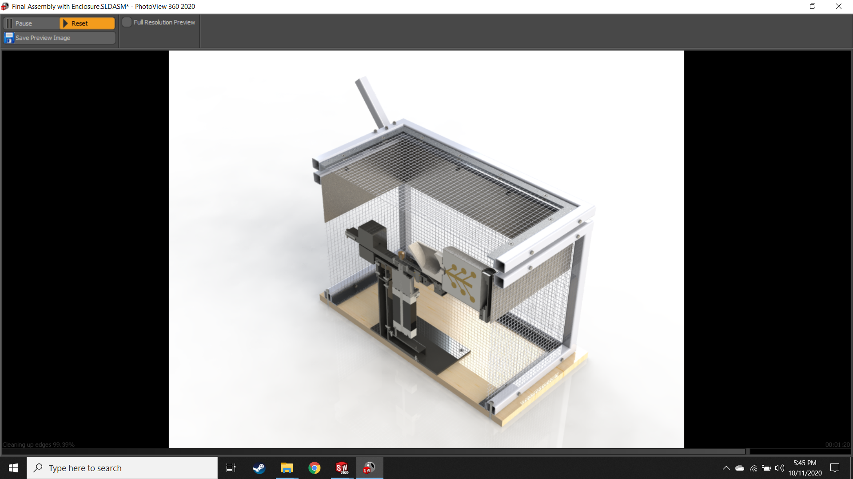

*Figure 6.14: Isometric section view of 3D rendering of final CAD model*

## Motor Selection

Electrical power is the product of current $I$ and voltage $V$:

$$P=I•V$$

Mechanical power is the product of torque $τ$ and angular velocity $ω$:

$$P=τ•ω$$

An electric motor is a converter of electrical power into mechanical power. The output mechanical power of the power transmission system equals the electrical power of the motor minus some losses due to inefficiency in the drivetrain. When more current is applied to the motor, the magnetic field inside becomes stronger. Consequently, the attraction between the poles increases. This means that the current to the motor is directly proportional to the output torque. Similarly, the faster the rotor spins through the stator field, the greater the counter-electromotive force it will generate, in accordance with Faraday’s law of induction. This means, as expected from the equations describing electrical and mechanical power, voltage and rotation speed are also directly proportional. In other words: to change the rotation speed of an electric motor, adjust the supplied voltage; to change the output torque, adjust the supplied current.

The output torque and rotation speed can also be affected by reduction systems like gearboxes. Commonly, planetary gearboxes are used since the relationships are straightforward. The output torque of the gearbox $τ_{out}$ equals the product of the input torque $τ_{in}$ and the reduction ratio of the gearbox $i$, times the efficiency of the gearbox $η$. The output rotation speed $n_{out}$ equals the input speed $n_{in}$ divided by the reduction ratio, again times the efficiency. In mathematical form:

$$τ_{out}=τ_{in}•i•η$$

$$n_{out}=\frac{n_{in}}{i}•η$$

Similarly, output torque and rotation speed can also be affected by power transmission systems like belt drives. The relationships are the same but the reduction ratio $i$ is the ratio of the driving pulley to the driven pulley and the efficiency $η$ is the efficiency of the belt and pulleys.

The selection of a motor and drivetrain is a delicate dance between the requirements of the design and the standard components that are available for purchase, as well as their interfacing options. The required torque $τ_{req}$ is calculated using the minimum angular acceleration $α$ from the preliminary calculations and the machine’s moment of inertia $I$ about the rotation axis:

$$τ_{req}=I•α=\left(0.1605 kg•m^{2}\right)•\left(27.5 \frac{rad}{s^{2}}\right)=4.414 Nm$$

The required power $P_{req}$ is calculated using the required torque and the minimum angular velocity $ω$ from the preliminary calculations:

$$P_{req}=τ_{req}•ω=\left(4.414 Nm\right)•\left(36.515 \frac{rad}{s}\right)=156.755 W$$

Given these values and the aforementioned relationships, a suitable motor and gearbox configuration was chosen.

Motor:

|  |  |  |
| --- | --- | --- |
| DB56D036030–A – Brushless DC Motor | | |
| Motor size | Nema 23 | Macintosh HD:Users:hinkleaj:Desktop:Thesis:Diagrams, Pics & Tables:DB56D036030-A .jpg |
| Rated power | 188 W |
| Rated torque | 60 Ncm |
| Rated current | 7.5 A |
| Rated speed | 3000 RPM |
| Rated voltage | 36 V |

*Figure 6.15: DB56D036030–A – Brushless DC Motor and relevant technical data*

Gearbox:

|  |  |  |
| --- | --- | --- |
| GP56–S1–7–SR – High-Torque Planetary Gearbox | | |
| For motor size | Nema 23, Nema 24 | Macintosh HD:Users:hinkleaj:Desktop:Thesis:Diagrams, Pics & Tables:GP56–S1–8–SR.jpg |
| Efficiency | 92% |
| Rated output torque | 12.1 Nm |
| Reduction ratio | 7 |
| Max axial shaft load | 1302 N |
| Max radial shaft load | 516 N |

*Figure 6.16: GP56–S1–7–SR – High-Torque Planetary Gearbox and relevant technical data*

### Check of axial shaft load

In this design, the weight of the casting arm is the axial shaft load. Since the max axial load is 1302 N, the 6.6 kg mass of the machine is significantly less than the maximum admissible mass of 132.7 kg.

### Check of radial shaft load

Any imbalance in the casting arm will result in a radial load on the gearbox shaft due to the centrifugal forces. The maximum mass that can be out of balance on the casting arm can be calculated using the permissible radial shaft load.

$$m_{imbalance, max}=\frac{F_{per}}{ω^{2}•L}=2.20 kg$$

# Chapter 7. STRUCTURAL ANALYSIS

## Articulated Arm Assembly

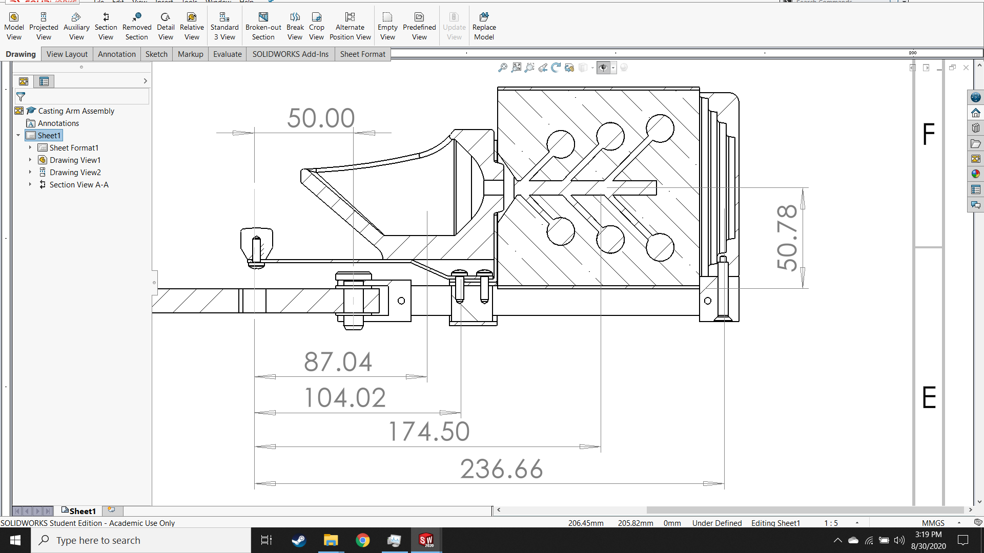

Driven axis

$$m_{crucible}$$

$$m_{slide assembly}$$

$$m_{flask assembly}$$

$$m_{flask cradle}$$

Centrifugal force

*Figure 7.1: Schematic of slide assembly showing components and forces relevant for calculations*

### Pre-tension loads for bolts

*Table 7.1: Maximum loads and minimum pretension calculations for bolts in slide assembly*

|  |
| --- |
| Dynamic pulsating load $0≤load≤F_{centrifugal}$ Maximum centrifugal load ($α=0\frac{m}{s}$) $$F_{N,max}=m•a_{N}=m•ω^{2}•L$$ $m$: Relevant mass $a_{N}$ : Normal acceleration $L$ : Relevant distance from rotation axis $ω$ : Rotational velocity from gearbox ($375 RPM=39.27 \frac{rad}{s}$) |
| Bolted Connection:   |  |  |  | | --- | --- | --- | | Flask cradle to flask cradle base | Flask base to slider bars | Slider bars to pin joint | |
| Masses:   |  |  |  | | --- | --- | --- | | Full slide assembly: $209.53 g$ Full flask assembly: $1070.94 g$ Crucible: $266.51 g$ Flask cradle: $522.13 g$ | Full slide assembly: $209.53 g$ Full flask assembly: $1070.94 g$ Crucible: $266.51 g$ Flask cradle: $522.13 g$ Cradle base: $83.04 g$ | Full slide assembly: $209.53 g$ Full flask assembly: $1070.94 g$ Full flask cradle assembly: $610 g$ Crucible: $266.51 g$ Slider bars: $122.29 g$ | |
| Maximum transverse loads (for pre-tensioning):   |  |  |  | | --- | --- | --- | |  |  |  | |
| Minimum pretension loads for bolts in slide assembly: $$F_{v}≥\frac{F_{T}}{μ•n}$$ $μ:$ Coefficient of static friction for stainless steel on stainless steel = 0.5  *𝑛*: Number of bolts sharing the load   |  |  |  | | --- | --- | --- | | 𝑛=1 | 𝑛=2 | 𝑛=2 |  |  |  |  | | --- | --- | --- | |  |  |  | |

### Deformation of plates at pretension

*Table 7.2: Plate deformation calculations for bolts in slide assembly*

|  |
| --- |
| Based on the approach created by German engineer, Felix Rötscher [Kisters].    *Figure 7.2: Calculation of substituting cylinder $A_{sub}$ for the clamped plates* |
| Bolted connection:   |  |  |  | | --- | --- | --- | | Flask cradle to cradle base | Cradle base to slider bars | Slider bars to pin joint | |
| Dimensions:   |  |  |  | | --- | --- | --- | |  |  |  | |  |  |  | |  |  |  | |  |  |  | |
| Formula selection:   |  |  |  | | --- | --- | --- | | Formula for small plates is chosen | $$D_{A}>d_{w}+L_{k}$$ Formula for large plates is chosen | $$D_{A}>d_{w}+L_{k}$$ Formula for large plates is chosen | |
| Area of the substituting cylinder $A_{sub}$ for a threaded hole:   |  |  |  | | --- | --- | --- | |  |  |  | |
| Elastic resilience of the plates:   |  |  |  | | --- | --- | --- | |  |  |  | |
| Deflection of the plates due to the pre-tension:   |  |  |  | | --- | --- | --- | |  |  |  | |

Settling forces [Kisters]

*Table 7.3: Settling losses and minimum assembly force calculations for bolts in slide assembly*

|  |  |  |  |
| --- | --- | --- | --- |
| Bolted connection:   |  |  |  | | --- | --- | --- | | Flask cradle to cradle base | Cradle base to slider bars | Slider bars to pin joint | |
| Settling losses $f_{z}$ for the real clamping length (bolted joints according to DIN 24014):   |  |  |  | | --- | --- | --- | |  |  |  | |
| Macintosh HD:Users:hinkleaj:Desktop:Screen Shot 2020-07-01 at 1.54.10 AM.pngDimensions :  Figure 7.3: Resiliencies and dimensions of the screws in the slide assembly   |  |  |  | | --- | --- | --- | |  |  |  | |  |  |  | |  |  |  | |  |  |  | |  |  |  | |  |  |  | |
| Deflection of cylinder $f$: $$f=∆L=ε•L=\frac{L•σ}{E}=\frac{F•L}{E•A}$$ Elastic resilience $δ$: $$δ=\frac{1}{K}=\frac{f}{F}=\frac{L}{E•A}=\frac{4•L}{π•E•d^{2}}$$ Resilience of screw head: $$δ_{H}=\frac{0.4•4}{π•d•E}$$ Resilience of unthreaded portion: $$δ_{S}=\frac{4•L_{S}}{π•E•d^{2}}$$ Resilience of unengaged threaded portion: $$δ_{T}=\frac{4•L_{T}}{π•E•{d_{T}}^{2}}$$ Resilience of threaded hole: $$δ_{N}=\frac{0.33•4}{π•d•E}$$ Resilience of bolt:   |  |  |  | | --- | --- | --- | |  |  |  | |
| Loss in pretension load due to settling:   |  |  |  | | --- | --- | --- | |  |  |  | |
| Minimum and maximum assembly forces:   |  |  |  | | --- | --- | --- | |  |  |  | |
| Compare maximum assembly force to permitted force $F_{v,ass,per}$ $$F_{v,ass,per}=0.9•R_{p0.2}•A_{s}$$ $R_{p0.2}$: 0.2% yield strength (235 MPa) $A_{s}$ : Loaded cross-sectional area   |  |  |  | | --- | --- | --- | |  |  |  |   For all three bolted connections, $F_{v,ass,max}≤F_{v,ass,per}$ so the bolts can take the lateral loads. |

Operational Load [Kisters]

*Table 7.4: Operational load calculations for the bolted connection between flask cradle and cradle base*

|  |
| --- |
| Centrifugal Force $F_{C}$ Operational load on bolt $F_{B}$ $$q$$ $$\sum{M_{q}}=0⟺F_{B}=\frac{44.60 mm}{8.00 mm}•F_{c}=3055.83 N$$*Figure 7.4: Free body diagram of bolted joint and sum of moments about the assumed rotation point $q$* |
| Load ratio $ϕ$ $$ϕ=\frac{δ_{B}}{δ_{B}+δ_{p}}=0.0874$$ Additional load for plates due to application of operational load $F_{P,B}$ $$F_{P,B}=\left(1-ϕ\right)•F_{P,B}=2788.76 N$$ Additional load for bolt due to application of operational load $F_{S,B}$ $$F_{S,B}=ϕ•F_{B}=267.073 N$$ Comparison of additional load on bolt to permissible load $$F_{S,B}=267.073 N≤0.1•R_{p0.2}•A_{s}=325.579 N$$ Since the additional load on the bolt is less than the permissible load, plastic deformation of the bolt due to the load is not to be expected with a safety factor of 1.2. |

In bolted connections, the pre-tensioning friction absorbs the shear dynamic loads dynamically. With proper pre-tensioning, there is no relative motion between plates or between bolts and plates. Therefore, all wear in the bolted fastener is caused by the dynamic tensile load.

### Tensile stress in slider bars

Technically, the friction between the plates should dynamically absorb the dynamic tensile load on the slider bars, and the full cross-section should be loaded. Doing the stress calculation using the reduced cross-sectional area of the hole ensures the ability of the slider bars to endure the load even if the bolted joint loosens over time.

|  |
| --- |
| Modulus of elasticity: 304 Stainless: 190 GPa  Ultimate tensile strength $R_{m}=517.017 MPa$ Tensile strength at yield $R_{e}=206.807 MPa$ Shear strength 298.490 MPa |
| Mass for weight force: $2279.27 g$ |
| Rotational velocity $ω=39.27 \frac{rad}{s}$ |
| Dimensions and second moment of area: $$L=157.25 mm$$ $$h_{F}=50.78 mm$$ $I_{z}=843.75 {mm}^{4}$ (for one slider bar) |

The centrifugal load $F_{C}$ acts to create a moment $M_{C}$ on the slider bars at the bolted connection to the cradle base. This moment and the weight force of the flask assembly (applied at the end of the slider bars) create a bending load.

$$m•g$$

$$M_{C}=F_{C}•h_{F}=27.83 Nmm$$

$$L$$

$$M_{R}$$

$$R$$

**FBD**

**SFD**

**BMD**

*Figure 7.5: Free-body, shear force and bending moment diagrams (left), and relevant input parameters for Bernoulli-Euler beam theory (right) for slider bars*

Calculated:

Max shear force: $F_{V,max}=mg=22.36 N$

Max bending moment: $M_{max}=M_{C}+mgL=31350.1 Nmm$

Max bending stress: $σ_{b,max}=\frac{M_{max}•γ}{I_{z}}=139.334 MPa$

The centrifugal load is transferred to the slider bars through the bolted connection, which causes an internal tensile stress. The bending load also causes an internal tensile/compressive stress. The exact dynamics of the casting process are complicated to calculate, but the maximum internal tensile stress $σ_{max}$ will always be less than the sum of the stresses caused by these two loads so

$$σ_{max}≤σ_{c}+σ_{b,max}=\frac{F_{C}}{A}+\frac{M_{max}•γ}{2•I_{z}}=155.94 MPa$$

$A$: Cross-sectional area of slider bars at the screw holes $= 33.00 {mm}^{2}$,

$γ$: Distance from neutral axis to extreme fibers $=7.5 mm$

The tensile strength of AISI 304 stainless steel is 206 MPa and the ultimate tensile strength is 517 MPa. Therefore, under normal operating conditions, failure of the slider bars due to tensile load is not to be expected with a factor of safety of at least 1.3 against plastic deformation, and a safety factor of at least 3.3 against rupture.

### Pin Joint Calculations

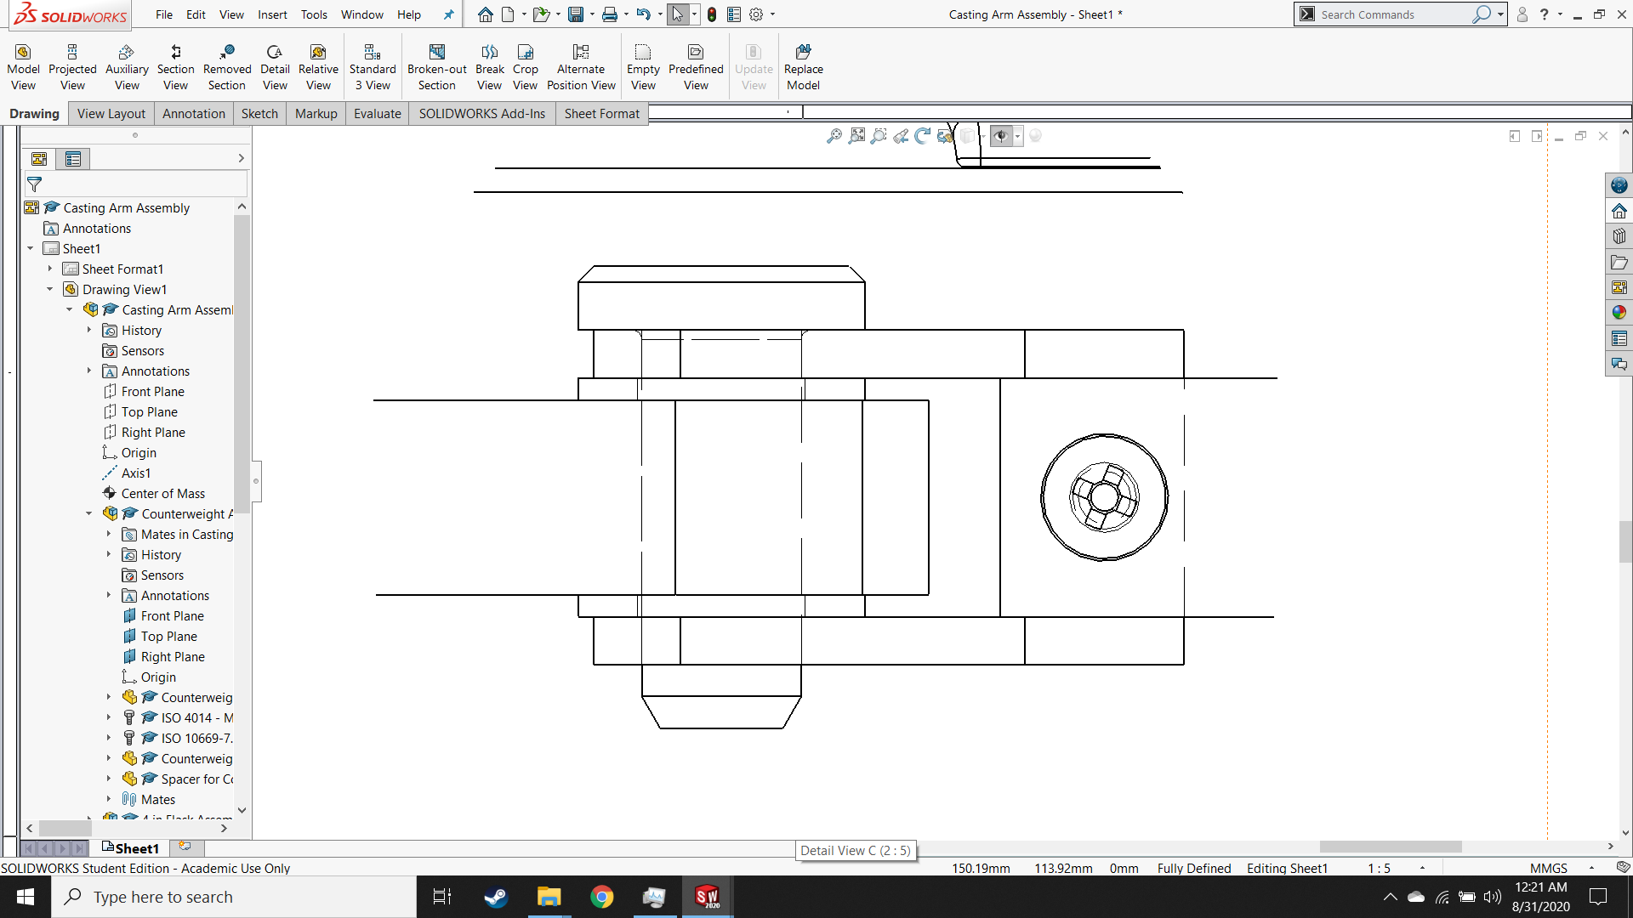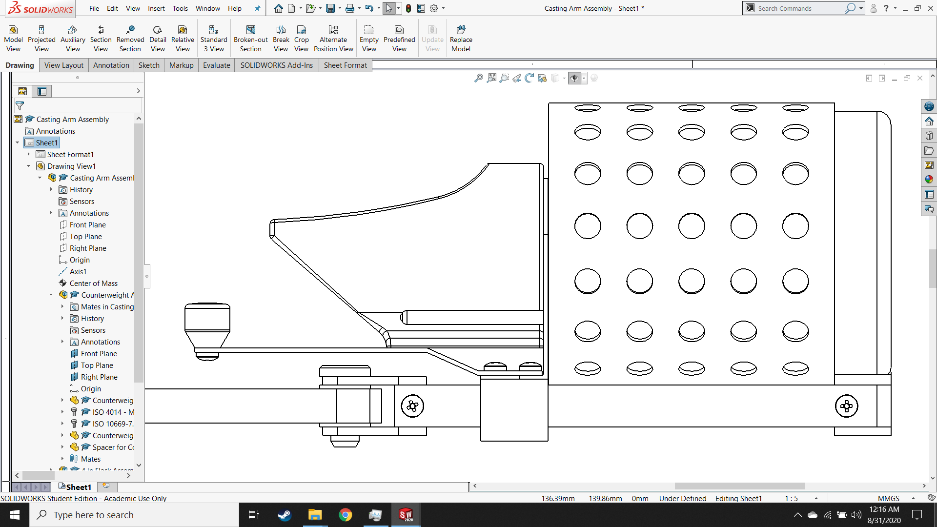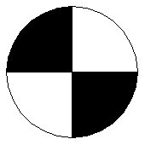

Driven axis

Weight force $mg$

Centrifugal Force $F_{C}$

Blade

Pin

Clevis

*Figure 7.6: Schematic of casting arm showing components of, and forces applied to, pin joint*

First, solve for reaction forces at pin joint:

$$A_{y}$$

$$A_{x}$$

$$B_{x}$$

$$m•g$$

$$F_{C}$$

$$r_{F}$$

$$h_{d}$$

$$h_{u}$$

$$h_{F}$$

$$r_{F}=118.78 mm$$

$$h_{F}=50.19 mm$$

$$h_{u}=h_{d}=9 mm$$

$$m=2377.13 g$$

$$F_{C}=548.131 N$$

*Figure 7.7: Free body diagram of casting arm with relevant dimensions*

Equations of equilibrium

$$\sum{M_{A}=0}⟺m•g•r_{F}+F_{C}•\left(h_{F}-h_{u}\right)=B_{x}•\left(h_{d}+h_{u}\right)⟺B_{x}=1167.87 N$$

$$\sum{F_{x}}=0⟺A_{x}=F_{C}+B_{x}⟺A_{x}=1716.00 N$$

$$\sum{F_{y}}=0⟺A_{y}=m•g⟺A_{y}=23.32 N$$

### Clevis Pin

Case 3 pin joint: clearance between clevis and pin, modeled as two cantilever beams, fixed at one end, with partially distributed uniform loads applied at the free ends.



FBD

SFD

BMD

$$w_{B}=\frac{B_{x}}{t_{c}}$$

$$w_{A}=\frac{A_{x}}{t_{c}}$$

$$t_{c}$$

$$L$$

*Table 7.5: Properties of clevis pin for pin joint analysis*

|  |
| --- |
| Pin name: Form B ISO 2341 – A – 10x20 – St |
| Modulus of elasticity: 304 Stainless: 190 GPa  Ultimate tensile strength $R_{m}=517 MPa$ Tensile strength at yield $R_{e}=206 MPa$ Shear strength 298 MPa |
| Static load: from weight force ()   |  |  | | --- | --- | |  |  | |
| Pulsating load: from centrifugal force ()   |  |  | | --- | --- | |  |  | |
| Dimensions:   |  |  | | --- | --- | |  |  | |

*Figure 7.8: Free-body, shear force and bending moment diagrams for $⊘$ 10 mm clevis pin*

*Table 7.6: Analysis of clevis pin for pin joint according to [Kisters]*

|  |  |  |
| --- | --- | --- |
| Shear force:   |  |  | | --- | --- | |  |  | |
| Bending moment:   |  |  | | --- | --- | |  |  | | At cantilever, $x=L$ $$M_{A,max,S}=A_{S}•\left(\left(L-t_{c}\right)+\frac{t_{c}}{2}\right)=362.73 Nmm$$ $$M_{A,max,P}=A_{P}•\left(\left(L-t_{c}\right)+\frac{t_{c}}{2}\right)=4356.27 Nmm$$ $$M_{A,max}=A_{x}•\left(\left(L-t_{c}\right)+\frac{t_{c}}{2}\right)=4719.00 Nmm$$ | At cantilever, $x=0$ $$M_{B,max,S}=B_{S}•\left(\left(L-t_{c}\right)+\frac{t_{c}}{2}\right)=362.73 Nmm$$ $$M_{B,max,P}=B_{P}•\left(\left(L-t_{c}\right)+\frac{t_{c}}{2}\right)=2848.92 Nmm$$ $$M_{B,max}=B_{x}•\left(\left(L-t_{c}\right)+\frac{t_{c}}{2}\right)=3211.63 Nmm$$ | |
| Max deflection   |  |  | | --- | --- | | At free end, $x=0$ $$∆_{A,max}=0.242 μm$$ | At free end, $x=L$ $$∆_{B,max}=0.165 μm$$ | |
| Bending stress  Static load: $σ_{per}=0.3R_{m}=103.5 MPa$ Pulsating load:   |  |  | | --- | --- | |  |  |   Since $σ_{max}≤σ_{per}$, failure of the clevis pin due to bending stress is not to be expected with a safety factor against rupture of at least 1.4. |
| Shear stress  Static load: $τ_{per}=0.2R_{m}=69 MPa$ Pulsating load:   |  |  | | --- | --- | |  |  |   Since $τ_{A}≤τ_{per}$, failure of the clevis pin due to shear stress is not to be expected with a safety factor against rupture of at least 3.5. |

Since the locations of the maximum values for bending and shear are different (shear stresses are zero when bending stresses are highest and vice versa), the calculation of an equivalent stress is unnecessary.

### Clevis and blade

The largest stresses in the clevis and blades occur next to the holes. The blade takes the full force from the pin and the clevis takes a proportion of the opposing force on each arm. The maximum stresses are the sums of the nominal stresses and the additional stresses from the stress concentration caused by the hole. Both the clevis and blade were fabricated from S235 mild steel ($R_{e}=235 MPa, R_{m}=360 MPa$).

*Table 7.7: Analysis of clevis for pin joint according to [Kisters]*

|  |  |  |
| --- | --- | --- |
| Thickness   |  |  | | --- | --- | |  |  | |
| Loaded width   |  |  | | --- | --- | |  |  | |
| Stresses $$σ_{max}=\frac{F_{V,max}}{2•c•t}+\frac{6•F_{V,max}•(d_{h}+c)}{8•c^{2}t}=\frac{F_{V,max}}{2•c•t}•\left(1+\frac{3}{2}\left(\frac{d_{h}}{c}+1\right)\right)$$ Static load: $σ_{per}=0.5R_{m}=180 MPa$ Pulsating load:   |  |  | | --- | --- | |  |  |   Since $σ_{max}≤σ_{per}$, failure of the clevis due to tensile stress is not to be expected with a safety factor against rupture of at least 1.6. |

*Table 7.8: Analysis of blade for pin joint according to [Kisters]*

|  |  |
| --- | --- |
| Thickness   |  | | --- | |  | |
| Loaded width   |  | | --- | |  | |
| Stresses   |  | | --- | |  |   Since $σ_{max}≤σ_{per}$, failure of the blade due to tensile stress is not to be expected with a safety factor against rupture of at least 2.1. |

## Casting Arm Assembly

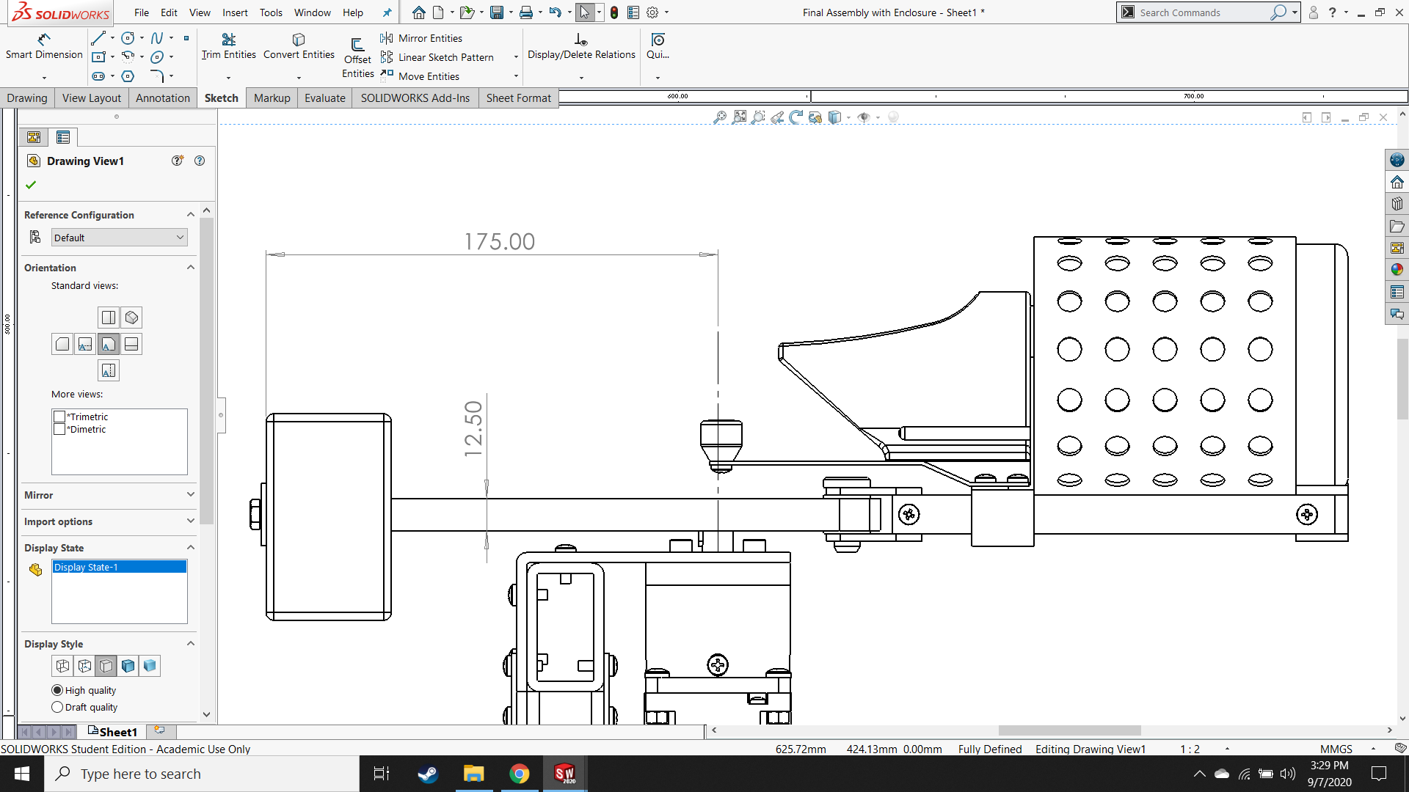

Weight force

Centrifugal force

Centrifugal force

Weight force

Driven Axis

*Figure 7.9: Schematic of casting arm assembly showing components and forces relevant for calculations*

### Counterweight arm

The moment created by the centrifugal force and the weight force of the articulated arm assembly is transferred through the pin joint to the counterweight arm. On the opposite side of the machine, the counterweight acts to keep the center of mass of the entire casting arm centered at the axis of rotation (driven axis in figure 7.9).

$$M_{C}=\left(A_{S}+B_{S}\right)•γ=18024.2 Nmm$$

$$W_{Counterweight}=27.7 N$$

$$W_{Articulated Arm}=110.9 N$$

**SFD**

**BMD**

$$V_{max}$$

$$M_{max}$$

$$R_{shaft}$$

**FBD**

*Figure 7.10: Free-body, shear force and bending moment diagrams for counterweight arm*

Calculated:

Reaction force from shaft: $R_{shaft}=W_{Counterweight}+W_{Articulated Arm}=138.66 N$

Max shear force: $F_{V,max}=W_{Articulated Arm}=110.90 N$

Max bending moment: $M_{max}=M_{C}+mgL=19564.8 Nmm$

Max bending stress: $σ_{b,max}=\frac{M_{max}•γ}{I_{z}}=21.47 MPa$

Once again, the bending load from the weight forces causes tensile stress, but there is also tensile stress caused by the centrifugal forces. The maximum internal tensile stress $σ_{max}$ will always be less than the sum of the stresses caused by these two loads.

$$σ_{max}≤σ_{c}+σ_{b,max}=\frac{F_{C}}{A}+\frac{M_{max}•γ}{I_{z}}=23.37 MPa$$

$A$: Cross-sectional area of counterweight arm at the axis of rotation $= 287.50 {mm}^{2}$,

$γ$: Distance from neutral axis to extreme fibers $=6.25 mm$

The tensile strength of S235 non-alloy steel is 235 MPa and the ultimate tensile strength is 360 MPa. Therefore, under normal operating conditions, failure of the counterweight arm due to tensile load is not to be expected with a factor of safety of at least 10.0 against plastic deformation, and a safety factor of at least 14.4 against rupture.

### Parallel key connection

*Table 7.9: Properties of shaft hub connection analysis*

|  |
| --- |
| HINKLE22113:Screenshot (185).pngFeather Key: DIN 6885 – Form A - 4 x 4 x 16 |
| Light interference fit N9/h7 to increase fatigue resistance |
| Hub properties   |  | | --- | | Modulus of elasticity: S235 Mild Steel: 210 GPa | | Ultimate tensile strength | | Tensile strength at yield $R_{e}=235 MPa$ | |

*Figure 7.11: Detail view of parallel key connection*

Damage of a key due to a shear load is very unusual for standardized parallel key connections. As such, no proof of the key is required. Furthermore, proof of the shaft for loads exceeding the design load have been provided by the manufacturer of the gear box so no proof of the shaft is provided in this document. Since the length of the key is less than 1.3 times the diameter of the shaft and since the design does not include alternating torsional moments, method C has been chosen for calculations according to DIN 6892. The calculation of the contact pressure $P$ requires only the applied load $F$ and the loaded area $A$, and proofing the hub requires only that the applied pressure is less than the permitted pressure.

$$P=\frac{F}{A}≤P_{per}=\frac{R_{e}}{Safety Factor}$$

*Table 7.10: Analysis of parallel key connection hub according to DIN 6892*

|  |  |
| --- | --- |
| Inertia of casting arm assembly   |  | | --- | |  | |
| Torque required from motor   |  | | --- | |  | |
| Force applied by key   |  | | --- | |  | |
| Loaded area   |  | | --- | |  | |
| Stresses   |  | | --- | |  |   Since $P_{max}≤P_{per}$, failure of the counterweight arm due to the parallel key connection is not to be expected with a safety factor against plastic deformation of at least 9.8. |

### Bolt for retaining counterweight

During the normal casting operation, the counterweight is held onto the casting arm via an oversized steel washer and an M6 bolt. Since there is no transverse load on this bolt, beginning with a pretension calculation is unnecessary. The centrifugal force on the counterweight creates an operational load for the bolt that must be compared to its permissible load. Instead of calculating the pretension load directly, the operation load will be subtracted from the max permissible load to define the maximum pretension load for the bolt.

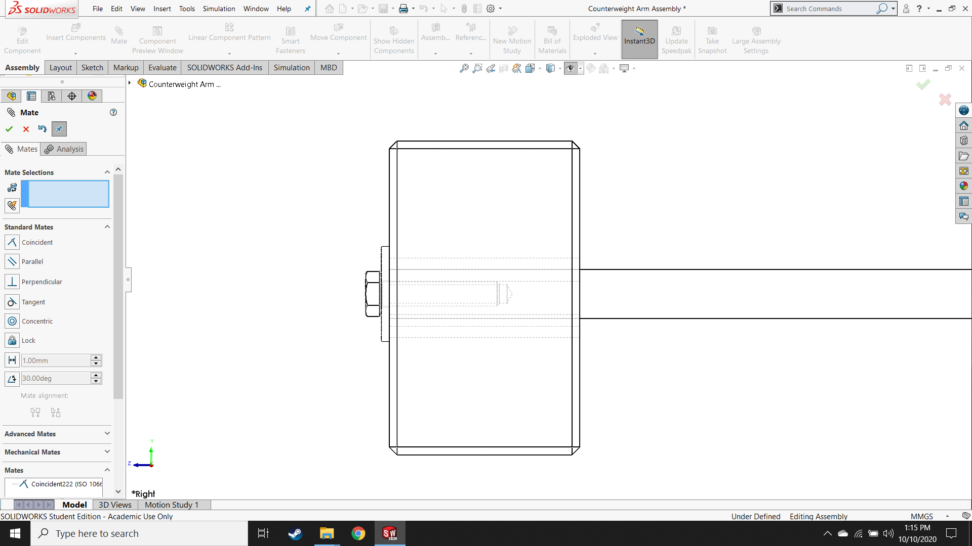

Centrifugal Force $F_{C}$

Operational load on bolt $F_{B}$

*Figure 7.12: Detail of counterweight and retaining bolt showing operational forces*

Operational Load [Kisters]

*Table 7.11: Operational load calculations for the bolt that retains the counterweight*

|  |
| --- |
| Force on bolt $$F_{B}=F_{C}=mω^{2}L=540.37 N$$ $m$: mass of counterweight $=2.3244 Kg$ $L$: distance from axis of rotation to center of mass of counterweight $=150.75 mm$ |
| Cross-sectional area $$A=πr^{2}=75.95 {mm}^{2}$$ $r$: minimum diameter of M6 bolt $=4.917 mm$ |
| Comparison of operational load on bolt to permissible load $$F_{B}=540.37 N≤0.1•R_{p0.2}•A=1784.92 N$$ $R_{p0.2}$: 0.2% yield strength (235 MPa) |
| Because the load on the bolt has to be less than the permissible load in order to prevent plastic deformation during operation, the pretension value for this bolt is constrained. $$F_{v,max}=0.1•R_{p0.2}•A-F_{B}=1244.55 N$$ |

# Chapter 8. FABRICATION PLAN FOR UNIQUE COMPONENTS

## Flask Cradle Assembly

### HINKLE22113:New folder:Screenshot (221).pngFlask Cradle

* Start with 100mm round stock and use lathe to cut outer shape and concentric rings
* Use mill to cut flat bottom and groove (no corner radius)
* Use mill to remove “corners”
* Use mill to make pilot hole
* Use M4 tap to make threads

*Figure 8.1: Design and plan for flask cradle*

### HINKLE22113:New folder:Screenshot (223).pngCradle Base

* Use mill to cut outer shape (zero corner radius for side grooves and for top notch)
* Use mill to make pilot holes for both holes and countersink for ISO 7046-1–M6x25–Z–25N (large diameter: 9.4 mm, small diameter: 4.5 mm, 90°)
* Use M4 tap to make threads in slider bar grooves

*Figure 8.2: Design and plan for cradle base*

## Slider Assembly

### Retainer for Crucible

* 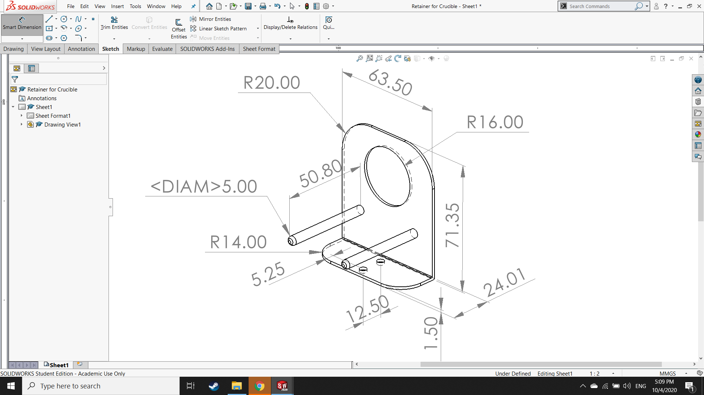Start with 1.5 mm sheet and cut rectangular shape and corner radii with band saw or angle grinder
* Use mill to drill 4 mm holes
* Bend 90° angle in metal brake or vice
* Machine support legs on lathe
* Spot weld support legs onto larger body
* Use mill to drill 27.5 mm hole (double check placement with crucible)

*Figure 8.3: Design and plan for retainer for crucible*

### HINKLE22113:New folder:Screenshot (225).pngSlider

* Start with rectangular block and cut outer shape with mill
* Use mill to drill 4 mm holes (not symmetric!)
* Use mill to remove slot material (permissible corner radius: 1.5 mm)

*Figure 8.4: Design and plan for slider*

### HINKLE22113:New folder:Screenshot (226).pngSlider Spacer

* Start with rectangular block and cut outer shape with mill
* Use mill to make pilot holes (symmetric!)
* Use M4 tap to make threads

*Figure 8.5: Design and plan for slider spacer*

### HINKLE22113:New folder:Screenshot (227).pngCrucible Grip Stick

* Start with 1.5 mm sheet and cut rectangular shape with band saw or angle grinder
* Use mill to drill 4 mm holes
* Bend 24.08° angles in metal brake

*Figure 8.6: Design and plan for crucible grip stick*

### Grip Stick Knob

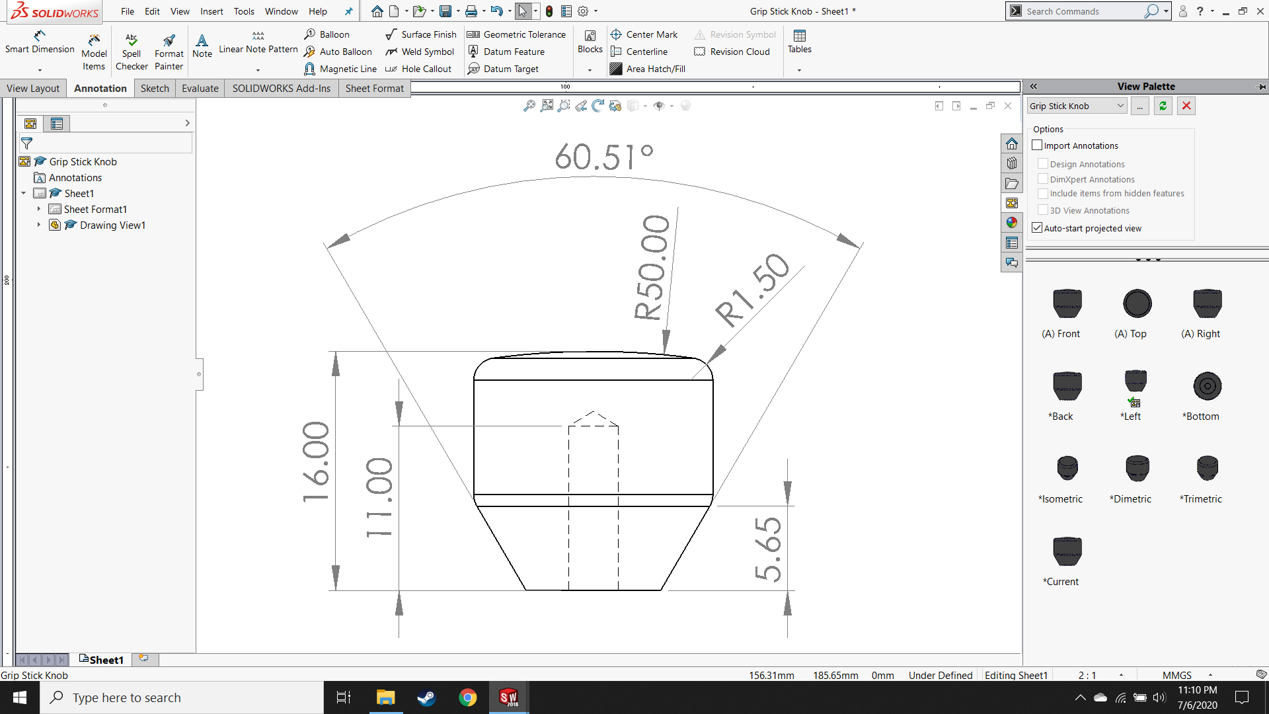

* 3D print outer shape (hopefully, if not, maybe COTS)
* Use mill to make pilot hole
* Use M4 tap to make threads
* Dimensions and angles don’t really matter, just make it comfortable

*Figure 8.7: Design and plan for grip stick knob*

## Pin Joint and Slider Bar Assembly

### Slider Bars

* 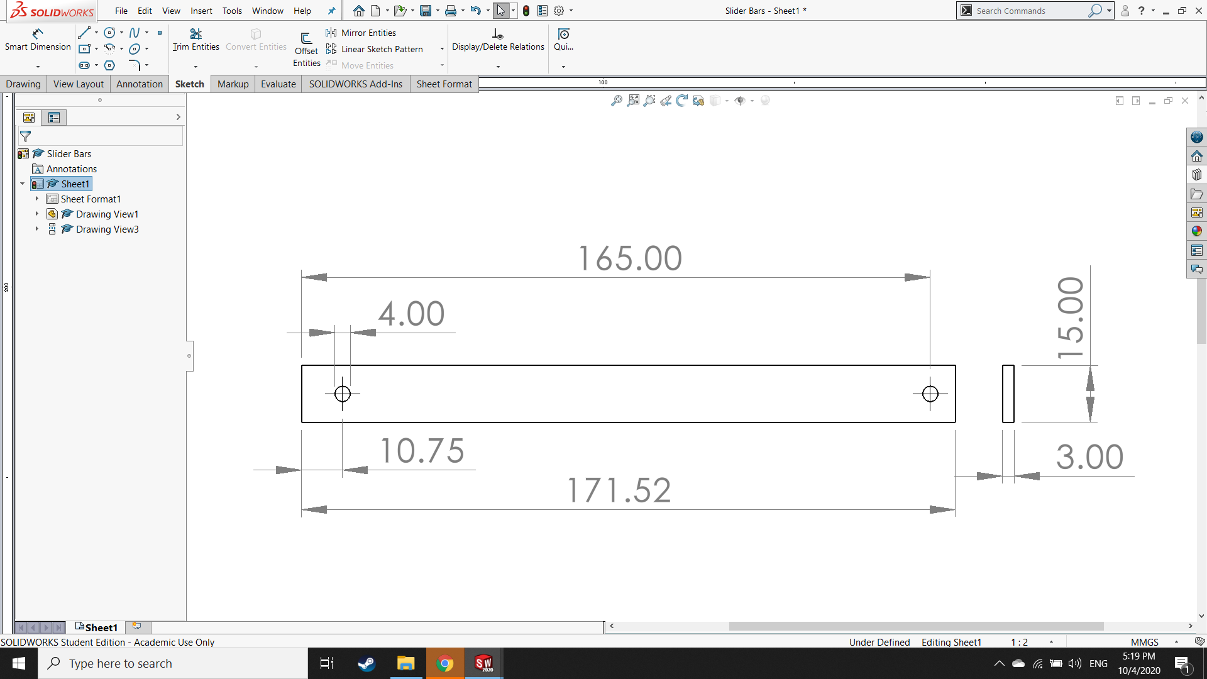Start with 3 mm sheet and cut rectangular shape with band saw or angle grinder (try to cut both pieces at once and separate after chamfer)
* Cut 1.5 mm chamfers with mill
* Use mill to drill 4 mm holes

*Figure 8.8: Design and plan for slider bars*

### HINKLE22113:New folder:Screenshot (231).pngPin Joint

* Start with block and cut outer (top view) shape with mill
* Use mill to drill pilot hole (sides) and hole for clevis pin (top)
* Use mill to cut grooves
* Use M4 tap to make threads

*Figure 8.9: Design and plan for pin joint*

## Counterweight Arm Assembly

### Counterweight Arm

* 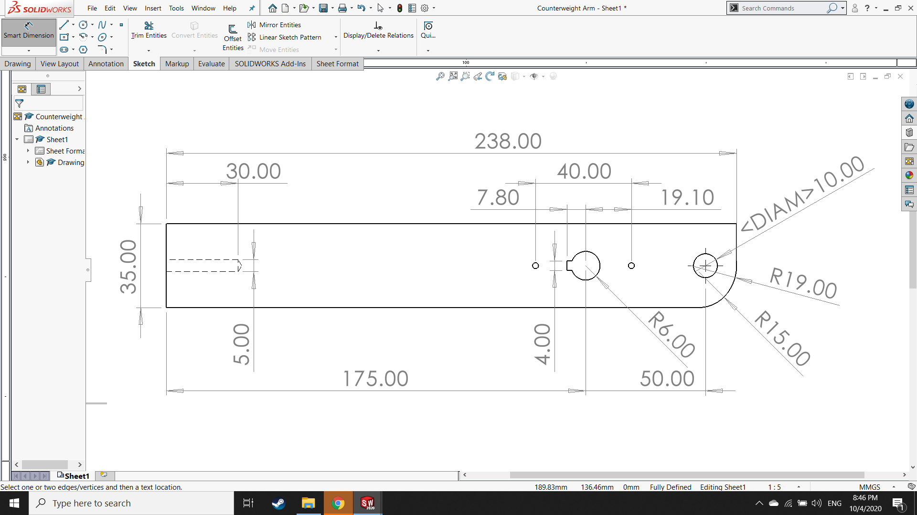Start with 10mm sheet and use band saw to cut outer shape
* Use mill to make holes for shaft and pin joint and guide hole in the end
* Use M6 tap to make threads
* May have to use die filer or hand files for key groove (to avoid corner radius)

*Figure 8.10: Design and plan for counterweight arm*

### HINKLE22113:New folder:Screenshot (234).pngCounterweight

* Make this part(s) and spacer(s) after casting arm assembly is complete (to precisely balance)
* Use mill to make slot (actual: 10 x 35mm, adjust outward for corner radius)
* Use grinder to make chamfer (just enough to be comfortable to hold)

*Figure 8.11: Design and plan for counterweight*

### Spacer for Counterweight

* 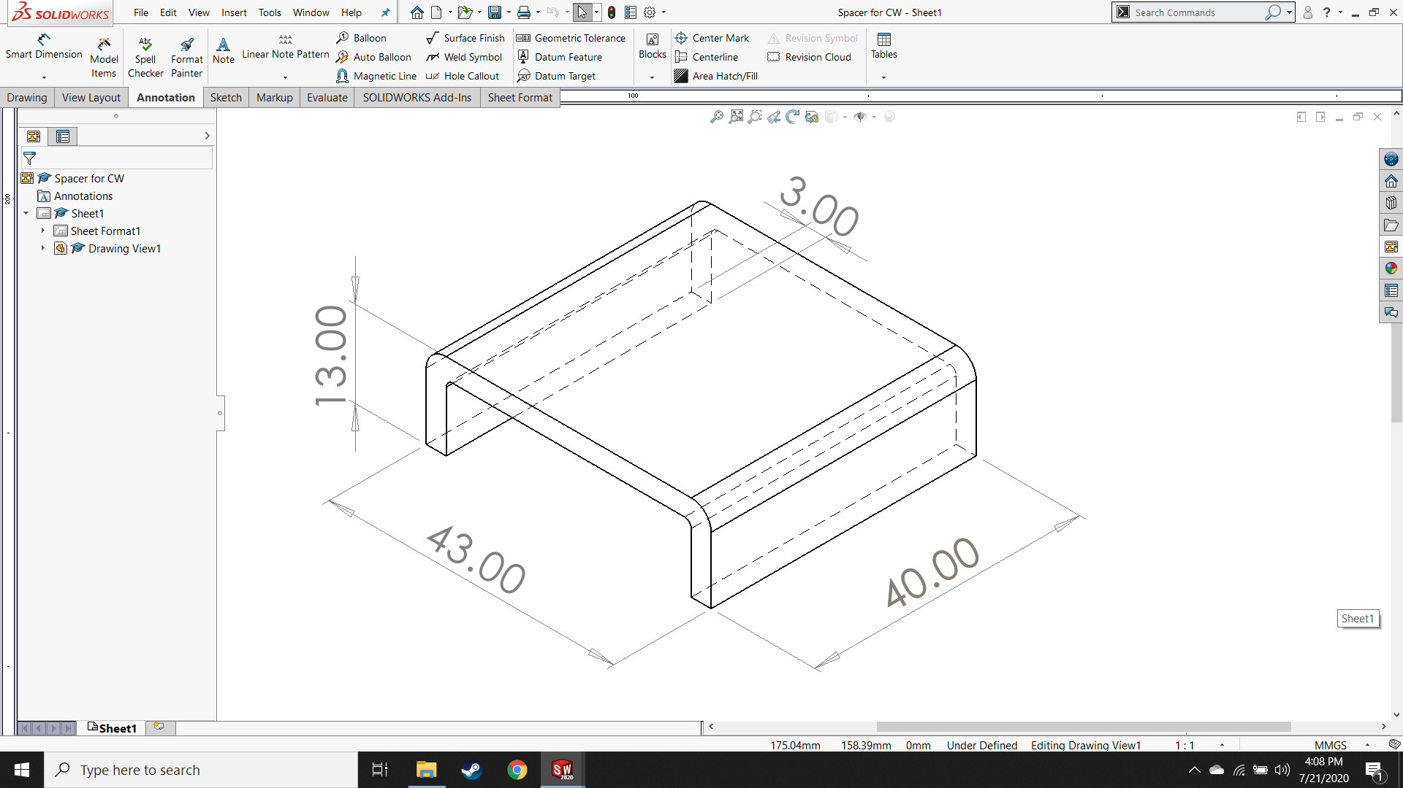Make this part(s) and spacer(s) after casting arm assembly is complete (to precisely balance)
* Start with 3mm sheet and use band saw or angle grinder to make outer rectangular shape
* Bend 90° angles in metal brake

*Figure 8.12: Design and plan for spacer for counterweight*

## Motor and Machine Base Assembly

### Bracket for Connection to Gearbox

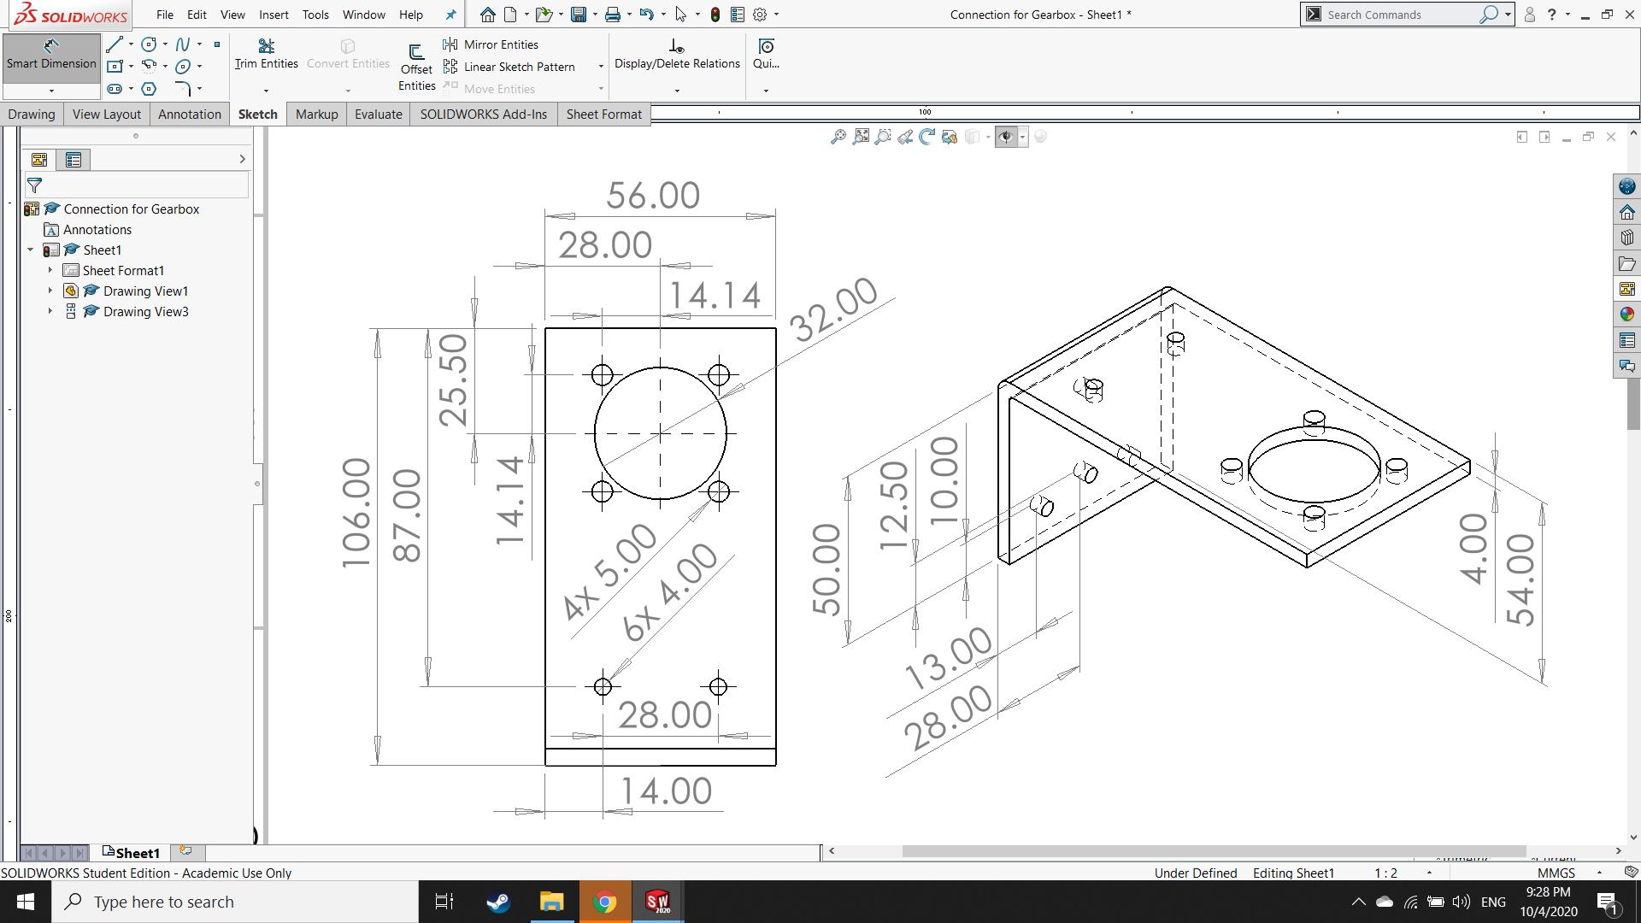

* Start with 120 x 80 x 4mm square tubing and cut outer shape with band saw or angle grinder
* Use mill to make holes

*Figure 8.13: Design and plan for bracket for connection to gearbox*

### Top Piece

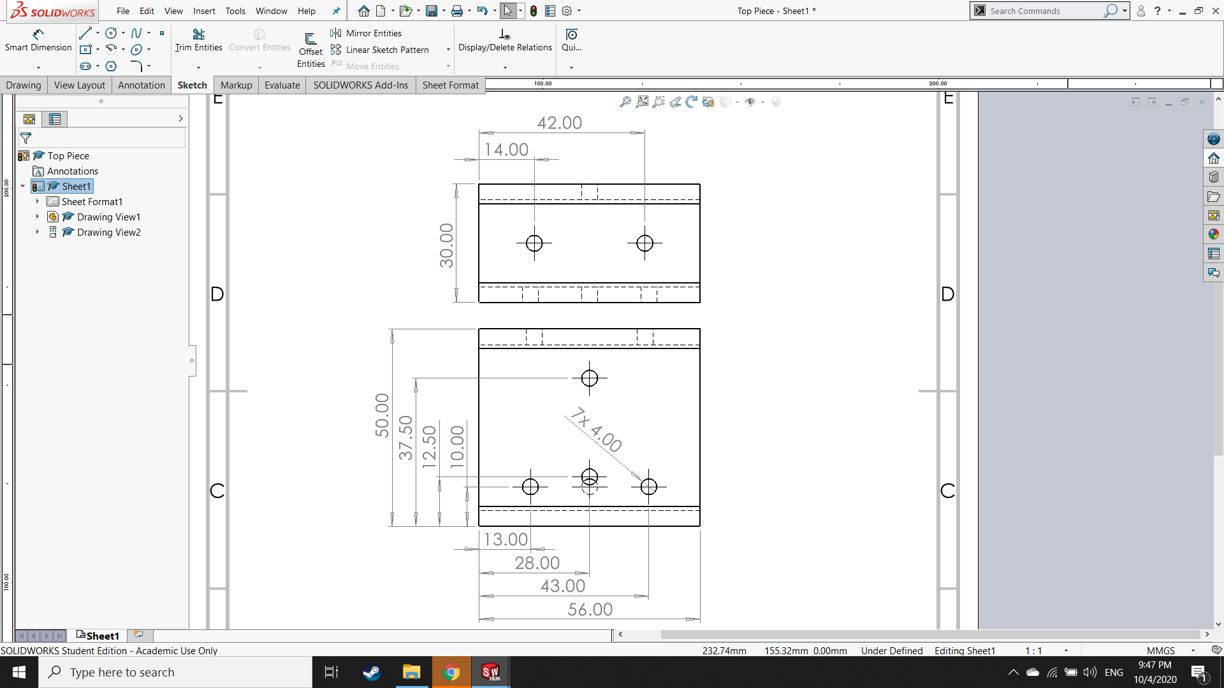

* Start with 30 x 50 x 4mm square tubing and cut length with band saw
* Use mill to make pilot holes (make brackets first for alignment)
* Use M4 tap to make threads

*Figure 8.14: Design and plan for top piece*

### HINKLE22113:New folder:Screenshot (247).pngVertical Post

* Start with 30 x 50 x 4mm square tubing and cut ~166.6mm length with band saw
* Use drill press to make guide holes (make brackets first for alignment)
* Use M4 tap to make threads

*Figure 8.15: Design and plan for vertical post*

### HINKLE22113:New folder:Screenshot (239).pngLegs

* 2x of these
* Start with 30 x 50 x 4mm square tubing and cut length with band saw
* Use mill to make bottom 4mm hole and guide holes (make brackets first for alignment)
* Use M4 tap to make threads

*Figure 8.16: Design and plan for legs*

### HINKLE22113:Screenshot (143).pngFoot

* 2x of these
* Start with 30 x 50 x 4mm square tubing and cut length with band saw
* Use mill to make bottom 4mm hole and guide holes (make brackets first for alignment)
* Use M4 tap to make threads

*Figure 8.17: Design and plan for foot*

### Corner Bracket

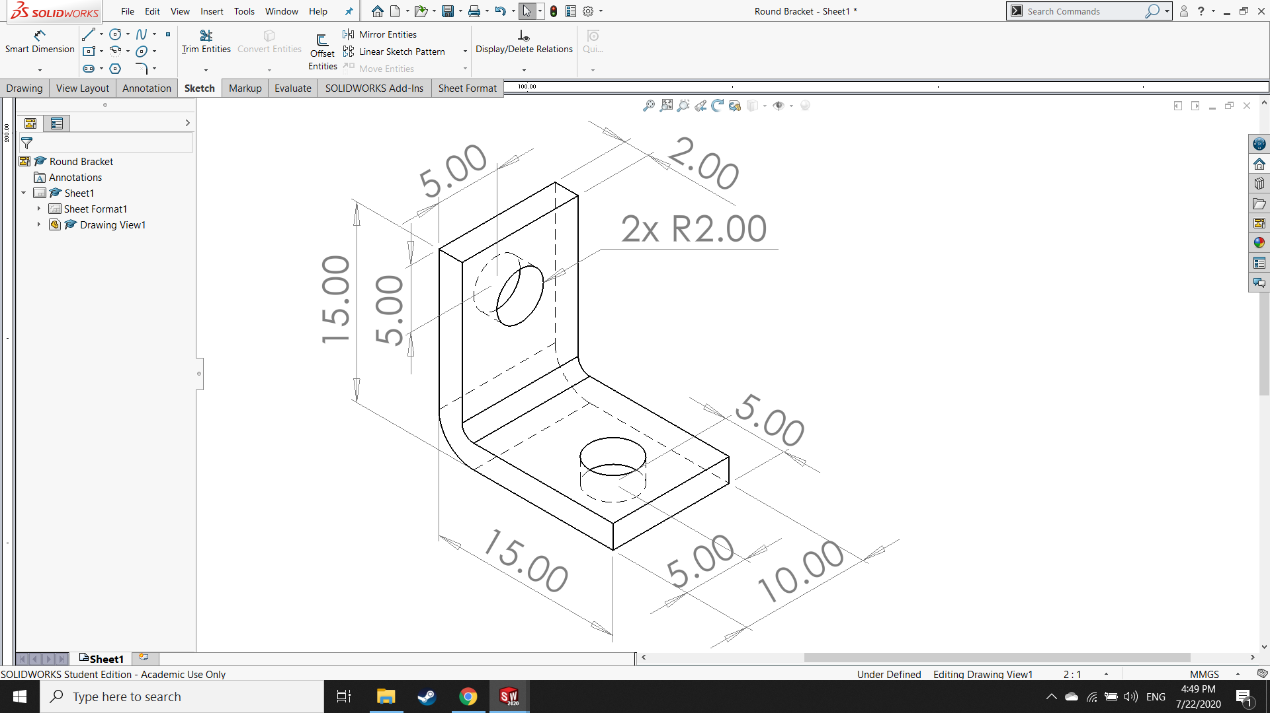

* 5x of these
* Start with 2mm sheet and use band saw to cut rectangular shape
* Bend 90° angles in metal brake
* Use mill to make holes (>4mm for clearance)

*Figure 8.18: Design and plan for corner bracket*

### Flat Bracket

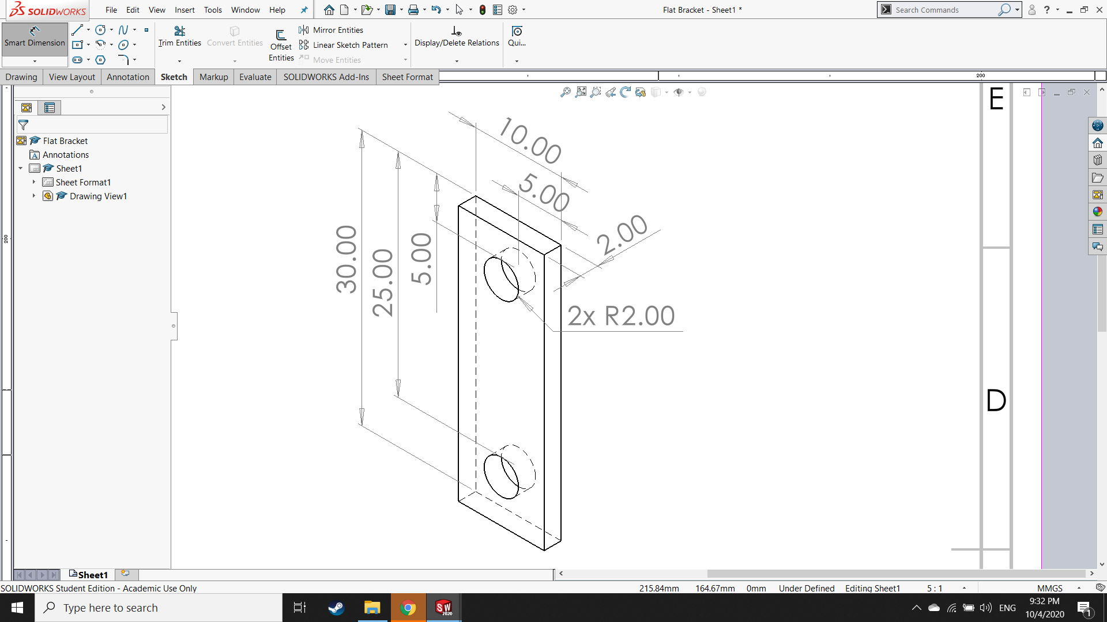

* 5x of these
* Start with 2mm sheet and use band saw or angle grinder to cut rectangular shape
* Use mill to make holes (>4mm for clearance)

*Figure 8.19: Design and plan for flat bracket*

### HINKLE22113:Screenshot (147).pngSpacer

* 2x of these
* Start with 4mm scrap and use band saw to cut rectangular shape
* Use mill to make hole (>4mm for clearance)

*Figure 8.20: Design and plan for spacer*

### HINKLE22113:New folder:Screenshot (248).pngBase Plate

* Start with 5mm sheet and use band saw or angle grinder to cut square shape
* Use mill to make guide holes and countersinks for ISO 7046-1–M4x16–Z–16N (large diameter: 9.4 mm, small diameter: 4.5 mm, 90°)

*Figure 8.21: Design and plan for base plate*

# Chapter 9. CONSTRUCTION

The design for the casting machine includes 39 “make” parts plus the parts that went into the enclosure. These parts were all fabricated using the equipment and tools in the HSRW workshop. Furthermore, they were fabricated from materials and supplies from the workshop whenever possible. This meant that certain design concessions were made and minor changes became necessary to accommodate those concessions. For example, in the original design, the entire articulated arm assembly was stainless steel. However, since there was mild steel stock already readily available in the workshop, the decision was made to use mild steel for several parts. Subsequently, corrosion of the parts became more of a significant concern and it became necessary to include a corrosion resistant coating for these parts during fabrication and assembly. A combination of quenching in oil and heavy-duty acrylic paint was used to meet this need.

There were also changes to the design due to unforeseen limitations of the equipment that was available in the workshop and the skill of the operator. For example, without access to a CNC machine, the geometry of some parts needed to be simplified so they could be made on the machines that were available. The limited skill of the of the operator combined with the realities of manufacturing led to concessions such as the relaxing of irrelevant tolerances and the removal of certain features which served aesthetic functions only.

The design was also affected by the unexpected introduction of new constraints by the university or by the project supervisor. For example, the original design included a rotating tub with a second shaft hub connection between the motor and the casting arm. Thus, no enclosure was necessary. However, the designer was informed that, in order to be used in the workshop, the machine must be fully enclosed for safety with a micro-switch that only allows power to the machine when the lid of the enclosure is fully closed. With the introduction of this new full-enclosure constraint, the rotating tub featured in the original design became redundant and unnecessary, and so was removed. This saved time in the manufacturing of the rotating tub parts. However, it meant that not only was all the time designing, CAD modeling and calculating the rotating tub lost, but an enclosure needed to be designed and fabricated as well.

Finally, the entire project was heavily affected by the coronavirus epidemic. Delays in receiving some of the standard parts (such as the crucible and casting flasks) resulted in subsequent design and fabrication delays. Shipping took longer from suppliers; access to the lab was severely limited, especially early on; and there simply wasn’t enough time to be able to do much of the machine testing, finite element analysis and condition monitoring that was originally planned. Furthermore, validation of the investment casting process had to wait until after the deadline.

## Fabrication of Unique Components

## Flask Cradle

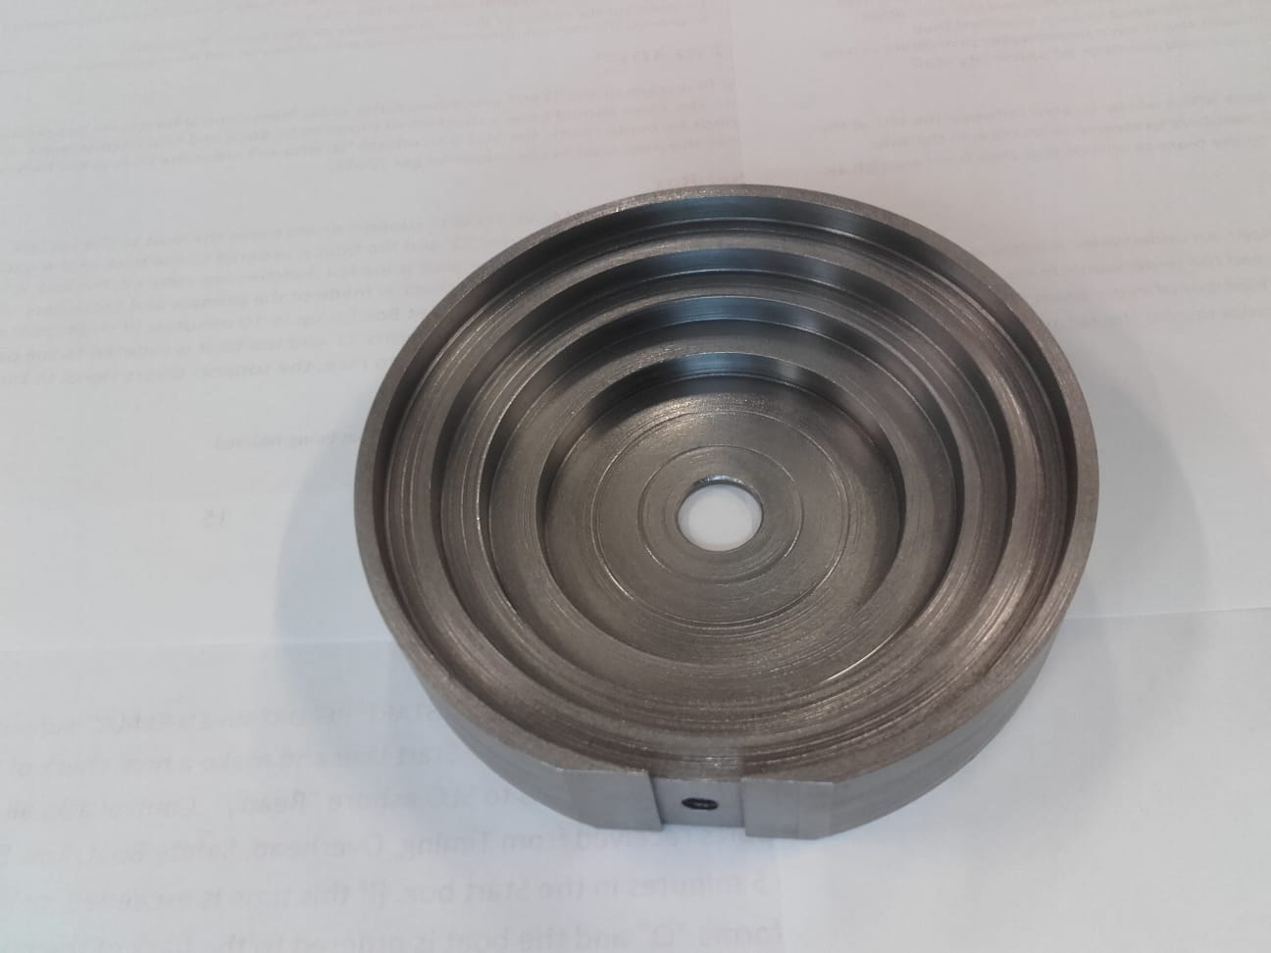 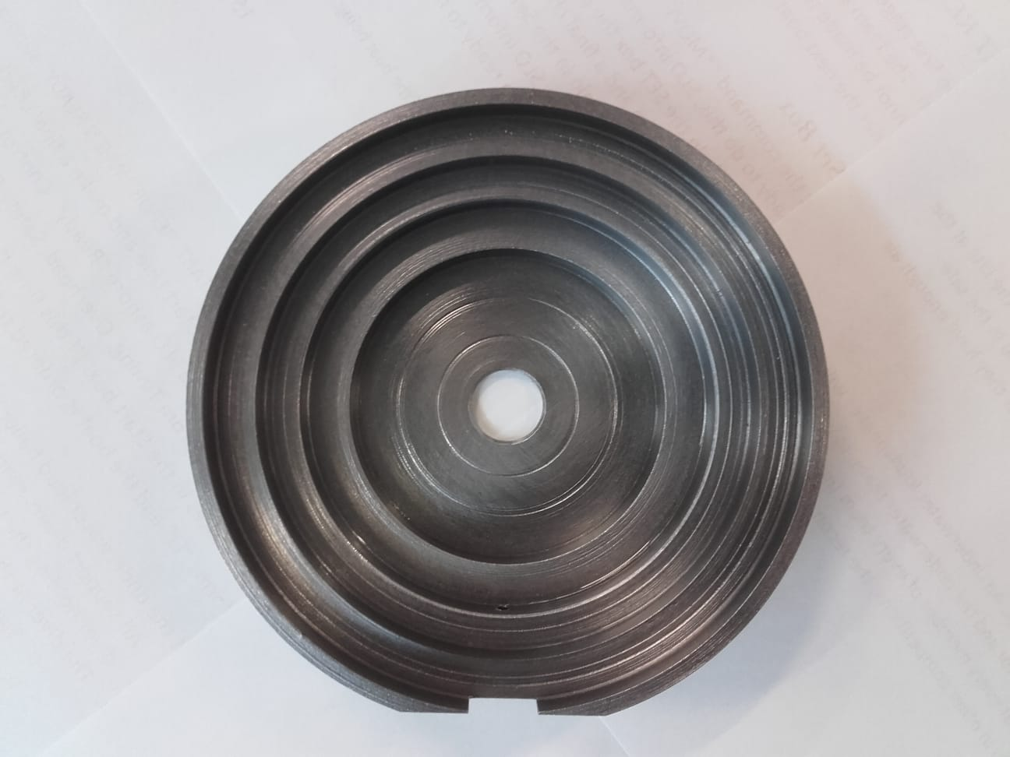

*Figure 9.1: Photos of finished flask cradle*

120 mm round mild steel was chosen for the flask cradle (instead of 304 stainless) since it was available in the lab. This part also ended up with a through hole in the center since it simplified boring out the steps for the flasks and it caused no structural effect. After checking calculations and seeing the cradle base as designed, the decision was made to go with a thicker design (20 mm thick instead of 15) for this part and an M5 bolt instead of M4. This was the author’s first experience turning steel on the lathe. The boring all went very well, but there was a considerable amount of difficulty trying to part the piece. After breaking the parting tool, the cut was finished with a hacksaw and then flipped in the chuck so the back side could be faced. There are a few scratches in the finished part from the failed parting, but overall it turned out pretty well. Most importantly, the geometry is correct.

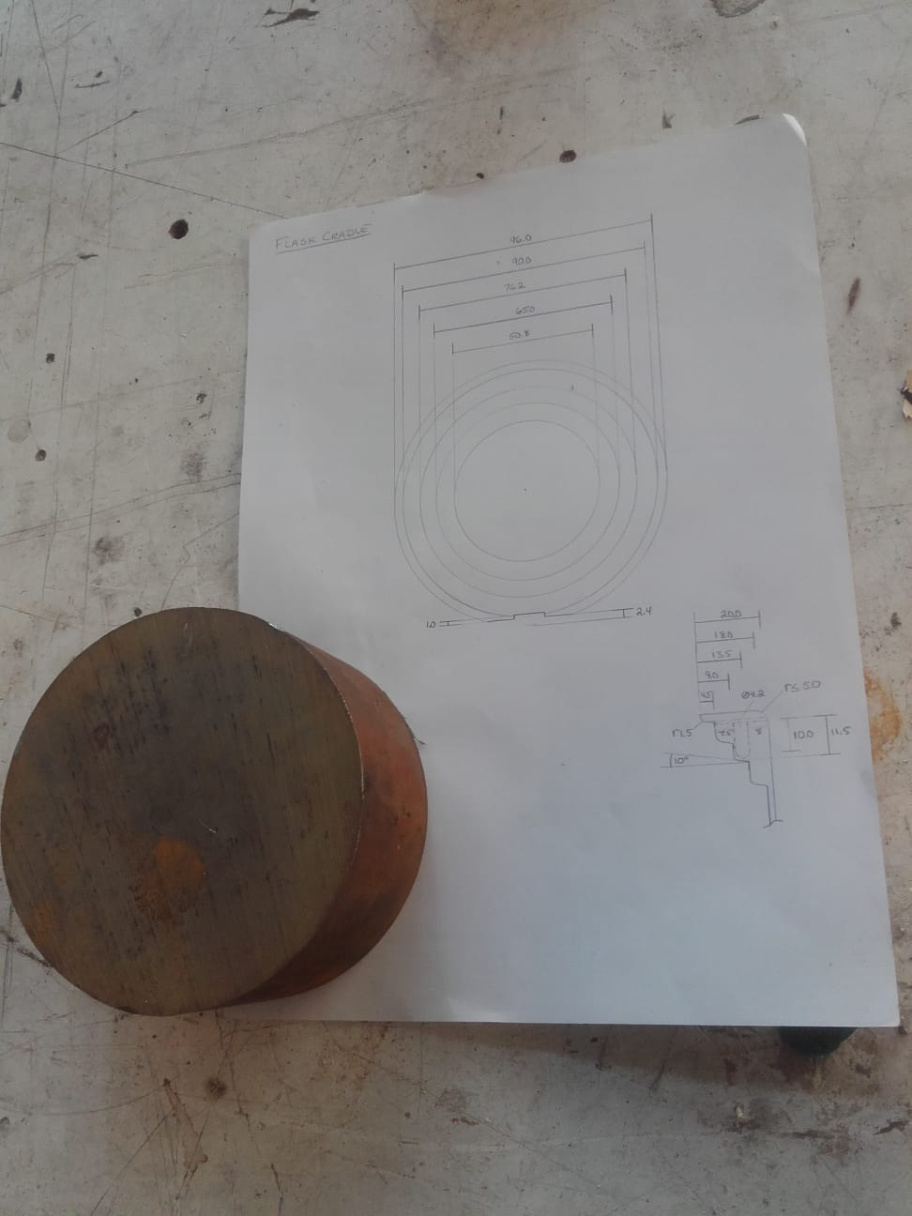 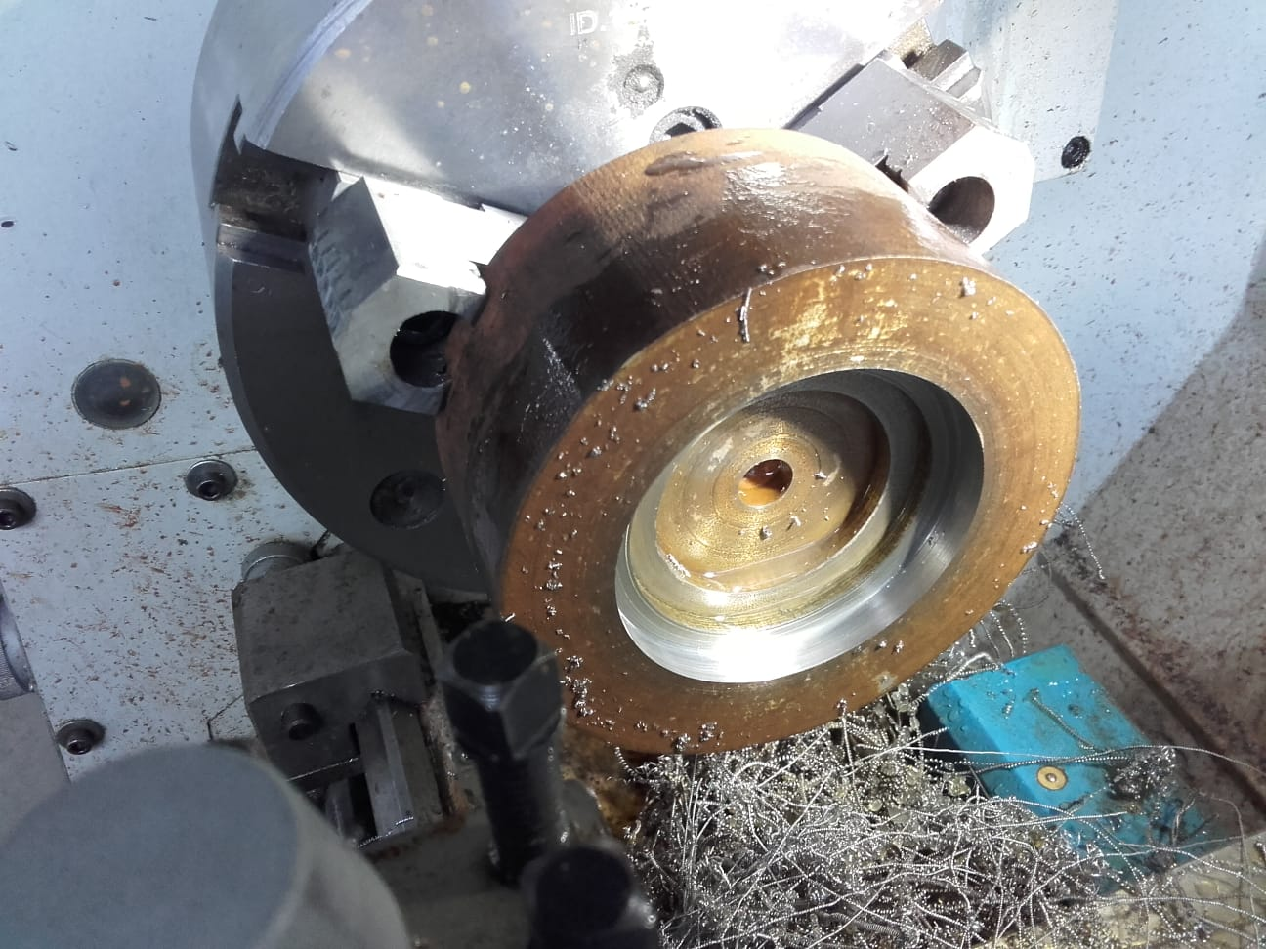

*Figure 9.2: Photos of flask cradle as a work in process. Starting material with the plan (left) and boring the steps on the lathe (right)*

## Cradle Base

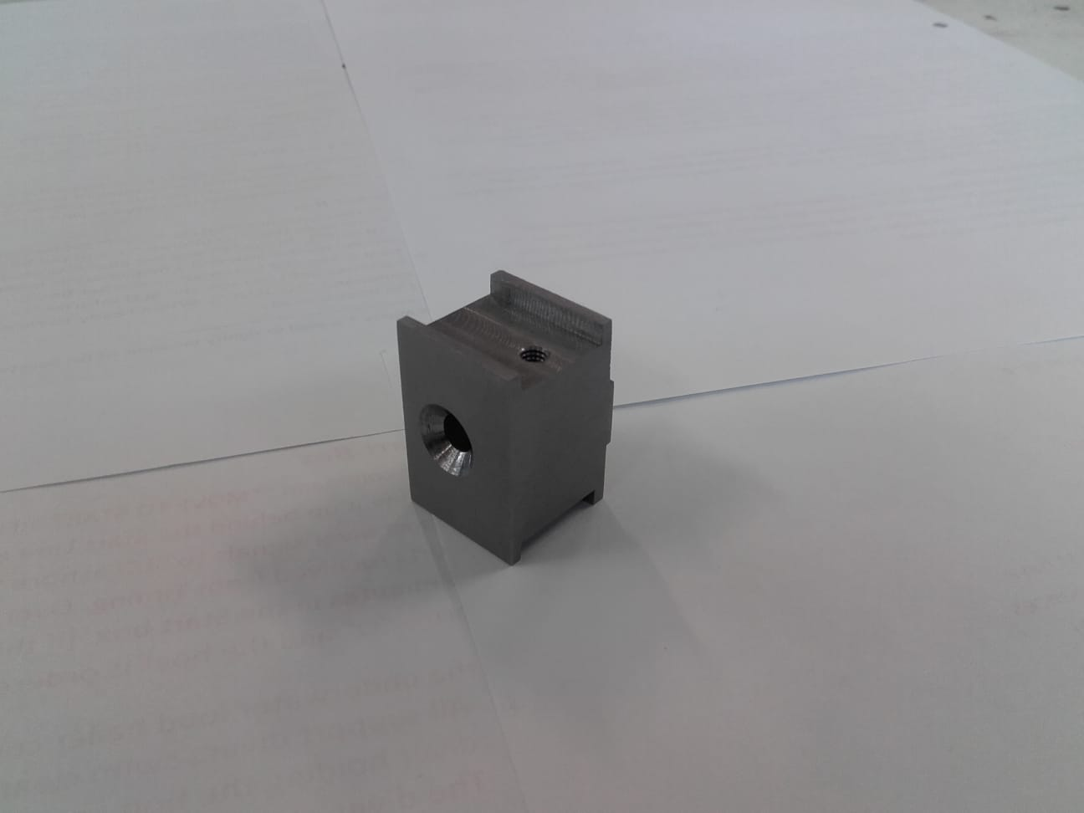 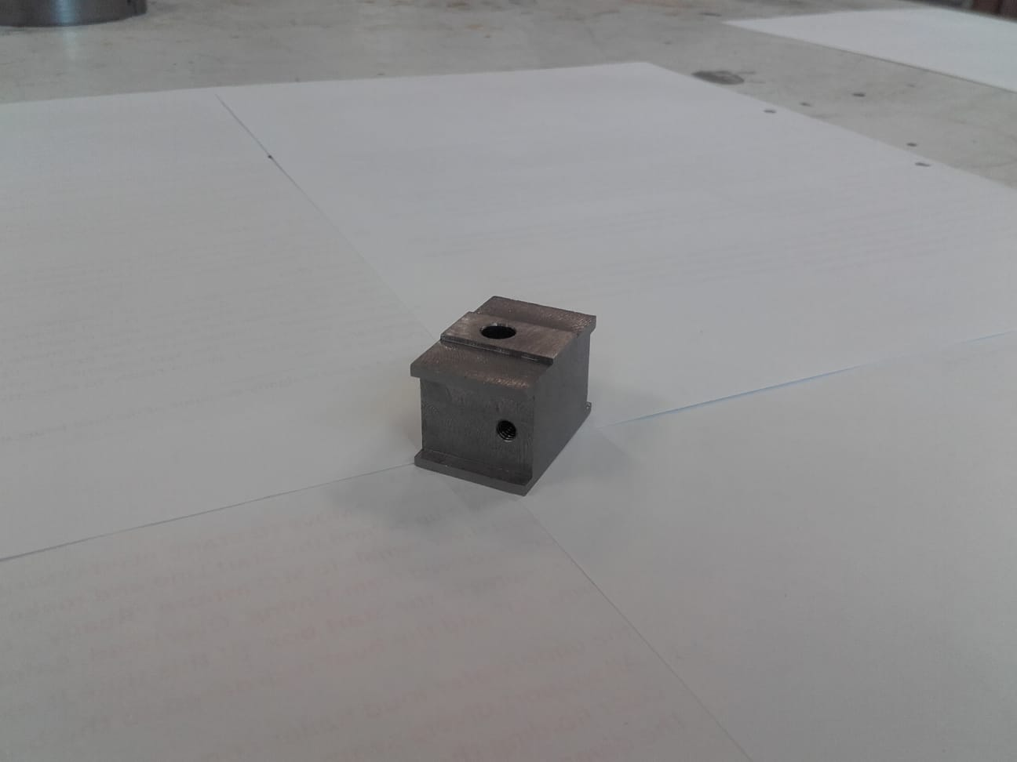

*Figure 9.3: Photos of finished cradle base*

30 x 40 mm bar mild steel was used to make the cradle base (instead of 304 stainless) since it was available in the shop. After making the original design, it became clear that the vertical CS hole was too close to the edge, so the part was remade, thicker (20 mm instead of 15 mm), and with an M5 bolt instead of M4 to match the change in the flask cradle.

## Retainer for Crucible

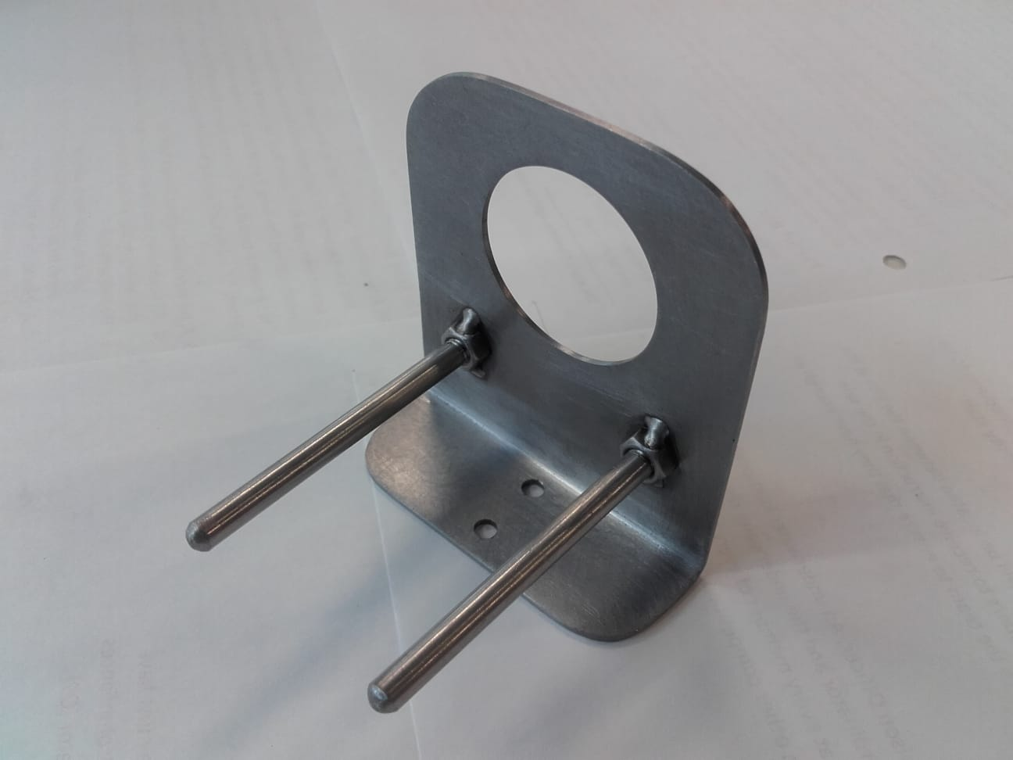 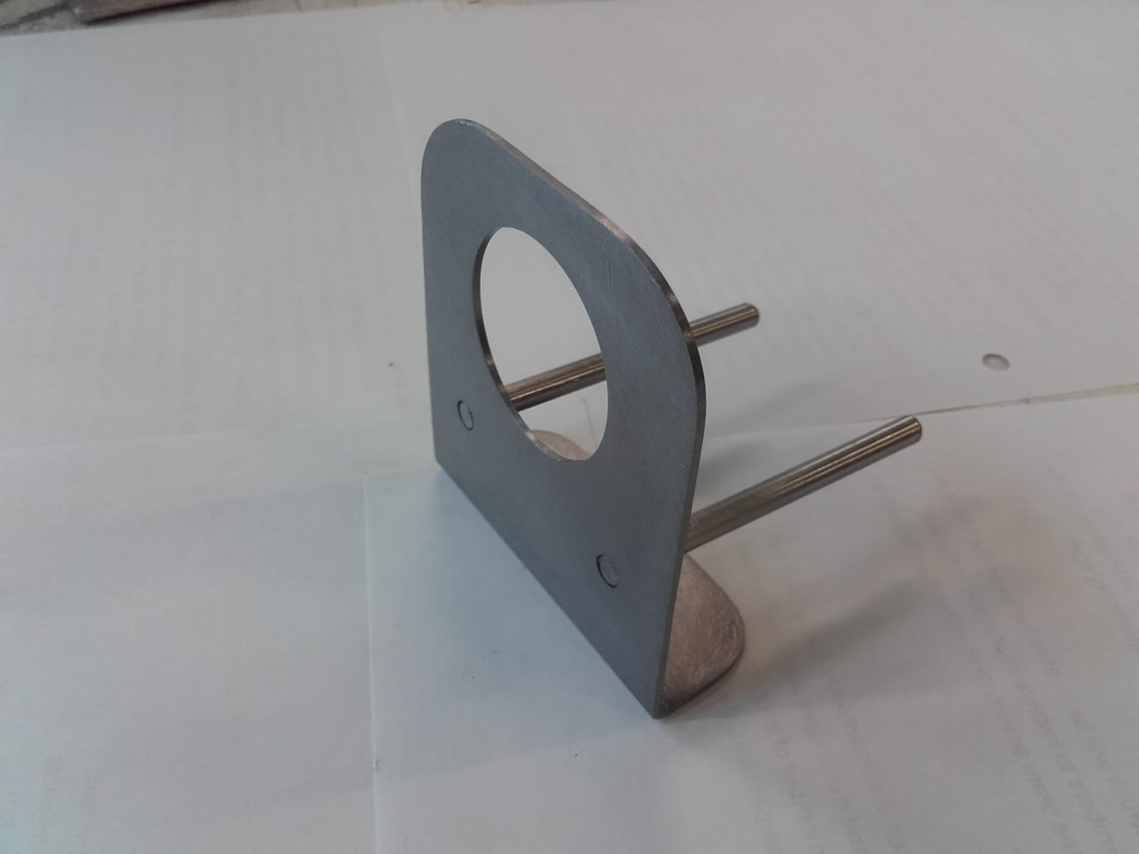

*Figure 9.4: Photos of finished retainer for crucible*

A piece of scrap mild steel in the lab that already had the 90° bend was used to make this part. The band saw and mill worked well to get the rectangular geometry and the bench grinder made easy work of grinding the big fillets in the top. Also found in the lab, was enough 5 mm round stainless to make the legs. Since it is not ideal to weld stainless to mild steel, the choice was made to weld two nuts to the plate and then thread the support legs. The threads on one of the arms is slightly misaligned, but the rest of the decision worked out nicely.

## Slider

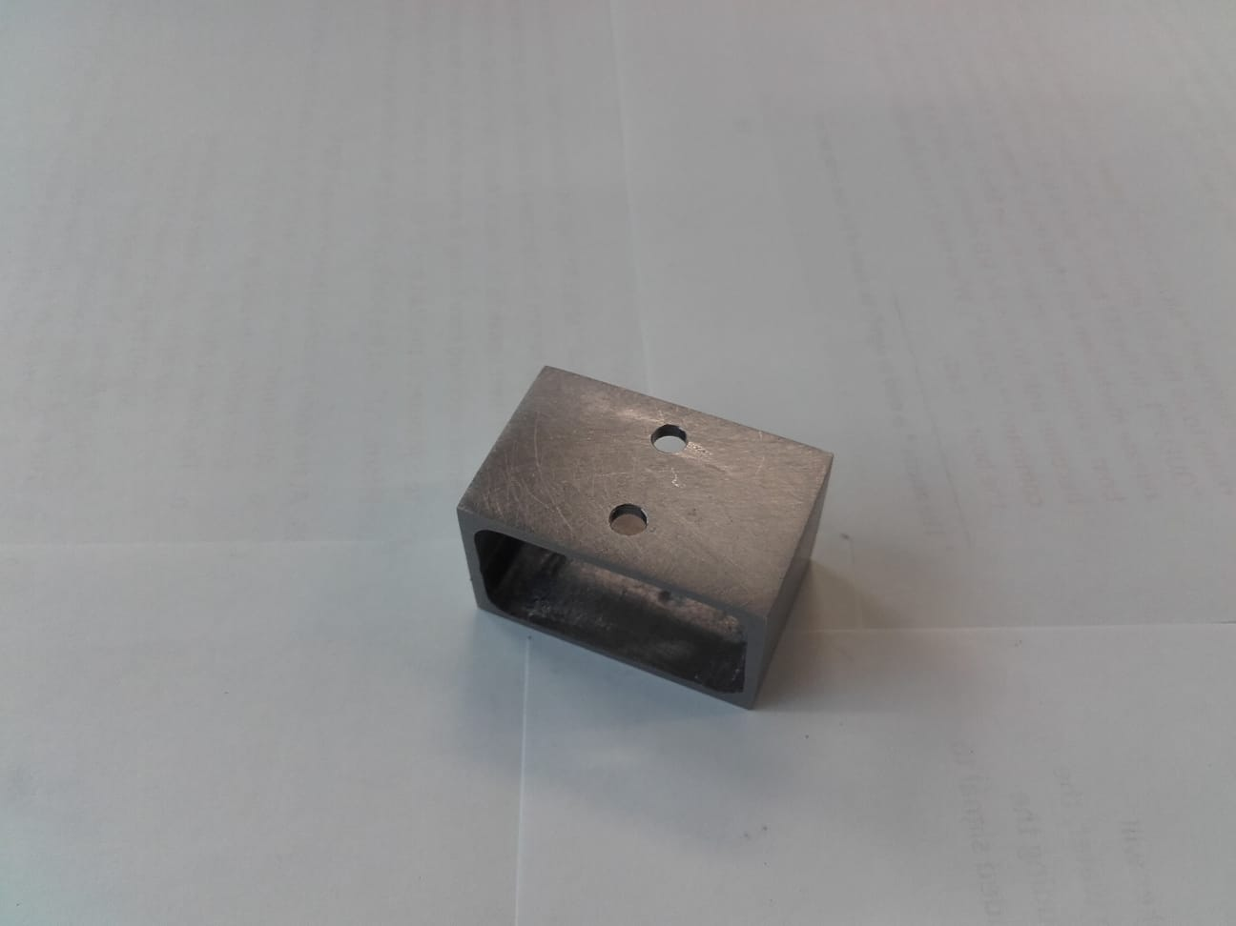 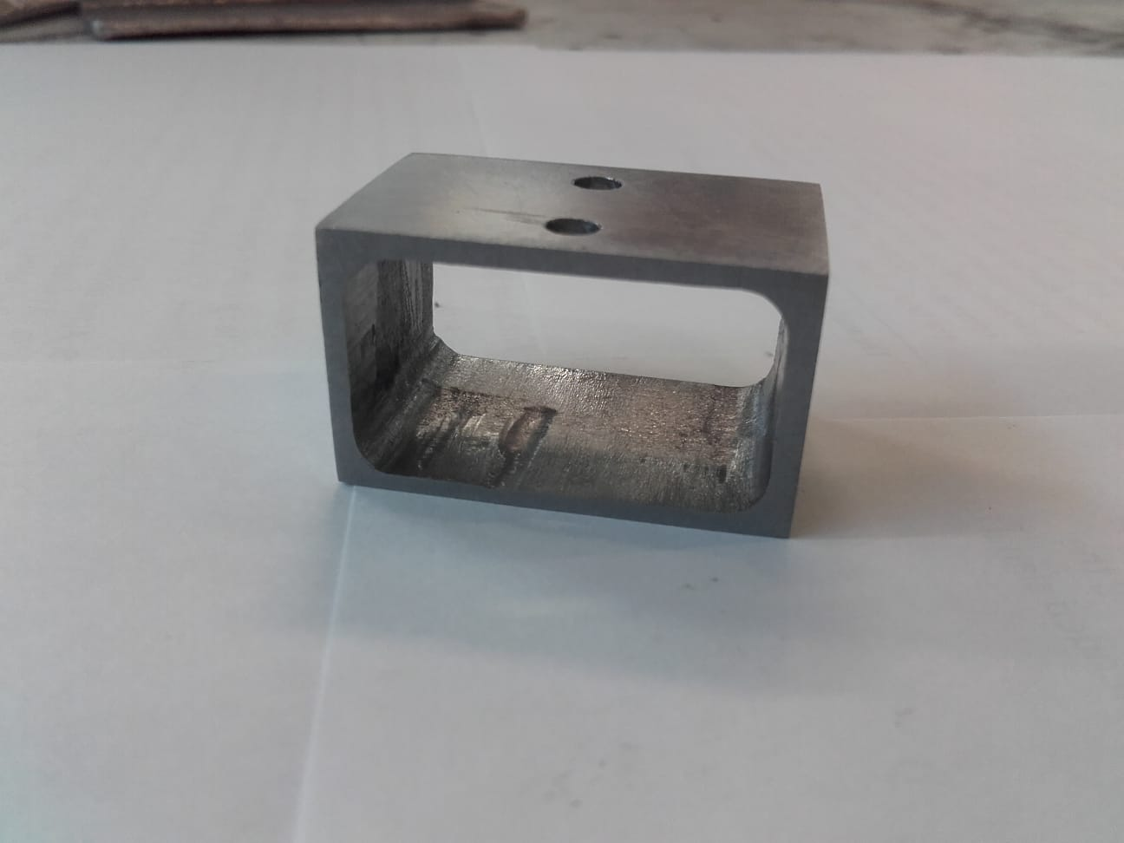

*Figure 9.5: Photos of finished slider*

The slider was manufactured from 30 x 40 mm bar mild steel (instead of 304 stainless) since it was available in the lab. There was no mill bit long enough to mill out the entire slot so half of it was cut from each side. The axes of the mill aren’t well aligned right now so, although the part is perfectly functional, the two halves of the slot are ugly. This was also one of the first parts that was made and you can see where a few ugly mistakes were made in the mill. Since more skills have been acquired, there is a desire to remake this part sometime after the mill is serviced. It could also be made longer, and/or the slot could be made narrower from top to bottom. The weight of the crucible offsets the center of gravity of the slider assembly so it leans back on the slider bars. It shouldn’t interfere with operation but it doesn’t look good. Because of this dramatic aesthetic effect, this is the least pleasing part in the entire assembly.

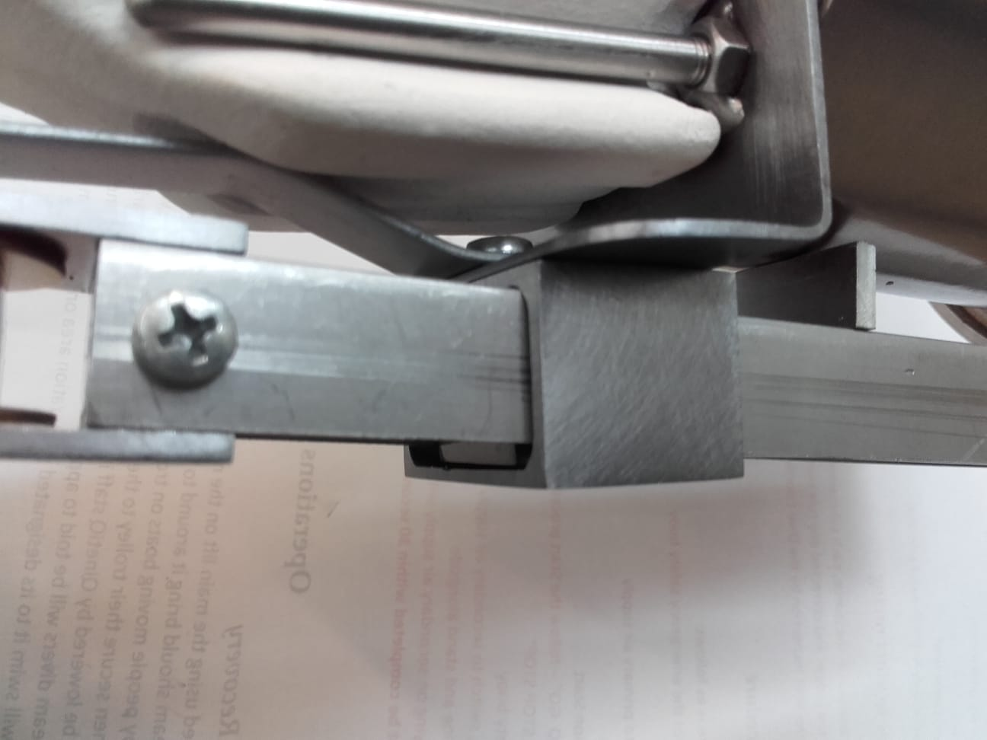 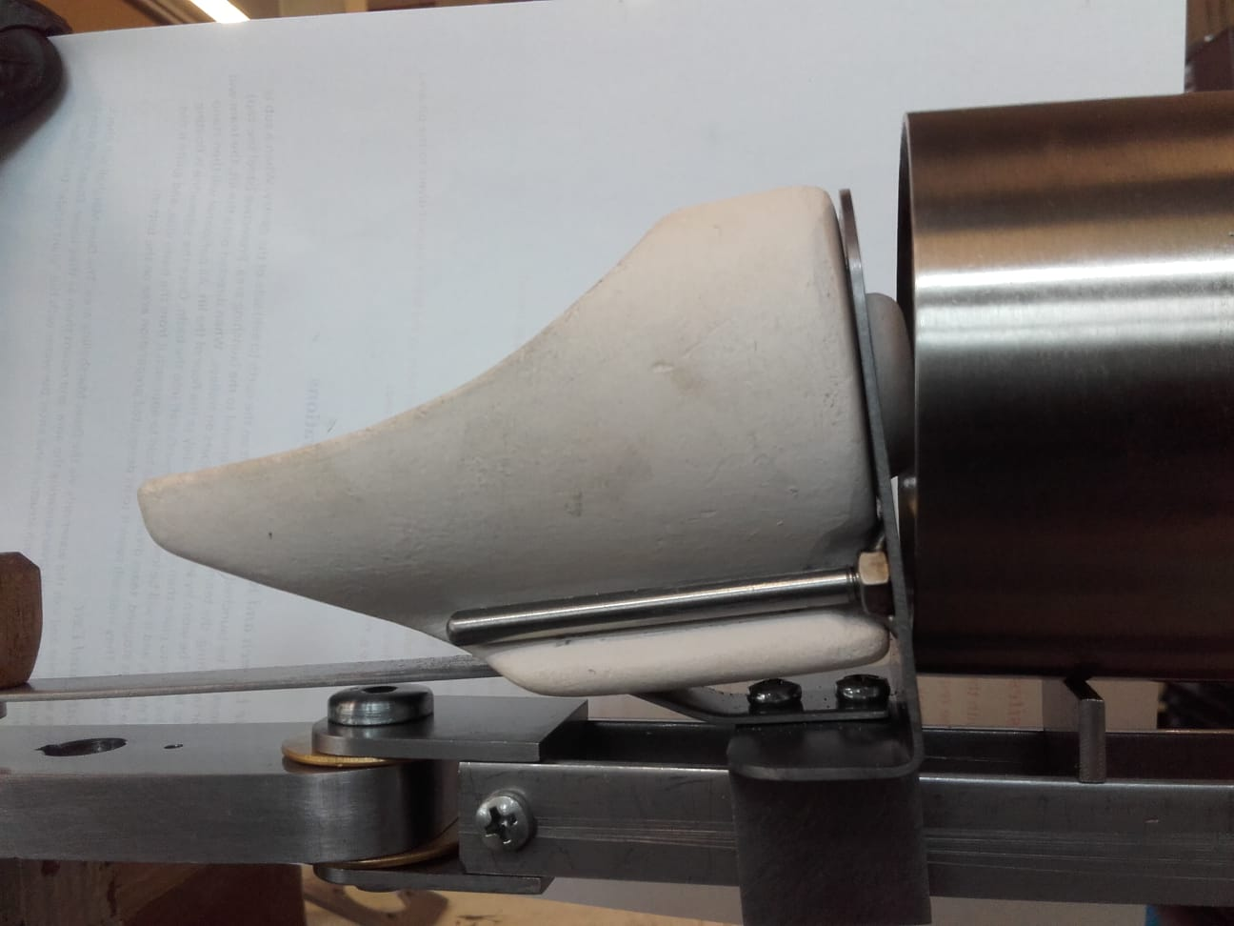

*Figure 9.6: Photos showing slider leaning back on slider bars when crucible is in place*

## Slider Spacer

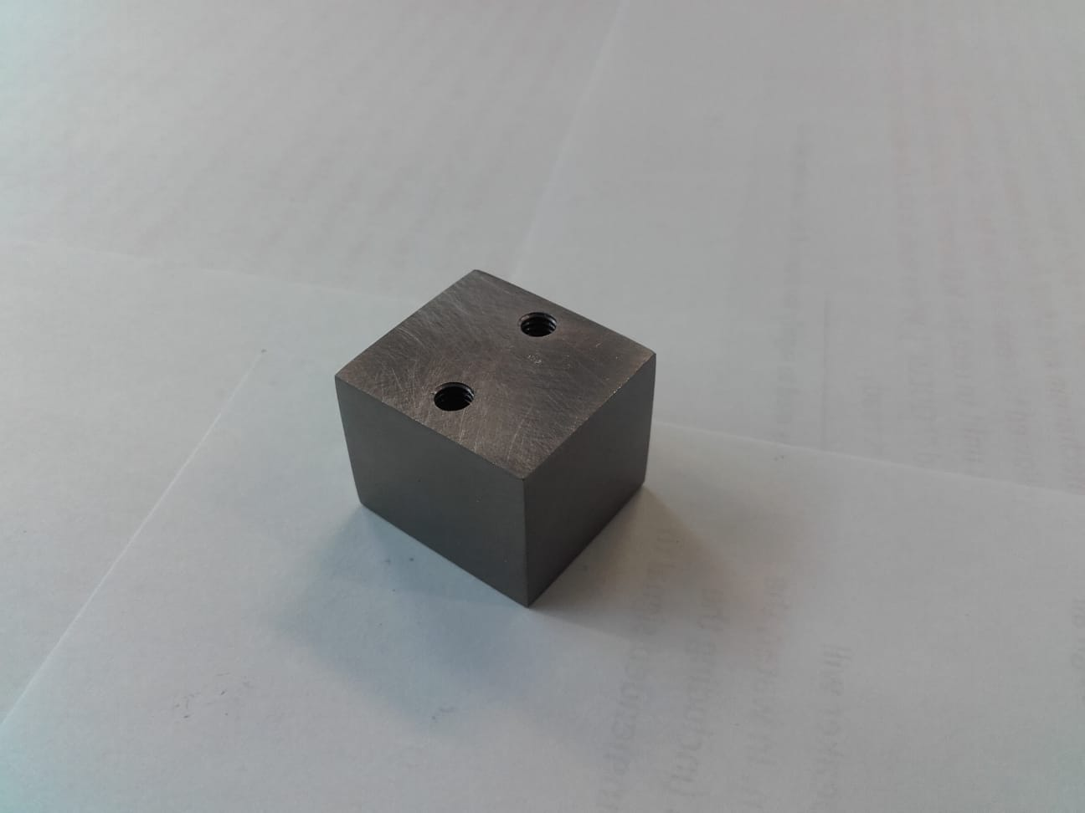

*Figure 9.7: Photo of finished slider spacer*

The slider spacer was made from 30 x 40 mm bar mild steel (instead of 304 stainless) since it was available in the lab. Through holes were chosen instead of blind holes since they are easier to tap.

## Crucible Grip Stick

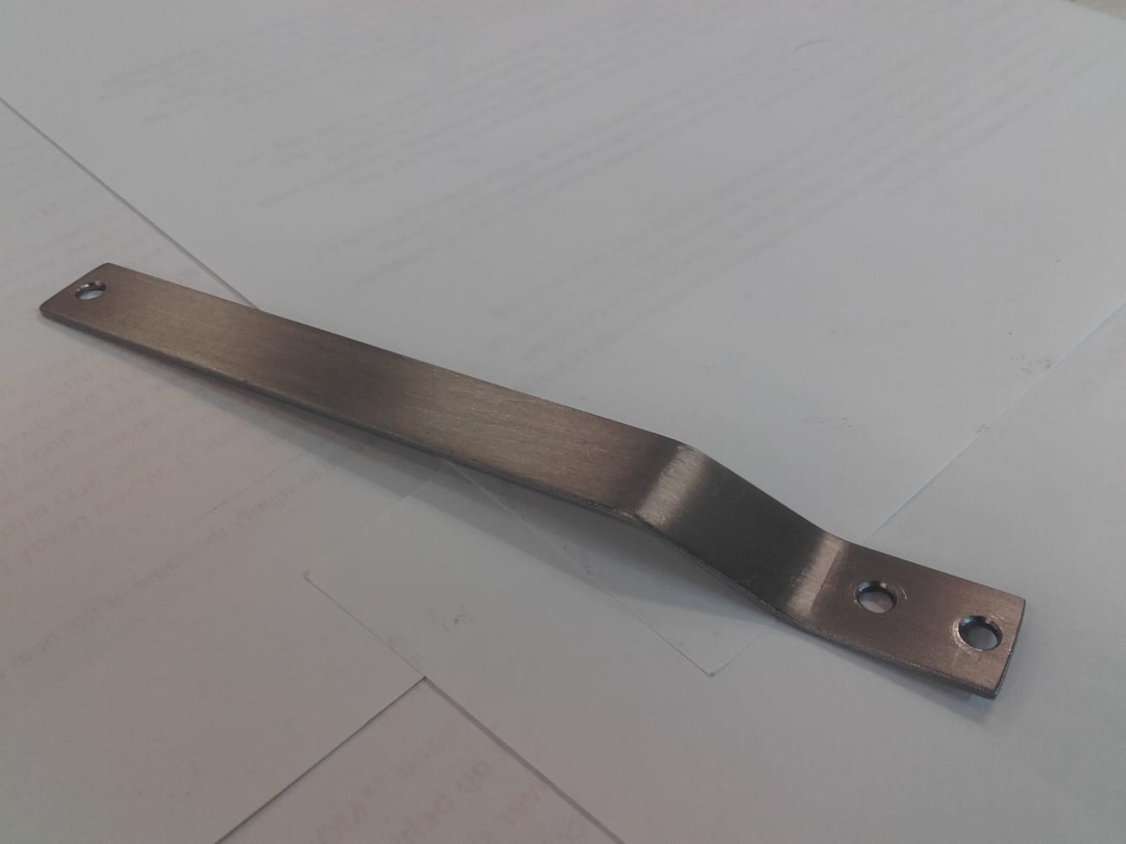 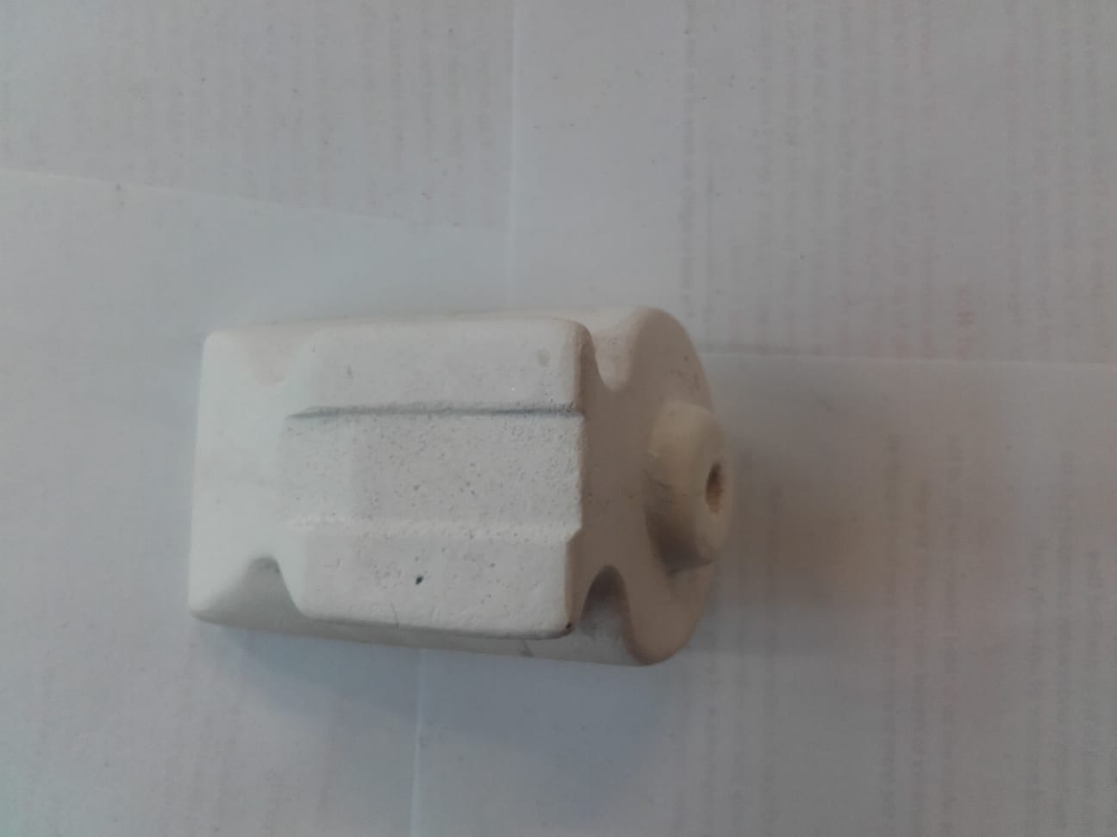

*Figure 9.8: Photos of finished crucible grip stick (left) and modified crucible (right)*

The crucible grip stick was fabricated from scrap 1.5 mm mild steel sheet (instead of 304 stainless) since it was available in the lab. The angles were bent in the bench vice, but it wasn’t possible to bend them exactly so the decision was made to remove a small amount of material in the shape of a slot from the bottom of the crucible since it’s easier to machine than steel.

## Grip Stick Knob

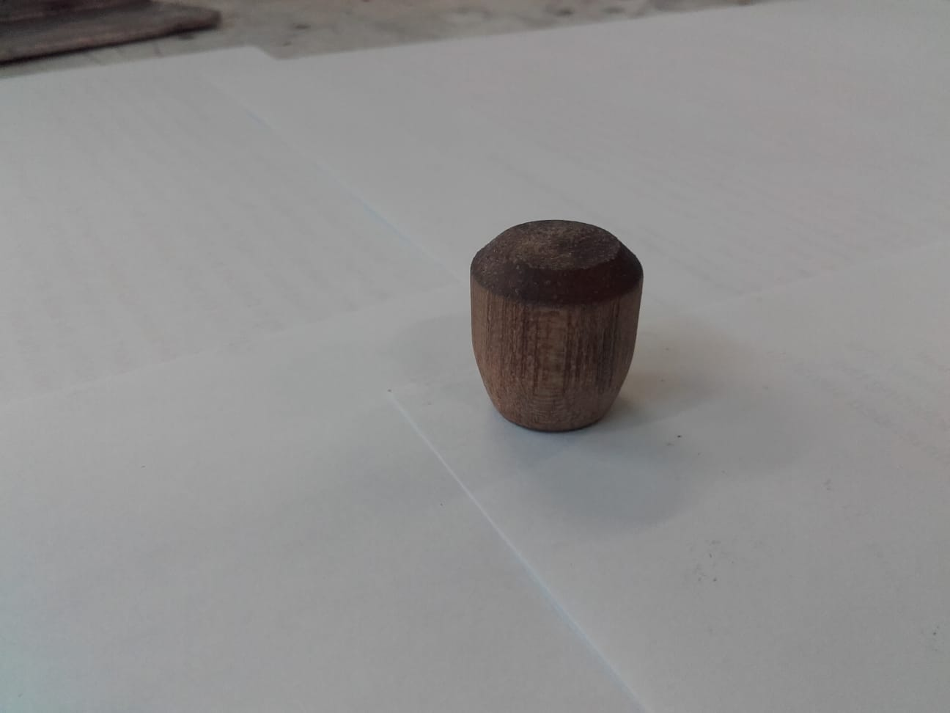 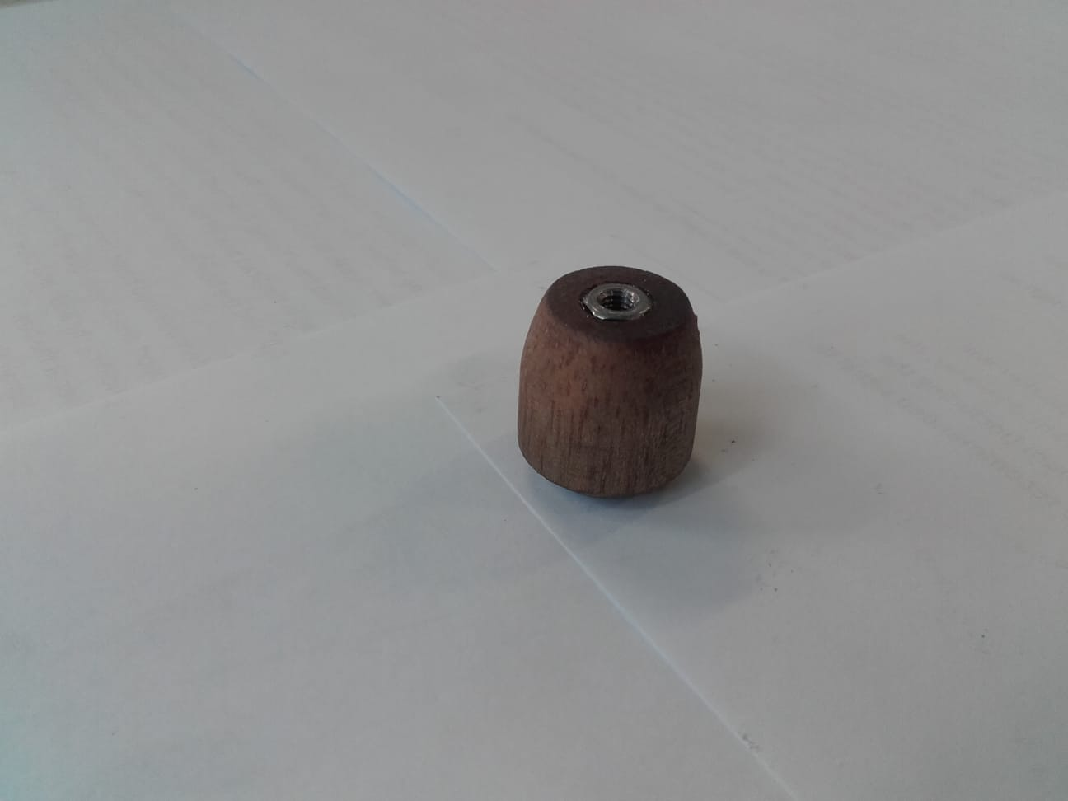

*Figure 9.9: Photos of finished grip stick knob*

The grip stick knob ended up being made on the lathe out of a piece of an old oak broom handle (instead of a thermoset plastic). Fine pitch threads don’t work well in wood; so two M4 nuts were glued into a slot with a two-part epoxy. The wood was finished using a few coats of cutting oil. Hopefully that will help give it a bit more heat resistance.

## Slider Bars

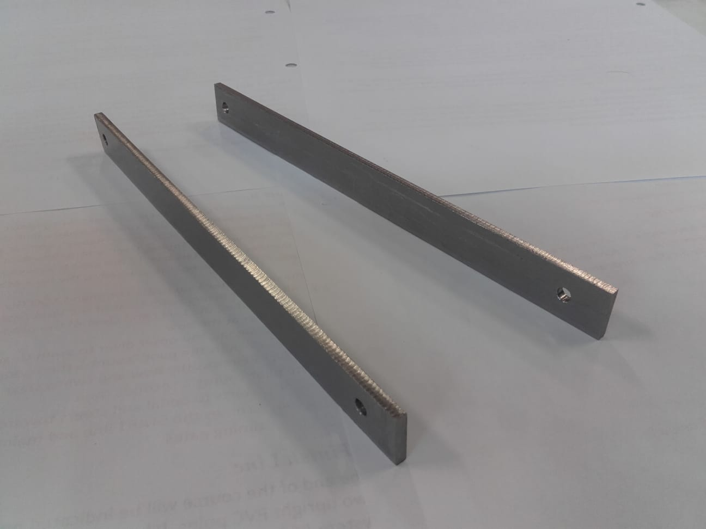

*Figure 9.10: Photo of finished slider bars*

The slider bars were manufactured from 3 mm sheet stainless from the lab. The decision was made to not add the chamfers since the fit is already a little bit too loose inside the slider. If the slider corrodes, the chamfers can always be added to the slider bars later to ease movement.

## Pin Joint

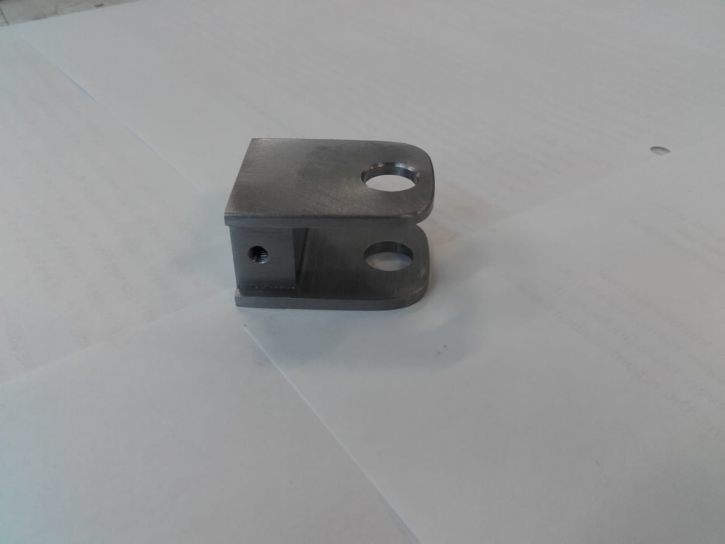 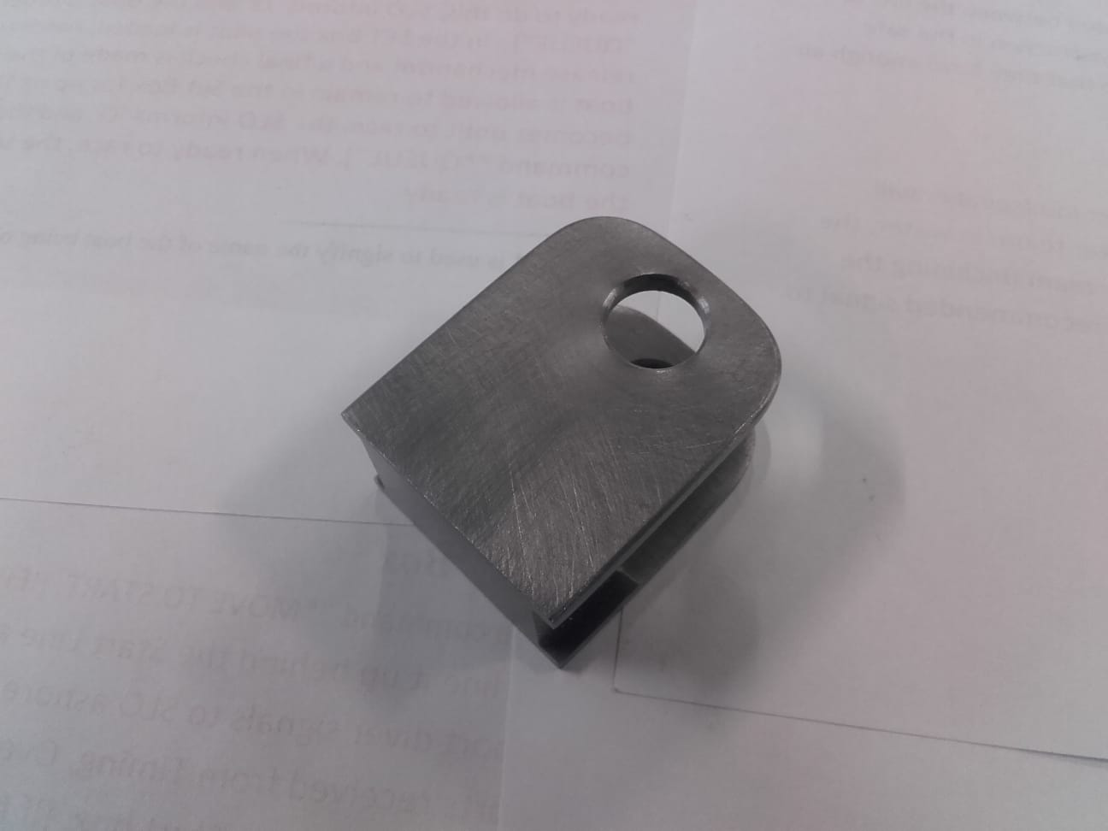

*Figure 9.11: Photos of finished pin joint*

The pin joint was fabricated from 30 x 40 mm bar mild steel since it was available in the lab. Technically, this part should have been called “slide bearing” since the brass spacers were used in the connection, but it looks like a pin joint so that’s what it was called. The angles in the design were unnecessary and complicated since the orientation of the spindle on the mill would have had to have been adjusted, so the part was just made rectangular and then the corners around the clevis pin hole were ground off on the bench grinder. Also, because of this part (since the calculations were a bit uncertain and the safety factor isn’t very large), the decision was made to temper all of the parts after the oil quench.

## Counterweight Arm

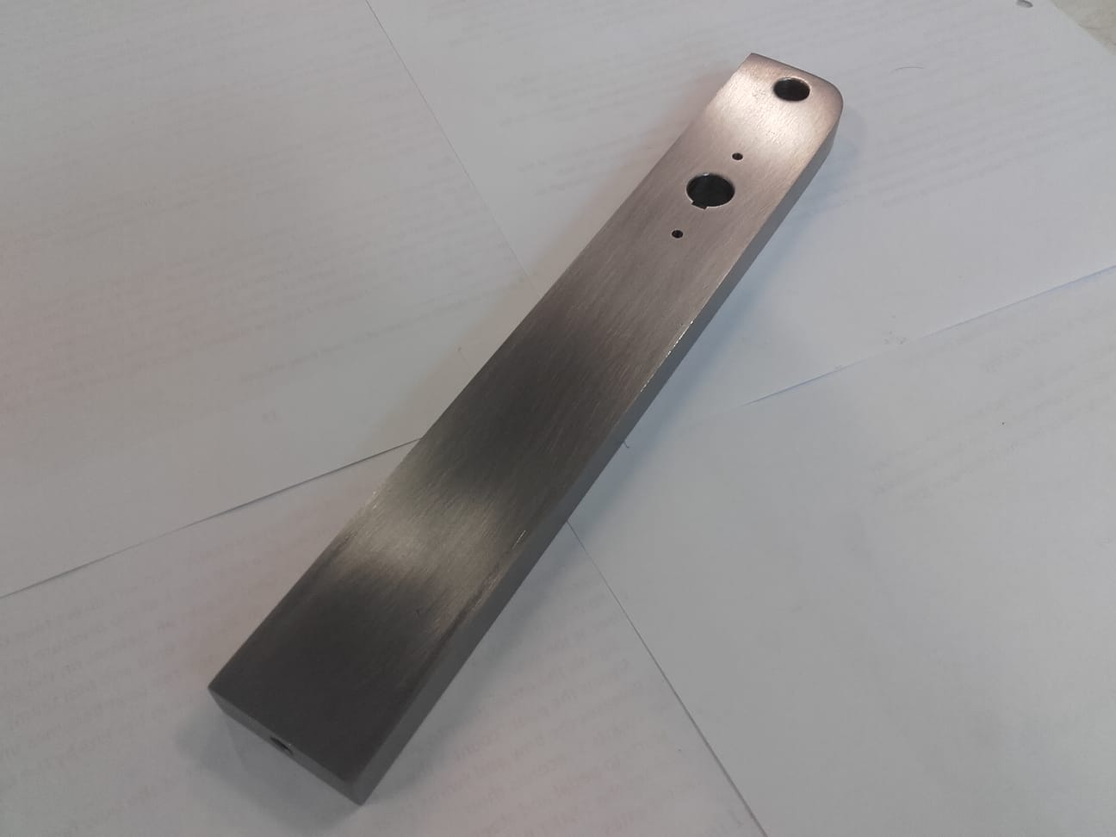

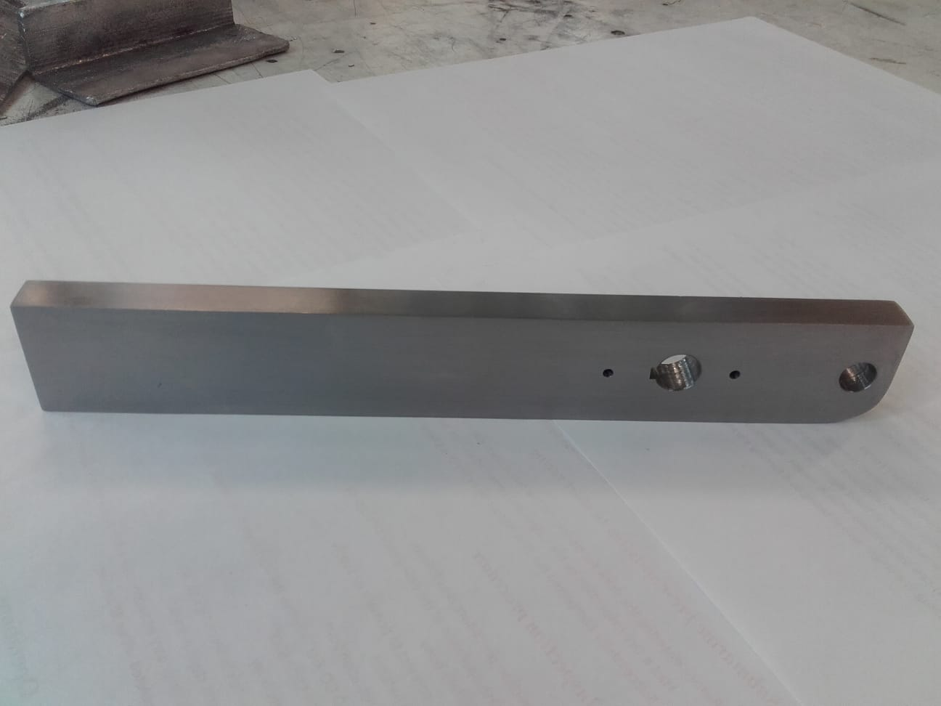

*Figure 9.12: Photos of finished counterweight arm*

The counterweight arm was made from 30 x 40 mm bar mild steel since it was available in the lab. The decision was also made to make it 12 mm thick (instead of 10) since it allows for a smaller counterweight and for a small groove to help with balancing. The filet was ground on the banch grinder. A long time was needed to figure out how to make the keyway since there is no access to a die filer or any small hand files in the lab. Mathias has a set of broaching tools and he was able to cut it in just a few minutes. This part took a lot of hand sanding to remove the mill marks but it turned out nice.

## Counterweight

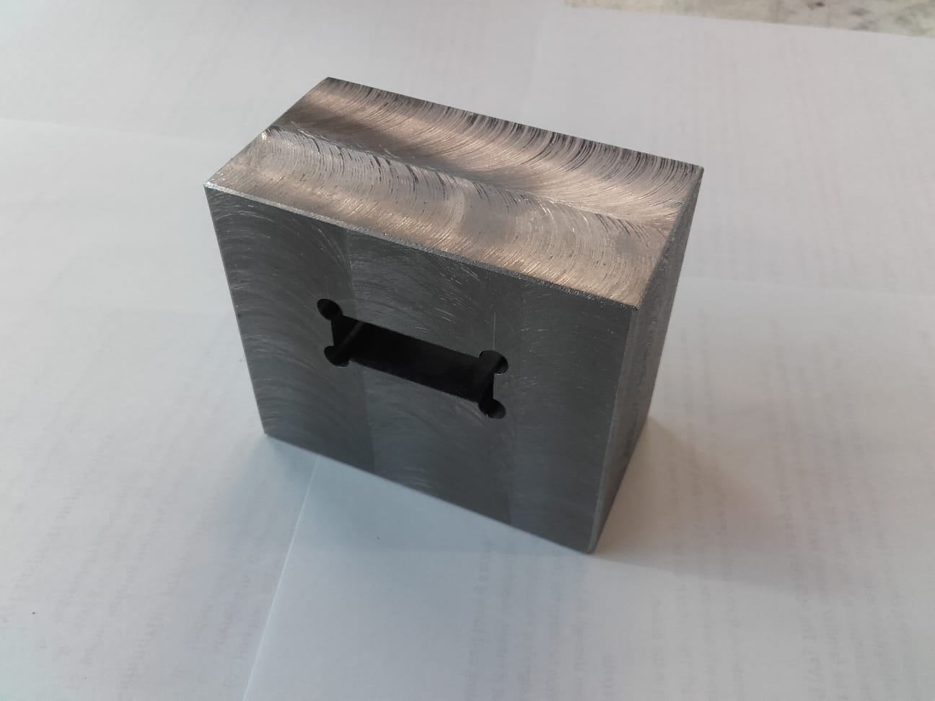 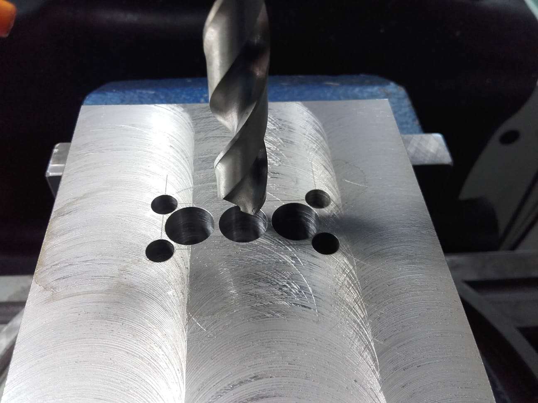

*Figure 9.13: Photos of finished counterweight (left) and work in process on the mill (right)*

A big piece of mild steel was found in the workshop and milled square follwed by two full days milling out the central square slot. It was brought close to the dimensions that would give the mass that had been calculated from the CAD model. However, that mass could not be relied upon to perfectly balancing the casting arm (as it could in the CAD file) since so many of the parts had been made from mystery-steel from the workshop with densities anywhere from 7500 kg/m3 up to 8300 kg/m3. A more practical approach was needed. When all the other parts were finished, the casting arm was completely assembled, and to the inside of the flask, was added the weight of casting metal (255 g) and the weight for the amount of investment that would fit in the largest flask (290 g). Then, material was iteratively removed from the counterweight until the casting arm was perfectly balanced at the point of rotation.

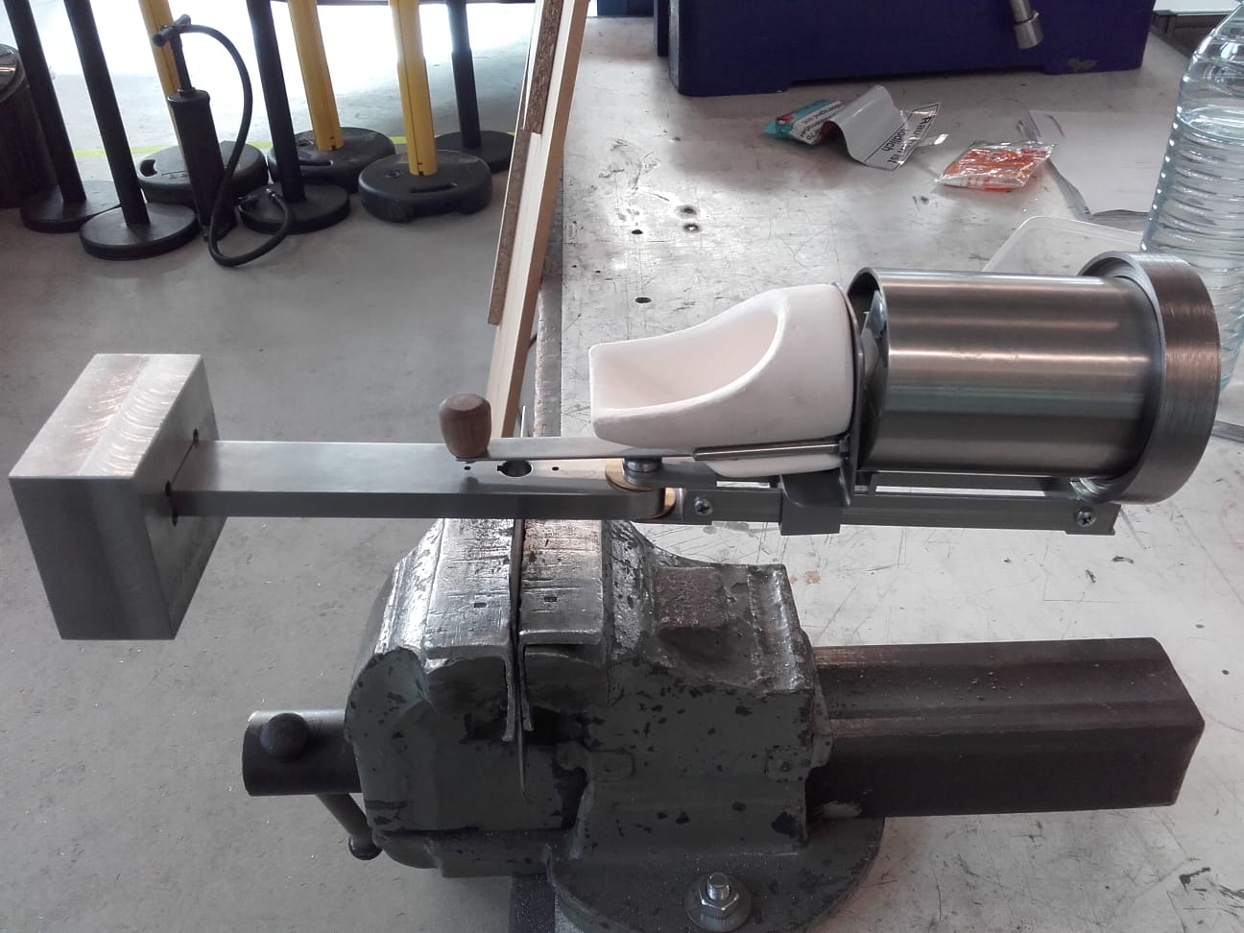

*Figure 9.14: Photo of casting arm balanced on 1.5 mm sheet steel in the bench vice*

## Spacer for Counterweight

Once the counterweight was sized, the weight of the casting metal and investment was added to the smaller flask and the counterweight was moved inward toward the axis of rotation until it balanced once again. Then the spacer was added and played with, iteratively taking off material and re-balancing until it was perfect. If we get more flasks in the future, this process can easily be replicated so each flask has a spacer that perfectly balances it on the casting arm.

## Bracket for Connection to Gearbox

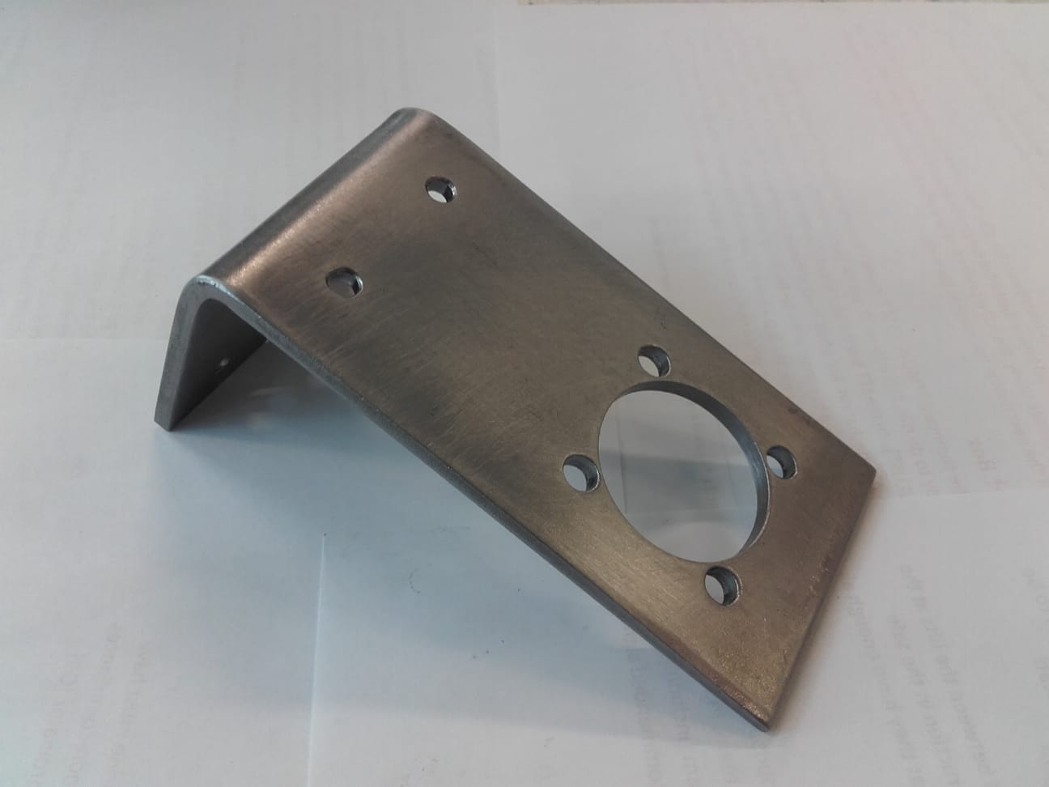 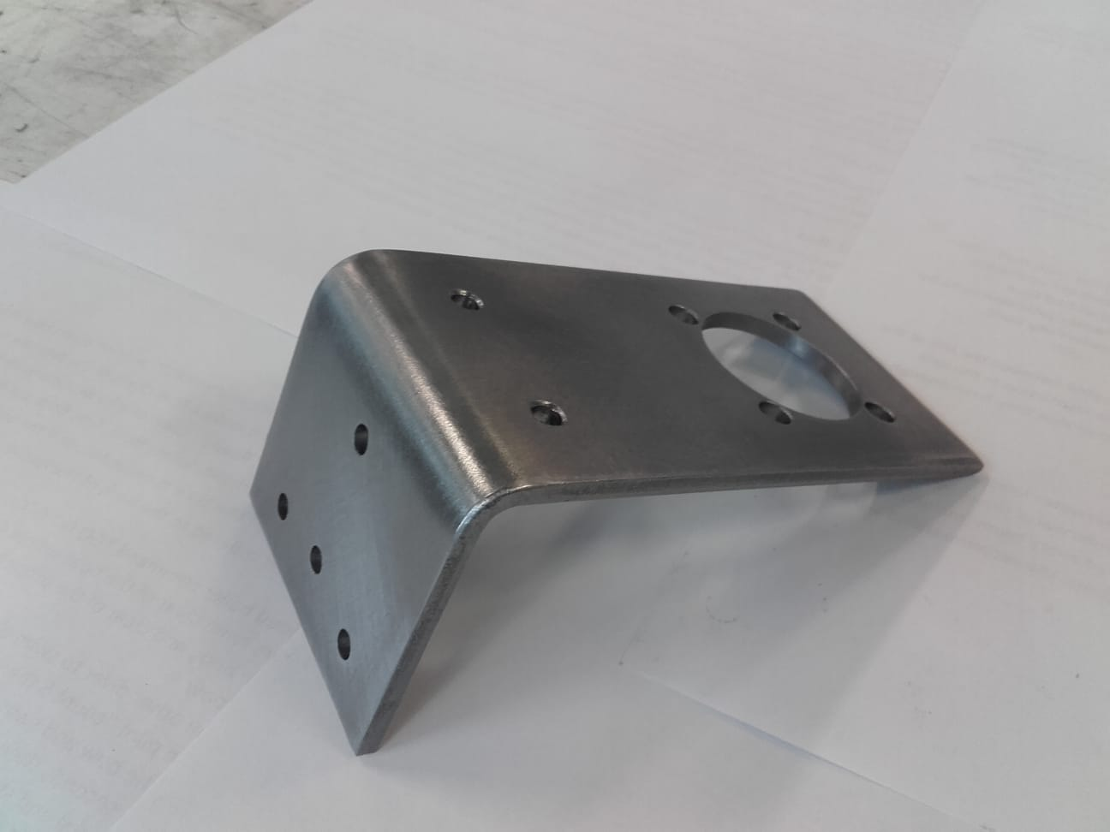

*Figure 9.15: Photos of finished bracket for connection to gearbox*

Mathias made the rough shape of this part by bending a piece of 4 mm plate mild steel. After some hammering and filing, it fit nicely. A tapered mill bit was used (the only bit we had with a 32 mm diameter since the boring tool is broken) so cutting the big hole was a bit sketchy, but it worked nicely in the end.

## Top Piece

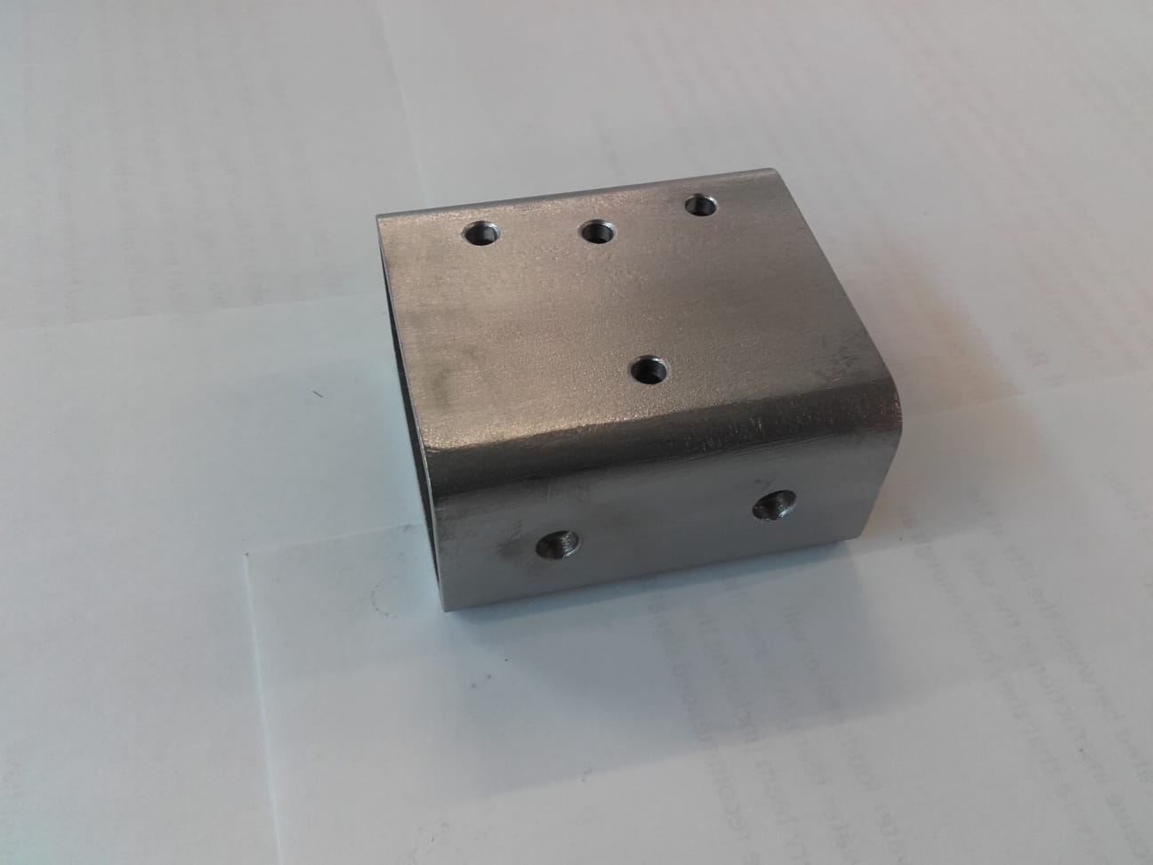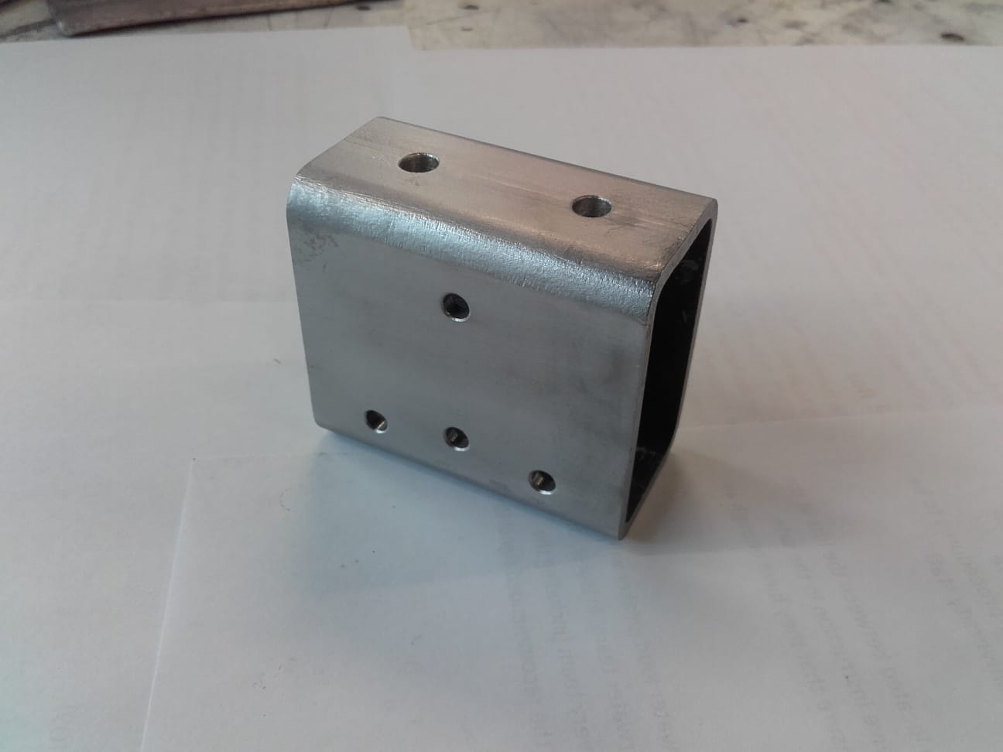

*Figure 9.16: Photos of finished top piece*

The decision was made to go with 3 mm thick tubing for most of the machine base assembly since it was readily available locally. This meant that the minimum thread depth could no longer be met for the M4 bolts so the threaded holes were replaced with through holes and nylon locking nuts. It’s a little trickier to assemble now, but at least all those holes didn’t have to be tapped.

## Vertical Post

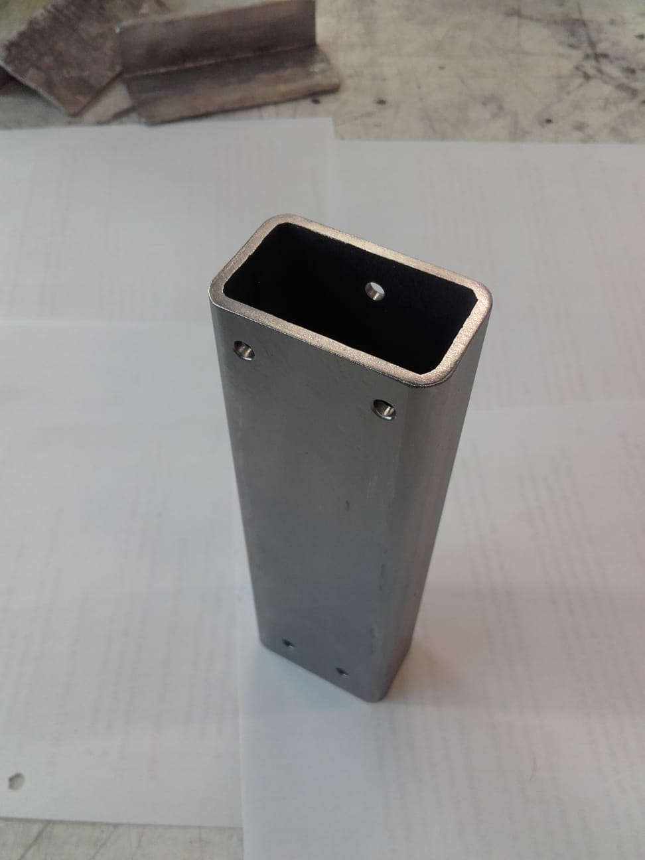

*Figure 9.17: Photo of finished vertical post*

Made from 3 mm thick tubing with locking nuts. There was also a bit of extra tubing so this part was made a little longer (169 mm instead of 160) to provide a bit more room for the cables coming out of the bottom of the motor. The steel tubing was all scratched up and the bluing was looking bad so all the pieces of the machine base assembly were cleaned up using a wire brush tool in the power drill. They turned out pretty well.

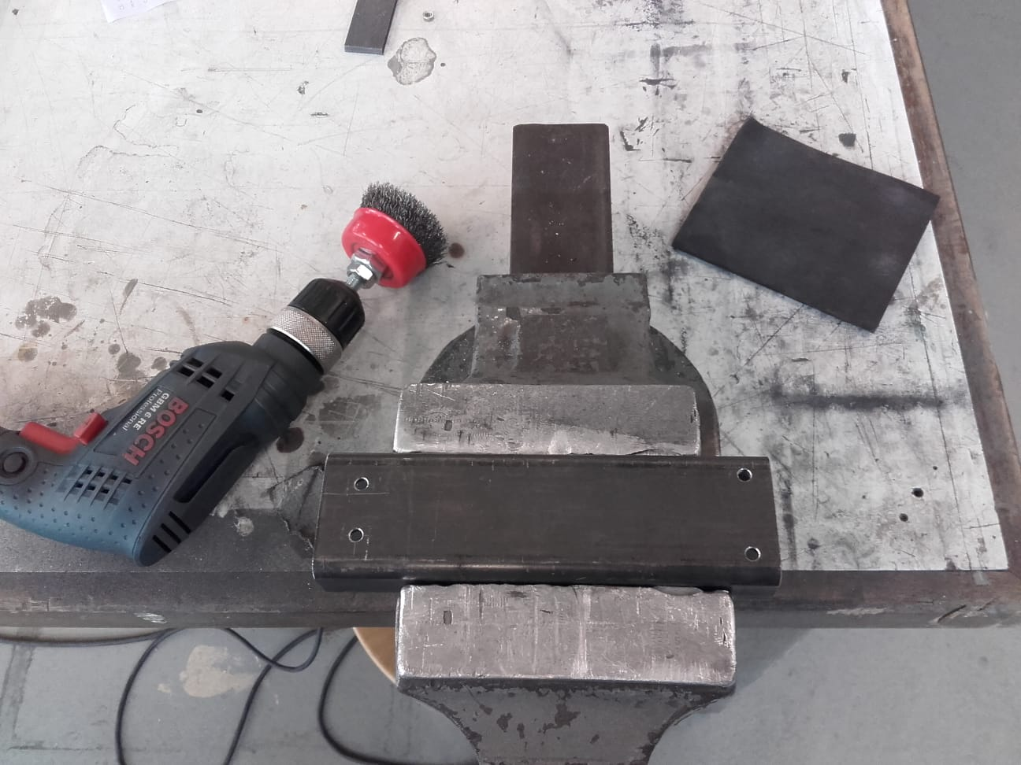 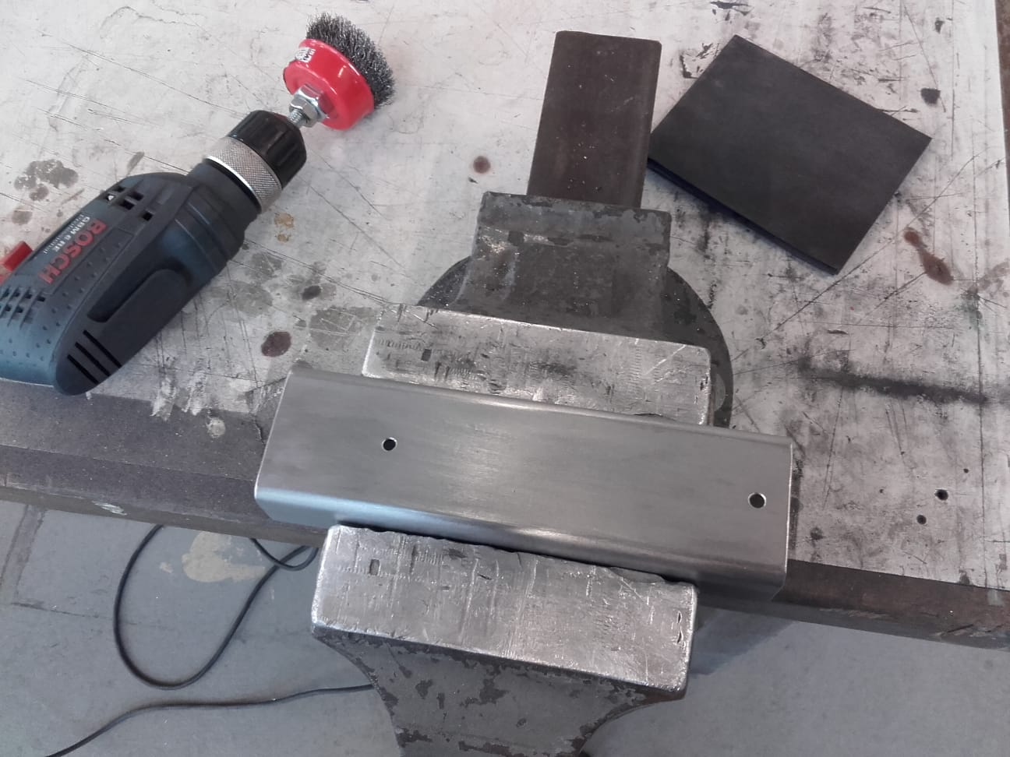

*Figure 9.18: Before (left) and after (right) photos of old finish removal and cleanup of parts in machine base assembly*

## Legs

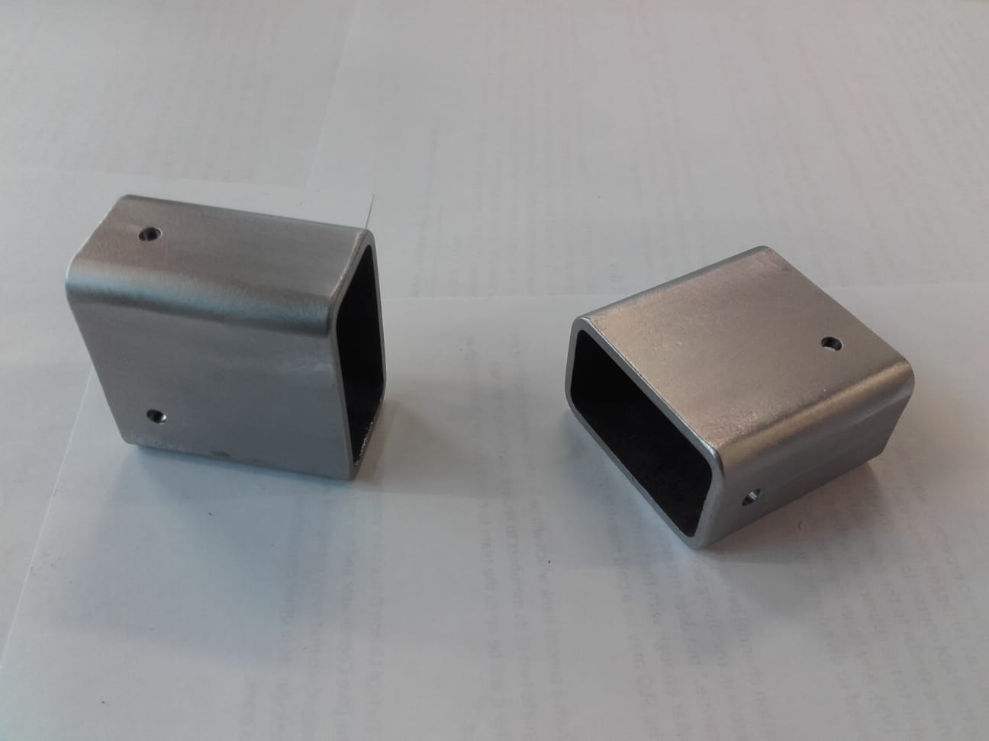

*Figure 9.19: Photo of finished legs*

Made from 3 mm thick tubing with locking nuts.

## Foot

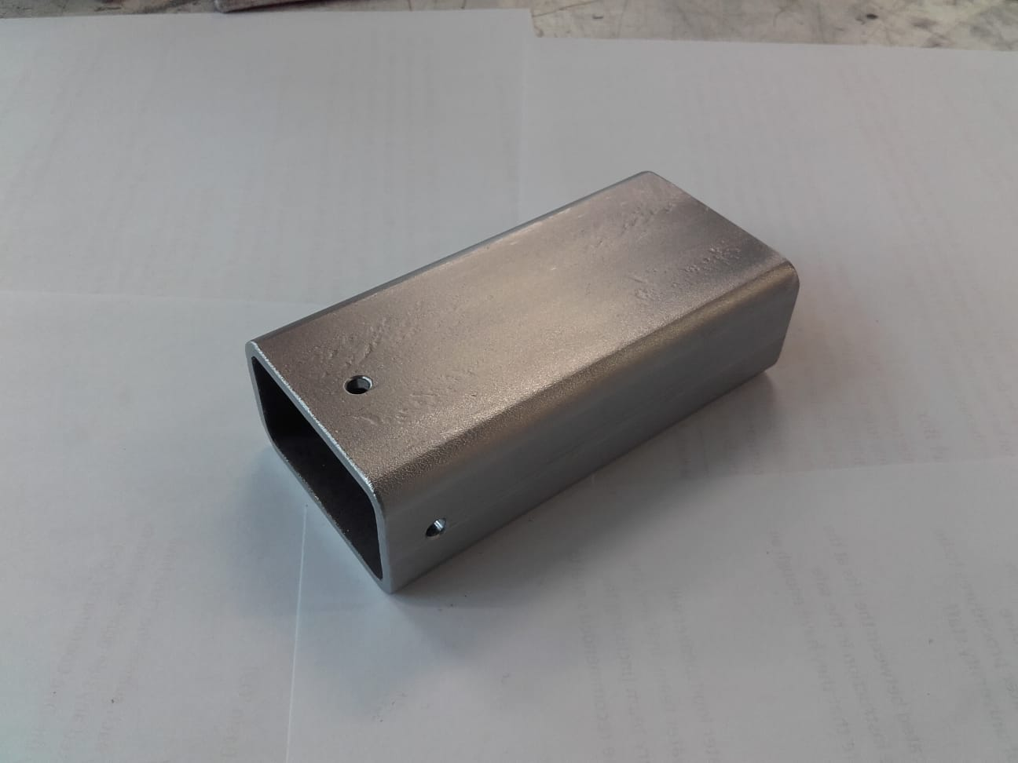

*Figure 9.20: Photo of finished foot*

Made from 3 mm thick tubing with locking nuts.

## Corner Bracket

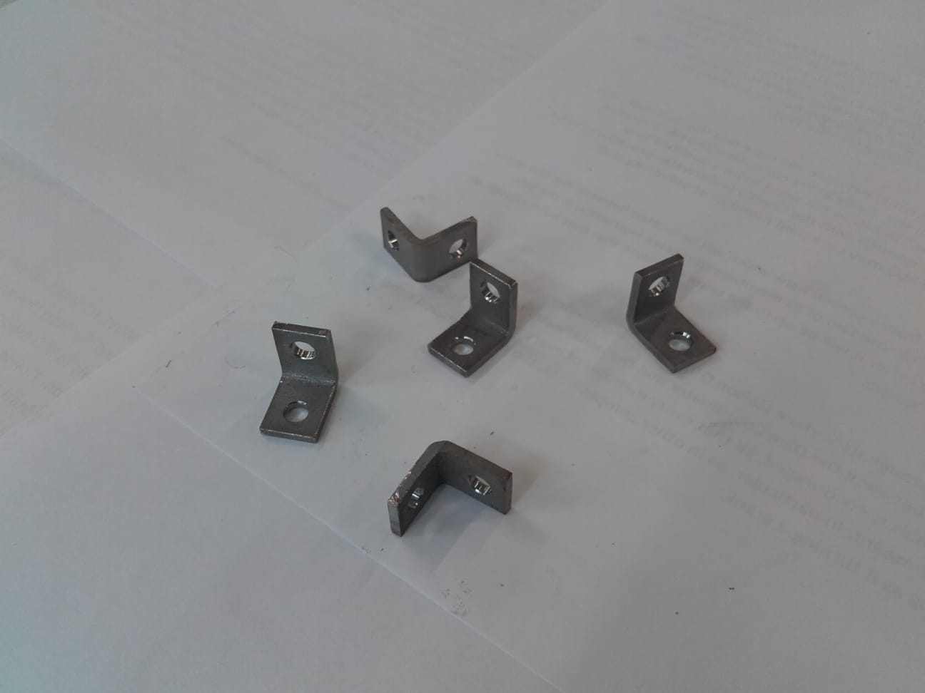

*Figure 9.21: Photo of finished corner brackets*

A piece of scap 1 inch L-bar was found in the lab. It worked perfectly for all five of these.

## Flat Bracket

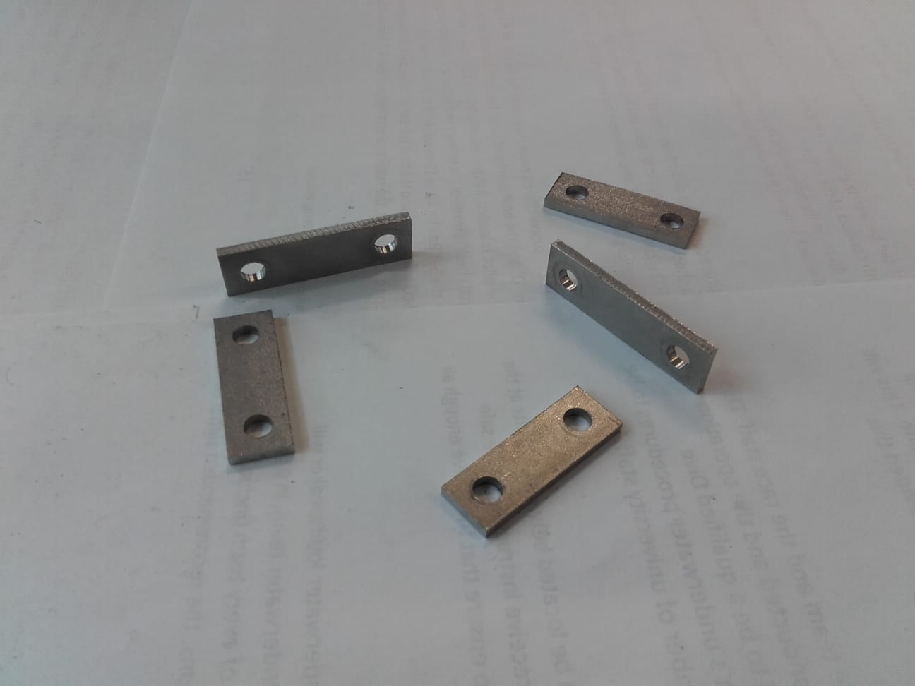

*Figure 9.22: Photo of finished flat brackets*

All five of these were made from a piece of 2 mm plate scrap from the lab.

## Spacer

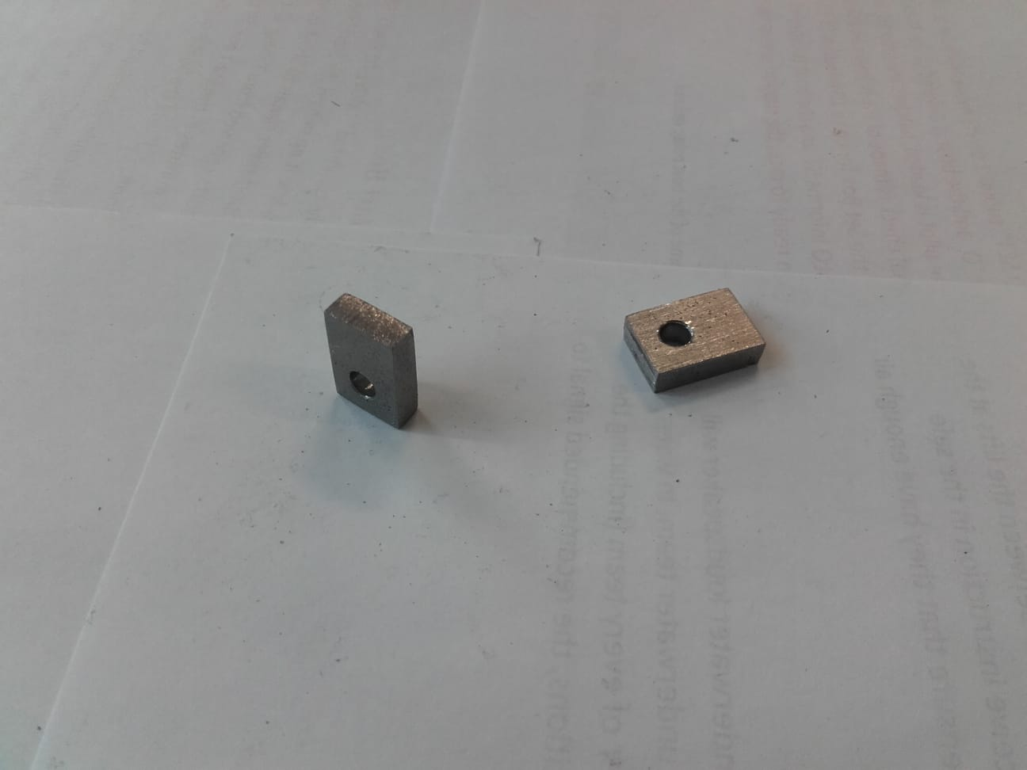

*Figure 9.23: Photo of finished spacers*

These were manufactured from 4 mm scrap found in the lab.

## Base Plate

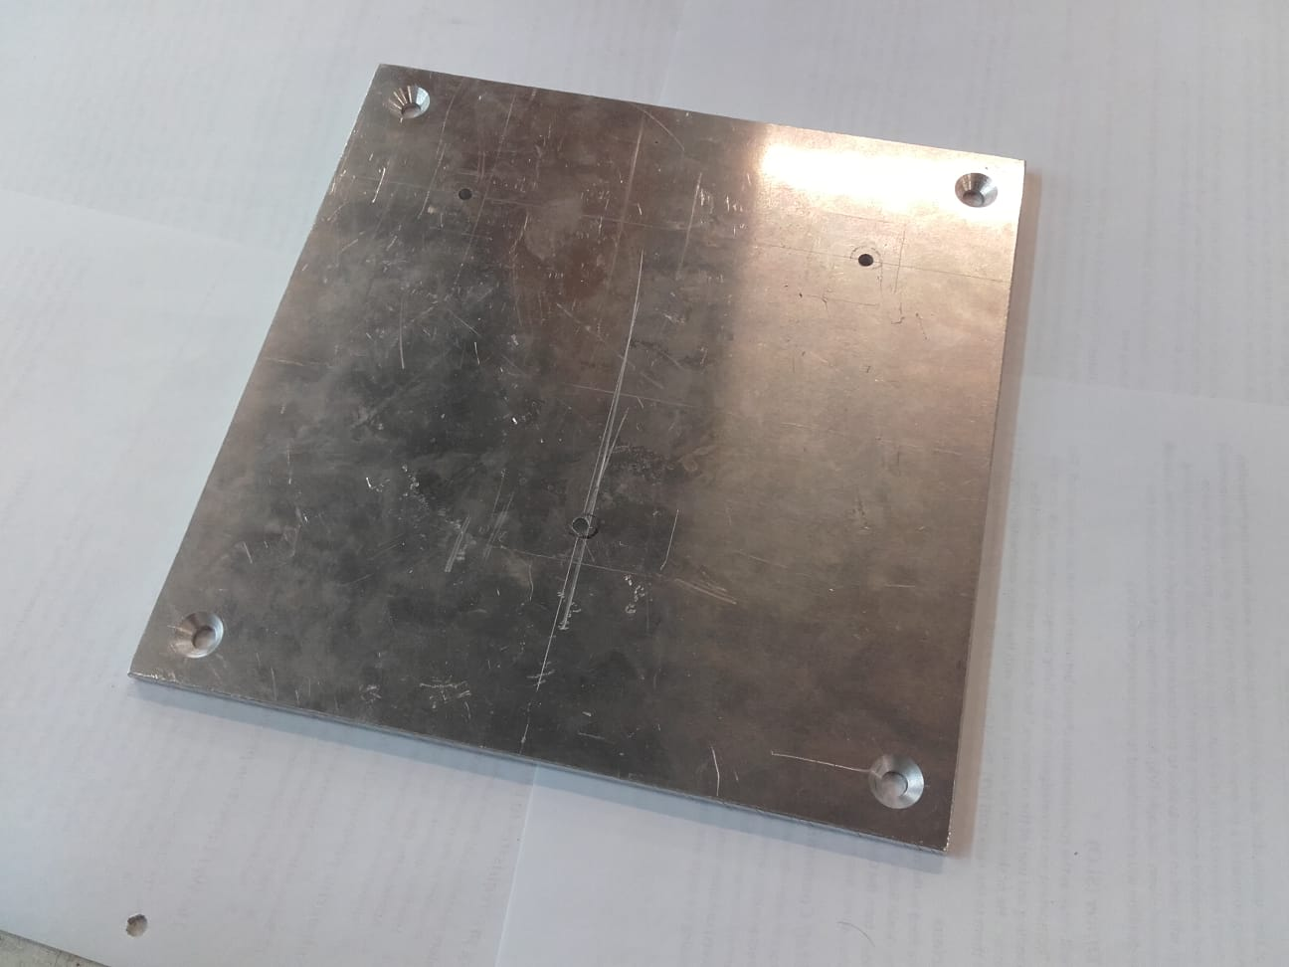 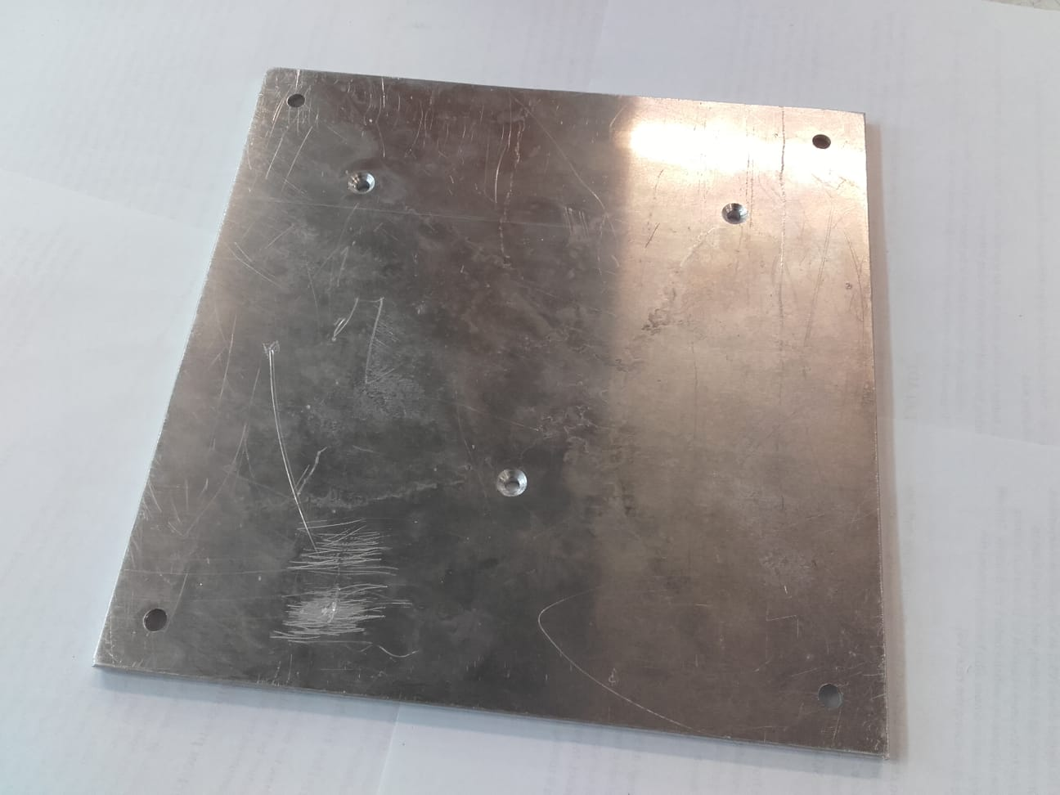

*Figure 9.24: Photos of finished base plate. Top (left) and underside (right)*

It wasn’t going to be easy to get a 500 x 500 x 5 mm plate of steel, so the decision was made to make this part much smaller (220 x 220 mm) and out of 6 mm aluminum, and then attach it to a larger piece of 3/4 inch plywood for the base of the enclosure. Since there is no rotating tub in the design anymore, so much mass at the base was no longer needed and this made construction easier and meant that readily available material could be used. The scrap piece that was utilized is pretty scratched up, but this is the connection to the enclosure and will liklely take some abuse over time so the surface finish is unimportant.

## Enclosure

For several weeks, the author thought the enclosure was going to be ordered and professionally made, so time was very limited when it came to designing and building it. The enclosure was designed and built on the fly, mostly using materials that were lying around in the shop. All we needed to buy were the hinges and hardware. We couldn’t find decent steel mesh so we just went with chicken wire.

Initially, the plan was to hand-paint them using an acrylic paint designed to protect against corrosion. After cutting and grinding, the plates were very rusty (see figure 9.25). All the rust was painstakingly removed and the surface was taken down to a 120-grit finish with sandpaper.

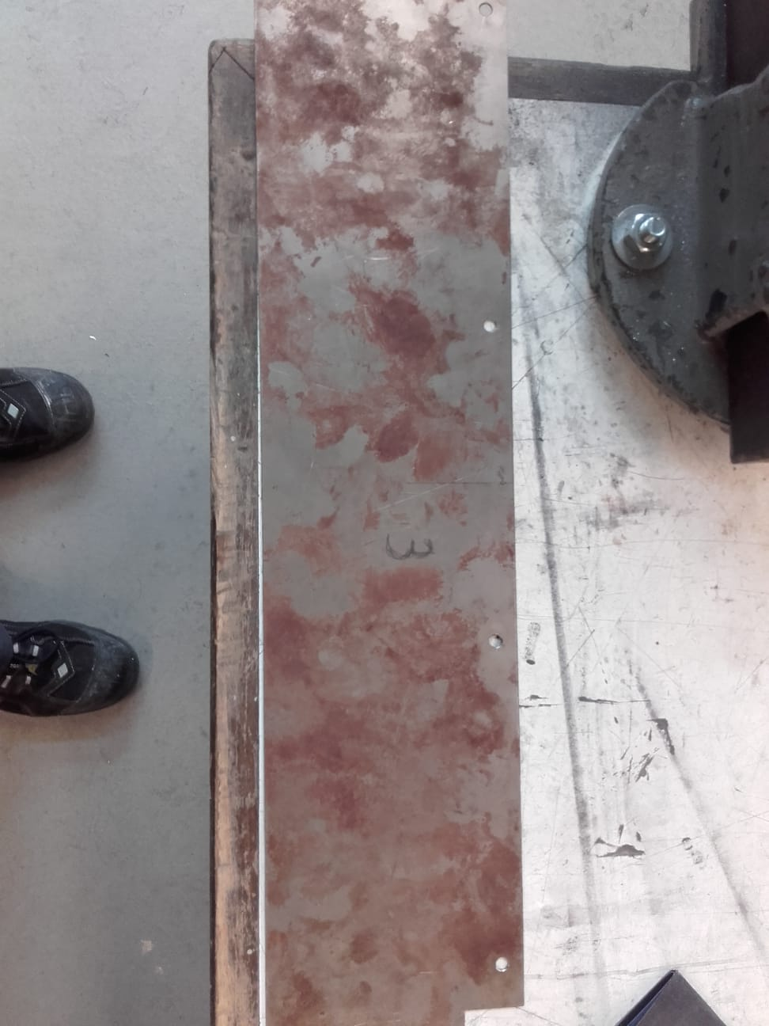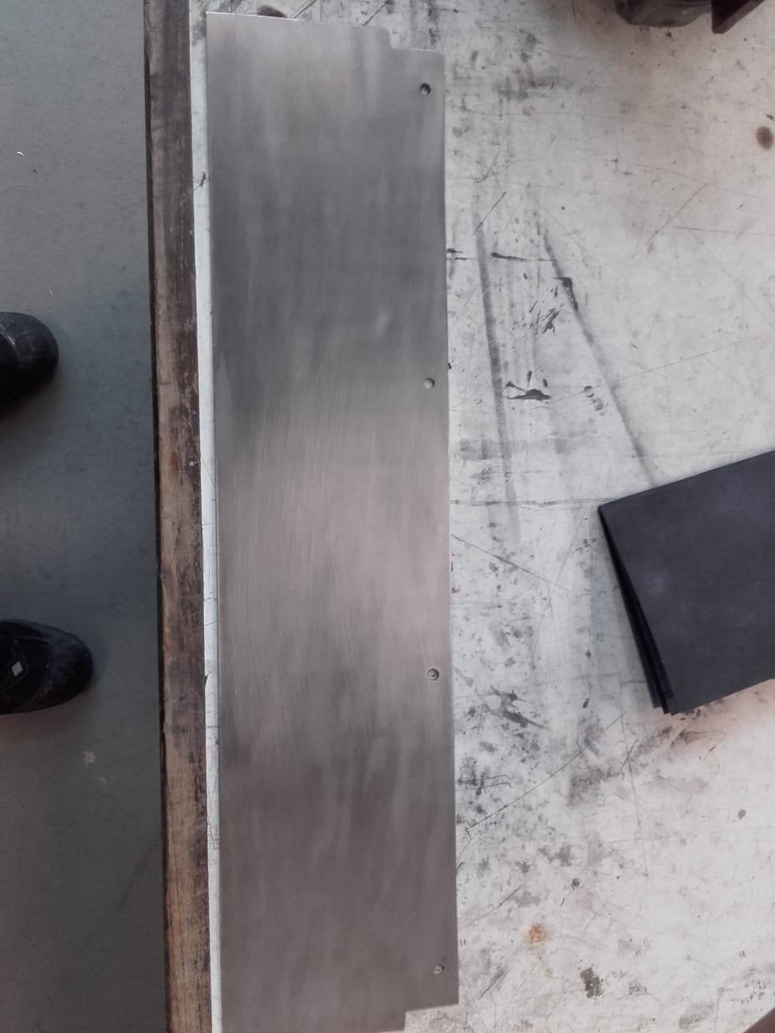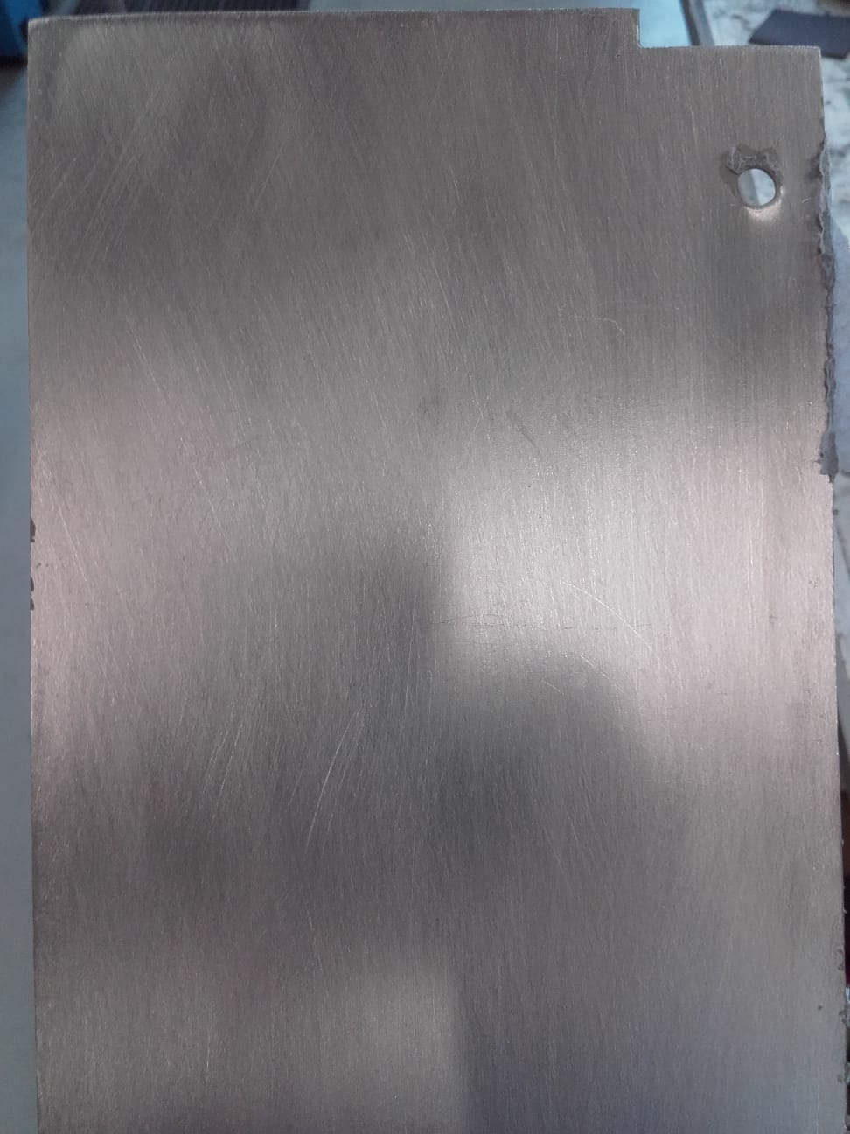

*Figure 9.25­­­: Photos of enclosure plates before (top left) and after (bottom left and right) sanding*

After degreasing with acetone, the plates were painted on one side with a brush. However, within minutes of painting, spots of rust started to develop and form all over the painted surfaces.

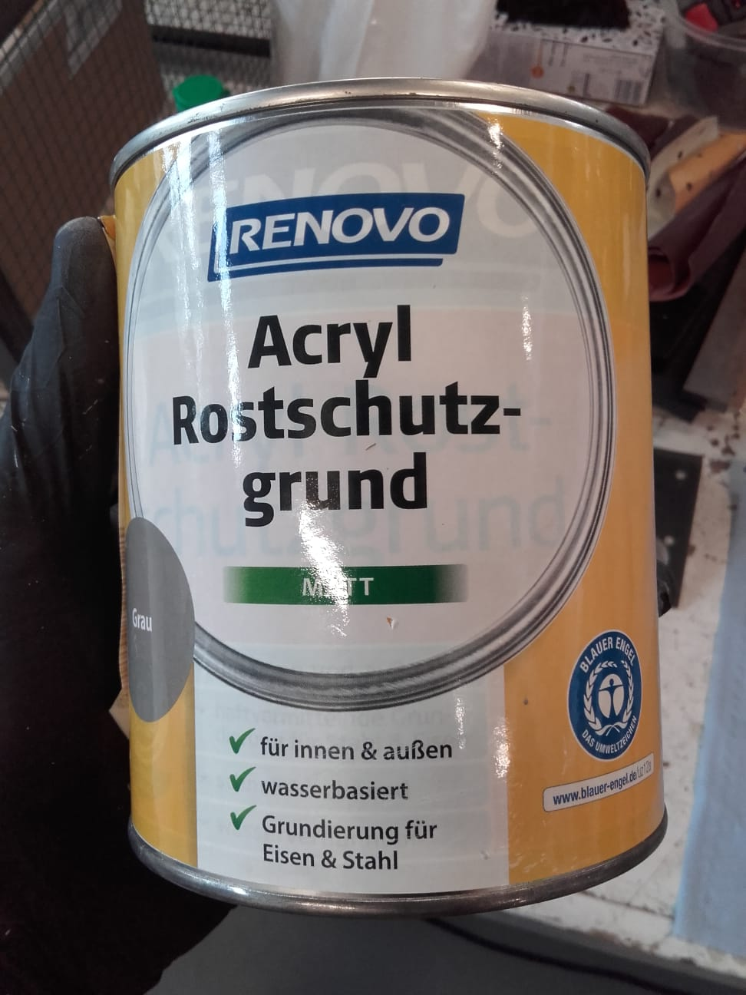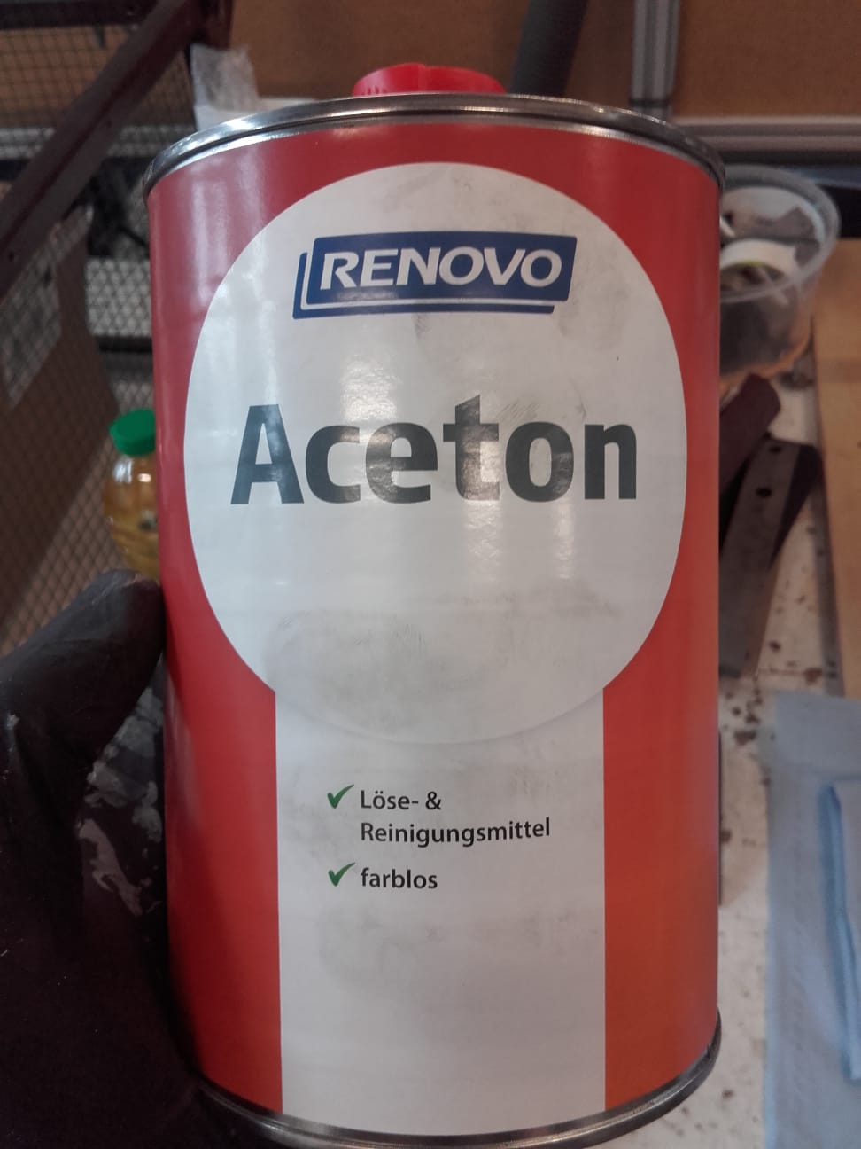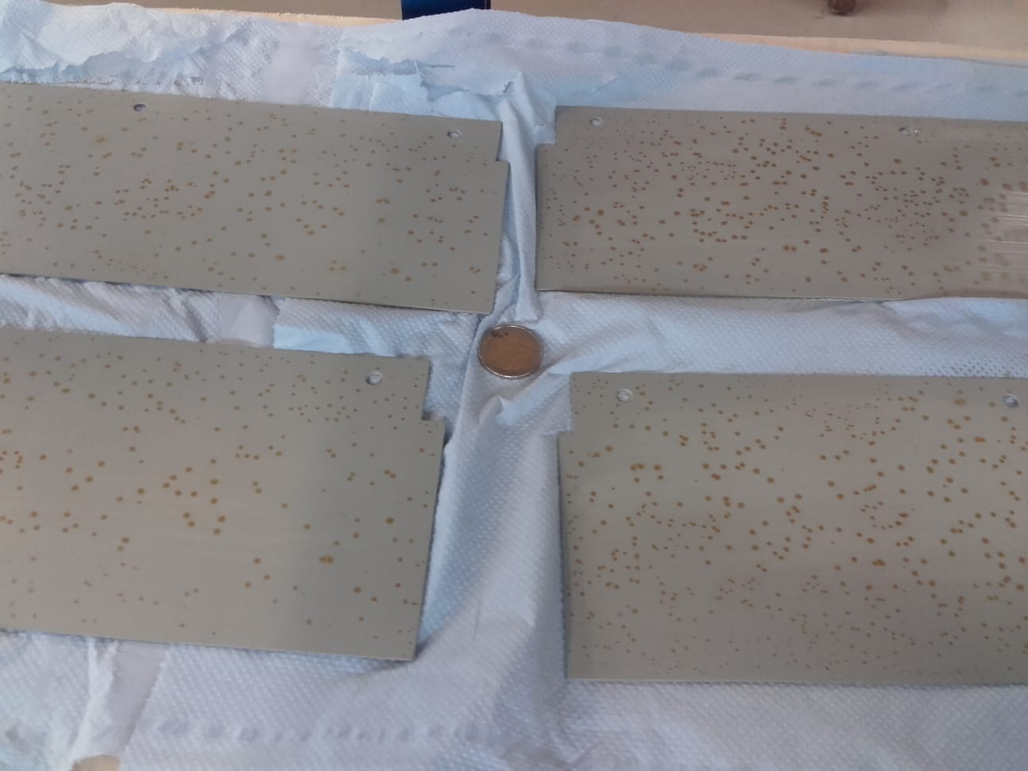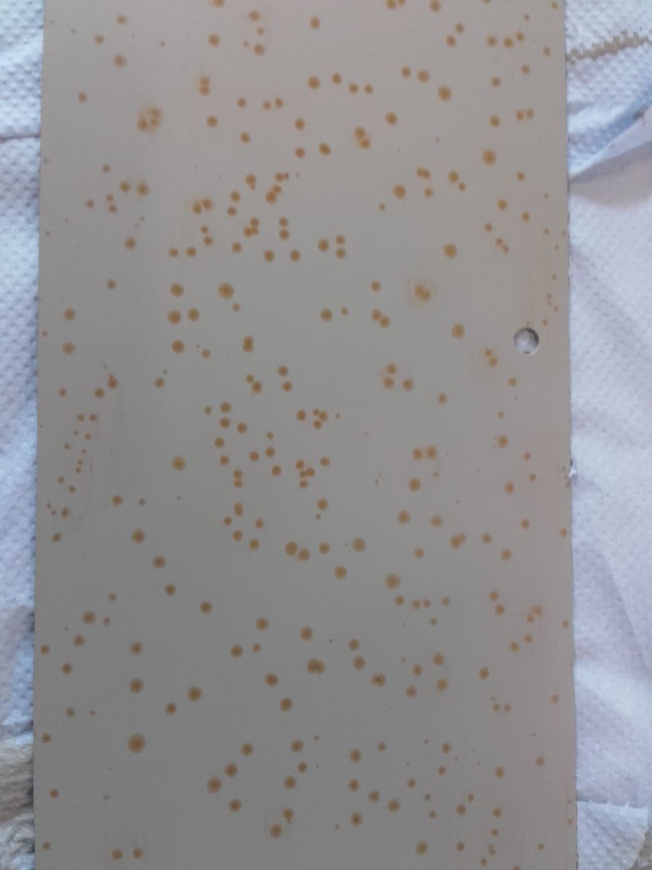

*Figure 9.26­­­: Photos of the paint and degreaser that was used (top left) and the rusty spots after the paint dried (bottom left and right)*

A few things could have gone wrong, but the most likely cause is that the paint we bought had been sitting on the shelf too long to be good anymore. A few chemistry-based options were briefly considered, but in the end, all the steel parts of the enclosure were professionally painted to prevent corrosion.

## Final Assembly

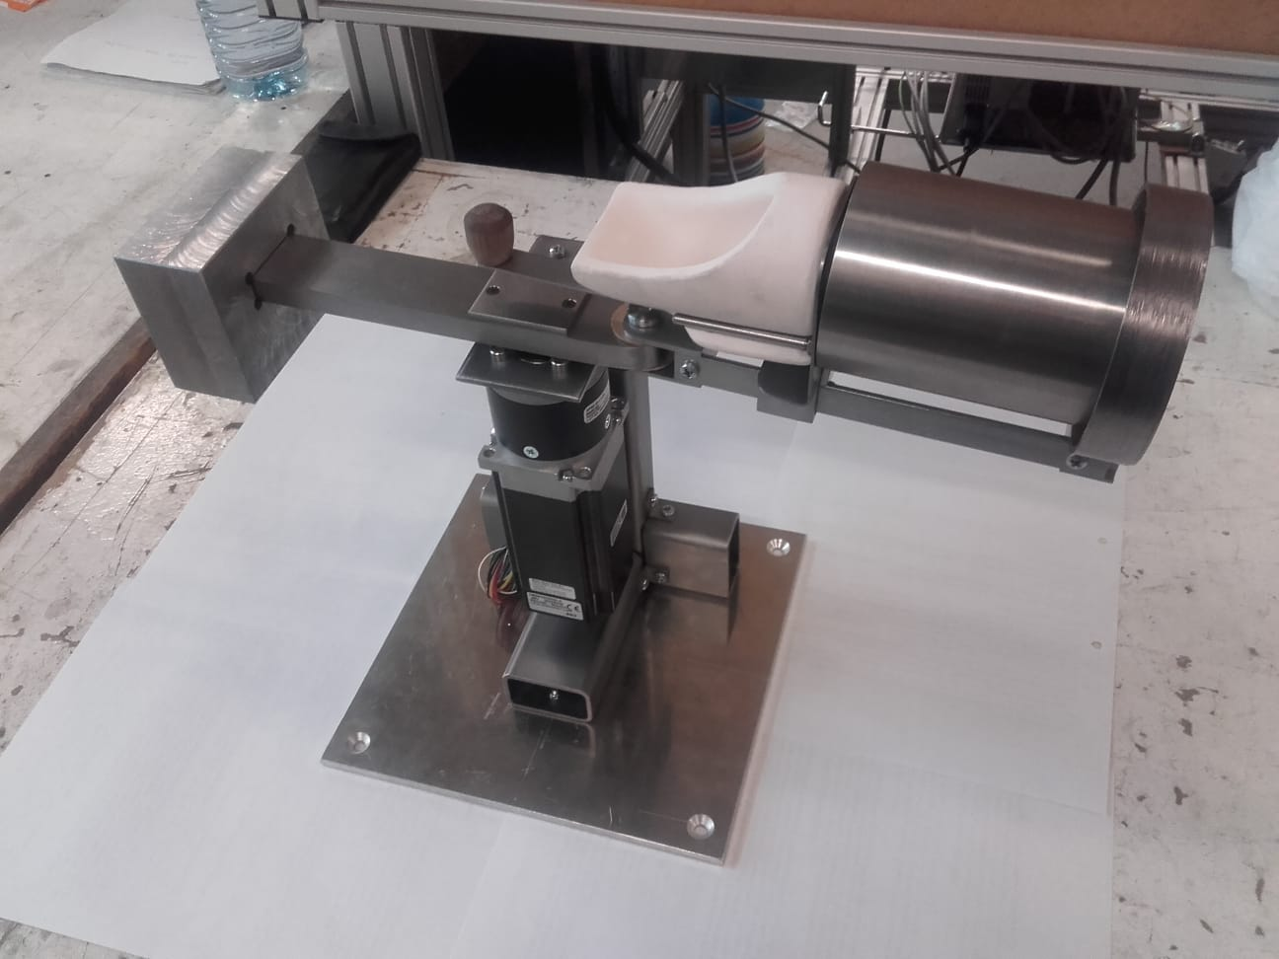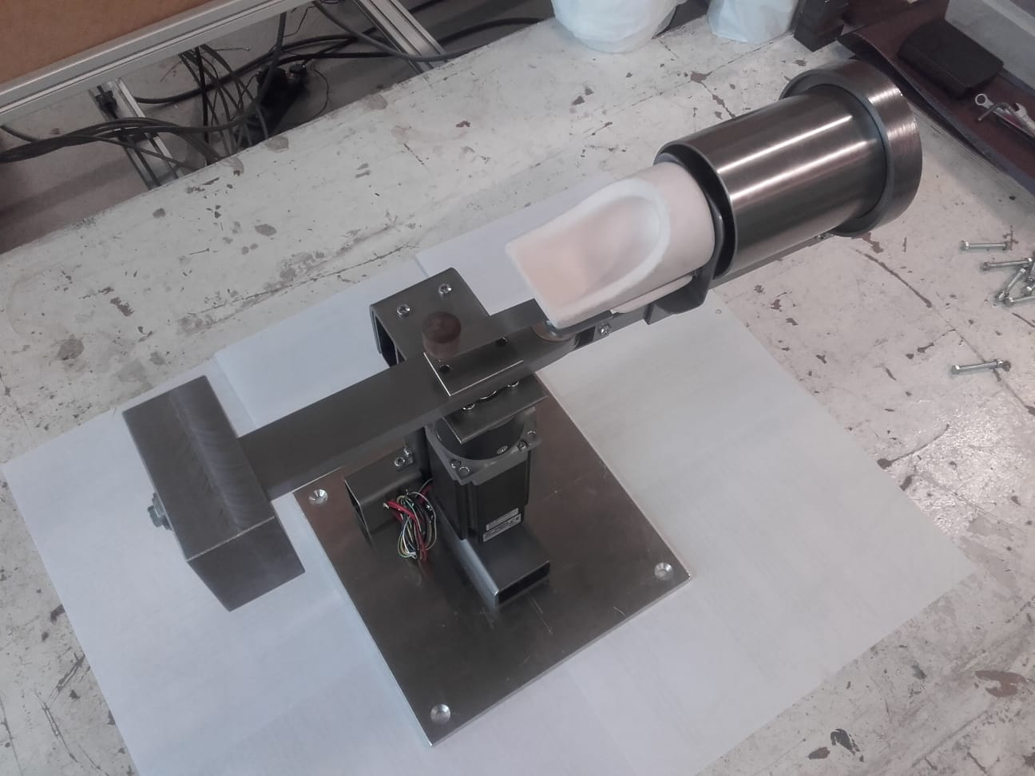

*Figure 9.27: Photos of assembled casting arm and machine base*

# Macintosh HD:Users:hinkleaj:Desktop:Thesis:Diagrams, Pics & Tables:Final pics for Construction:c5381ecb-9b4c-4ef0-a52a-c314c4b97af5.jpg

*Figure 9.28: Photo of fully assembled casting machine*

# Macintosh HD:Users:hinkleaj:Desktop:Thesis:Diagrams, Pics & Tables:Final pics for Construction:dcab8470-bf0a-4649-9aa2-6aaa48bba165.jpg

*Figure 9.29: Photo of fully assembled casting machine with enclosure lid open*

# Chapter 10. DISCUSSION

Overall, I think the project went well. I didn’t have time to do everything I wanted, but I am satisfied with the final result and I am looking forward to the investment casting process and to finally using the casting machine.

## Was the Spec met?

When creating the timeline for this project, I significantly overestimated the amount of access to the lab I would have. Because of coronavirus, I was unable to get into the lab for the first half of the project; this resulted in me doing a lot of unnecessary calculations, CAD work and documentation for parts and features that would not exist in the final iteration of the design. Furthermore, I wasn’t expecting that my time in the lab would be limited by the availability of supervision or that my progress would be so slowed by my own learning curve. I was originally hoping to be able to fabricate all of my parts in two or three 60-hour weeks. Instead, the fabrication was spread out over 11 weeks and the machine was barely assembled and tested before the final deadline. Because of this, finite element analysis of the final design as well as condition monitoring of the machine itself, became impossible.

There was also a problem with the motor and gearbox configuration that we ordered. Apparently, the gearbox failed the internal quality control and so would not have been available until mid December (two and a half months after the deadline for the project). Unfortunately, this information – hidden in the fine print – was not noticed when the purchase was made, so we waited six weeks for a motor that essentially wasn’t coming. Upon realizing the reality of the situation, a motor configuration with a new gearbox was immediately ordered, but the new gearbox (a 7:1 ratio rather than the original 8:1) changed the rotation speed and torque output of the drive shaft to levels outside the acceptable range. To solve this problem, a controller had to be included in the design as well. The controller allowed us to modify the pulse width, which changed the rotation speed by limiting the voltage to the motor; and to adjust the current at the new voltage so the torque requirements could be met. The ideal operating point of the casting machine was dialed in using a laser rotation counter.

Once the motor and controller are functioning properly, there may still be one final problem. Because I have made the machine out of mystery steels with varying densities and elastic moduli, I cannot trust my calculations for the natural frequency. If the natural frequency is near the driving frequency from the motor, then the machine will resonate and vibrations could increase in amplitude until the point of failure. I found a free smart phone app that does a Fast Fourier Transform of an audio signal in real time. There is a considerable amount of background noise in the lab, but I did a few small tests and according to the app, the frequency with which the machine vibrates when struck with a hammer (its natural frequency) is approximately 170 Hz. This is well above the driving frequency of only 5.83 Hz. The app may not be perfectly reliable and analyzing the audio signal is not quite as clear as analyzing the acceleration response would be, but I think we are safe enough to operate it. In case the app is completely off the mark, I may need to alter the stiffness or the mass of the machine to shift the natural frequency away from the driving frequency.

## Limitations of the Design

The most significant limitation built into the design is the rotation speed. Due to the bolted connection between the flask cradle and cradle base, rotation speeds in excess of 375 RPM are not permitted. If there is sufficient demand for higher rotation speeds someday, these parts may be replaced with a casted or welded part that may increase this limit. At that time, the calculations can be rechecked to find and possibly address the next weakest link.

The next limitation is the maximum amount of metal than can be casted at once. The casting machine is limited in the size of the flasks that it can receive, the volumetric capacity of the crucible, as well as by the stresses that are induced by the spinning mass during the dynamics of casting. The maximum size of the casting flask cannot be adjusted without remaking the slider bars and the enclosure. However, the maximum mass (and subsequently the limiting stresses) could be increased as long as the rotation speed is also adjusted to accommodate the change in the centrifugal force. It is worth noting that the centrifugal force is proportional to the product of the mass and the *square* of the rotation speed. This means that a small reduction in the rotation speed would result in a relatively significant increase in mass allowance, if the centrifugal force were to be held constant.

There are also a few minor safety considerations that limit the use of the machine such as cord-management and placement in the lab (juxtaposed with the kiln) during casting. More importantly, the casting process is limited by the casting procedure document. As there are so many variables and potential dangers during casting, neither the safety of operators nor the equipment can be ensured unless there is strict adherence to the procedures and protocols that have been laid out.

## Relevance to HSRW

According to DIN 8580, there are six main categories of manufacturing technologies. This project used technologies from five of those categories to create a machine designed for the sixth. *Disaggregation* is the first category and it was the main focus of the fabrication process. Several disaggregation technologies were used on nearly every part of the machine including cutting surfaces with both defined cutting edges (milling, turning, sawing, broaching, etc.) as well as undefined cutting edges (grinding, sanding, etc.). To represent the second category, *deforming*, there were the several bends of various angles that were needed for fabricating the slide assembly and the machine base assembly. *Joining* is the third category. This project includes an epoxy joint, a couple welds and almost 200 bolted connections of various sizes and for various purposes. The fourth category is *coating*. The paint on the enclosure and the oil quench for the casting arm and machine base assemblies belong in this category. One might expect the oil quench to be in the fifth category, *changing material properties*, but for this project, the quench was not a true quench since it was not done at high enough temperatures to change the properties of the materials. Technically, the type of oil quench done for this project is known as “heat coloring” or “hot bluing” even though it was done here for the purposes of corrosion prevention rather than to color the parts. However, the subsequent tempering, that was done to remove any of the residual manufacturing stresses in the parts, does in fact belong in the fifth category. And with all of those forces combined, a machine was created that will allow future students another opportunity to experience the final category, *shaping*.

This project has also included elements from a large number of the courses in my bachelor studies. The relevance of courses such as Mechanics, Manufacturing Technology, Physics and Project Management seemed obvious at the onset, but there were also unexpected aspects from courses such as Creativity and Technical Drawing that were surprisingly relevant. The approaches in my calculations were heavily dependent on my Engineering Design classes and even Thermodynamics and Drive Systems had their moments before the project was over. Of course, none of it would have been possible if I had not learned a great deal in the materials courses I have taken. Both Metallic Materials and Non-Metallic Materials were hugely helpful for this project. Finally, this project legitimately included hundreds of hours of CAD modeling and simulation and remodeling and more simulation. I think the relevance of this project with respect to the mechanical engineering curriculum at HSRW cannot be overstated.

## Going Forward

The final task that must be completed before the casting process can be tested is the acquisition of a new burnout kiln. At 1000 – 1500 euro, the cost of this piece of equipment is hardly negligible. However, since the kiln requirements for burnout are relatively high, any kiln that works for casting, will also work for a large variety of potential engineering projects from normalizing and tempering metals to enameling and firing ceramics as well as functions such as sterilization and dehydration. Beyond simple safety considerations, the applications are limited only by the imaginations of the students and the willingness of their supervisors to allow exploration.

The Enspire Lab now has a centrifugal casting machine. Some decisions will need to be made in terms of how it can be safely mounted for use and stored during disuse, but the machine is built and is functional. I will be the first to test the casting machine and process (hopefully in the next month), but it should be available for other student projects immediately after that. I made a scale CAD model of a Lego man for testing. I would like to 3D print the pieces in plastic, clean them up using the various modeling waxes and tools we recently acquired, and then cast them in sterling silver. I will take pictures of the process so more of a pictorial element can then be added to the casting procedure document. Hopefully this will reduce future confusion.

One major advantage of the new machine, over other competitively priced commercially available options, is the fact that the new machine uses a motor and a controller for power rather than a spring. This means that, unlike other models, the powering of our machine can be tailored to any specific application we choose, instead of the one-size-fits-all power delivery that comes from a torsional spring. The torque and rotation speed can be adjusted to match any casting metal perfectly. This will reduce wear and fatigue in the machine, but it will also allow us to tweak the process as the successes and failures of casting become apparent over time. I have yet to see this feature on a centrifugal casting machine that retails for less than 5000 euro.

# References

1) Centrifugal and Vacuum Casting for Jewelry: A Step-By-Step Guide. (2020). Retrieved May 29, 2020, from https://www.gensociety.org/article/lost-wax-casting/

2) Dentsply Neytech. (2003). Neycraft Centrifugal Casting Machine. Owner and Operator’s Manual. Burlington, NJ: Author

3) Gainsbury, P. E. (1979). Jewellery Investment Casting Machines. Gold Bulletin, 12(1),2-8. doi:10.1007/bf03215098

4) Sias, F. R., Jr. (2005). Lost-wax Casting: Old, New and Inexpensive Methods. Pendleton, SC: Woodsmere Press.

5) UltraFlex Power Technologies. (2010). UPT-017-300/400-00. Operation Manual. Ronkonkoma, NY: Author

6) Samuel, A. M., Mohamed, S. S., Doty, H. W., Valtierra, S., & Samuel, F. H. (2018). Effect of Melt Temperature on the Effectiveness of the Grain Refining in Al-Si Castings. Advances in Materials Science and Engineering, 2018, 1-11. doi:10.1155/2018/7626219

7) Fischer-Bühner, J. (2007). Advances in the Prevention of Investment Casting Defects Assisted by Computer Simulation. Schwaaäbisch Gmünd, Germany: The Research Institute for Precious Metals (FEM).

8) Campbell, J. (2015, 2011). Complete casting handbook: Metal casting processes, metallurgy, techniques and design (2nd ed.). Waltham, MA: Elsevier.

9) Kisters, P. (2019, February 18). Mechanical Engineering Design [PDF]. Kleve, NRW Germany: Hochschule Rhein-Waal.

# APPENDIX A

## Investment Casting Process and Procedure

Read this entire document before beginning the casting process. During casting, time is of the essence and inadequate preparation can be dangerous, so familiarity with the steps, variables and potential problems is necessary BEFORE the practical application begins. Trial runs should also be completed for each group of tasks to ensure that tools, surfaces, walkways, etc. are as they should be before introducing elements with time limits or inherent danger.

Furthermore, casting is cool and fun to watch…so the process inevitably attracts an audience. It is the responsibility of the person who is casting to regulate spectators in such a way that the casting process remains safe for everybody in the workshop.

Finally, there is a LOT to know about investment casting. The reader should not take this document as a comprehensive source of information, but rather as a guide for safe casting specifically in the Enspire Lab. There are many books and websites that discuss this topic in much higher detail and the reader is encouraged to seek them out.

**Table of Contents**

**Investment Casting Process and Procedure i**

**Equipment and Supply List ii**

Wax forming ii

Investment preparation ii

Burnout iii

Casting iii

Finishing iii

**Step-by-Step Procedure iv**

Preparing the Mold iv

Burnout viii

Casting ix

Melting Temperatures and Specific Gravities of Common Casting Metals xi

References xii

**Equipment and Supply List**

**Wax forming**

Materials

* Sprue wax

Basically any wax that is designed for lost-wax casting

*Others leave kiln-damaging carbon residues during burnout

* Tacky/ Sticky wax
* Sculptor’s wax
* Purple wax (purple buildup)
* Several commercially available SLA, SLS, or MJP 3D printing plastics designed for no residue during burnout

**Same problem as with wax: carbon buildup causes short-circuits that will kill the kiln over time

Tools

* Hand tools (exacto knives, dental tools, clay sculpting tools, etc.)
* 100mm (4") Depth Saw Frame
* Rubber sprue base(s) for investment flask(s)
* Hot-glue gun
* Digital scale

**Investment preparation**

* Rubber mixing bowl
* Investment material
* Investment flask(s)
* Latex gloves for handling the investment material (silica)
* Eye-protection for handling the investment material (silica)
* Dust mask for handling the investment material (silica)
* Measuring cup or beaker for water
* Scale to weight dry investment
* Vacuum chamber with bell jar big enough for largest flask
* Digital timer with large readout (investment material must be mixed, degassed, poured into flask and then degassed again—all within ~8 minutes)
* Wide masking tape or cellophane tape

**Burnout**

* Kiln capable of running at 800°C for up to 13 hours (must be near casting machine)
* Steel tray and a couple fire bricks to go under flask(s) to catch melted wax
* Some kind of ventilation to vent harmful fumes and to move oxygen through the kiln so the burned out carbon can form CO2 and escape the kiln
* Timer and attention for burnout schedule

**Casting**

* A friend or colleague to assist and supervise
* Leather Gloves
* Casting safety glasses No. 5
* Iron Tongs
* Oxygen/Acetylene torch
* Rosebud torch tip
* Flint striker
* Casting material (chips or pellets small enough to fit in crucible)
* Water bucket for quenching finished part
* Toothbrush for cleaning off residual investment material

**Finishing**

Depends on the casted parts, but probably includes: rotary tool with metalworking accessories, jeweler’s saw, metal files, grinding wheel, sandpaper of various grits, steel wool

**Step-by-Step Procedure**

**Preparing the Mold**

1. Sculpt desired parts (henceforth called “models”) from wax or 3D-print them from kiln-safe plastic. Check the models carefully for any defects and repair them if needed. The more finished the model, the less cleanup the finished casting will need. Model materials are significantly easier to work on than metal.
2. Weigh the appropriate rubber sprue base and record the weight.
3. Set the rubber sprue base on a flat surface and insert the sprue wax. Melt wax where the sprue wax and the sprue base meet. Use the alcohol lamp and a large sewing needle stuck into the end of a wooden dowel or pencil. Heat the needle and use it to melt and apply the wax.
4. Mount a small sprue onto the model, preferably in a spot that won’t be problematic on the finished piece (see figure). Put a fillet of wax where the sprue is attached to the model.

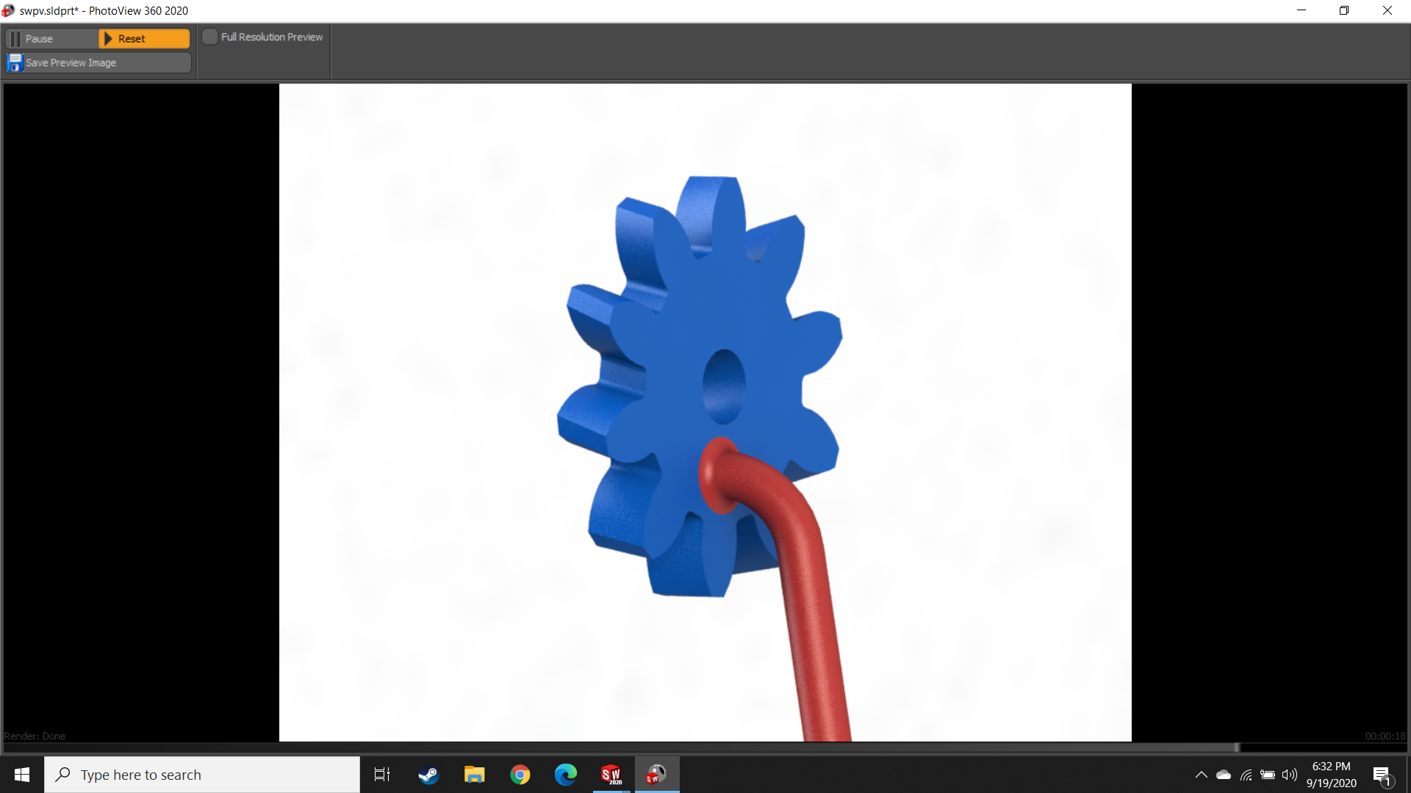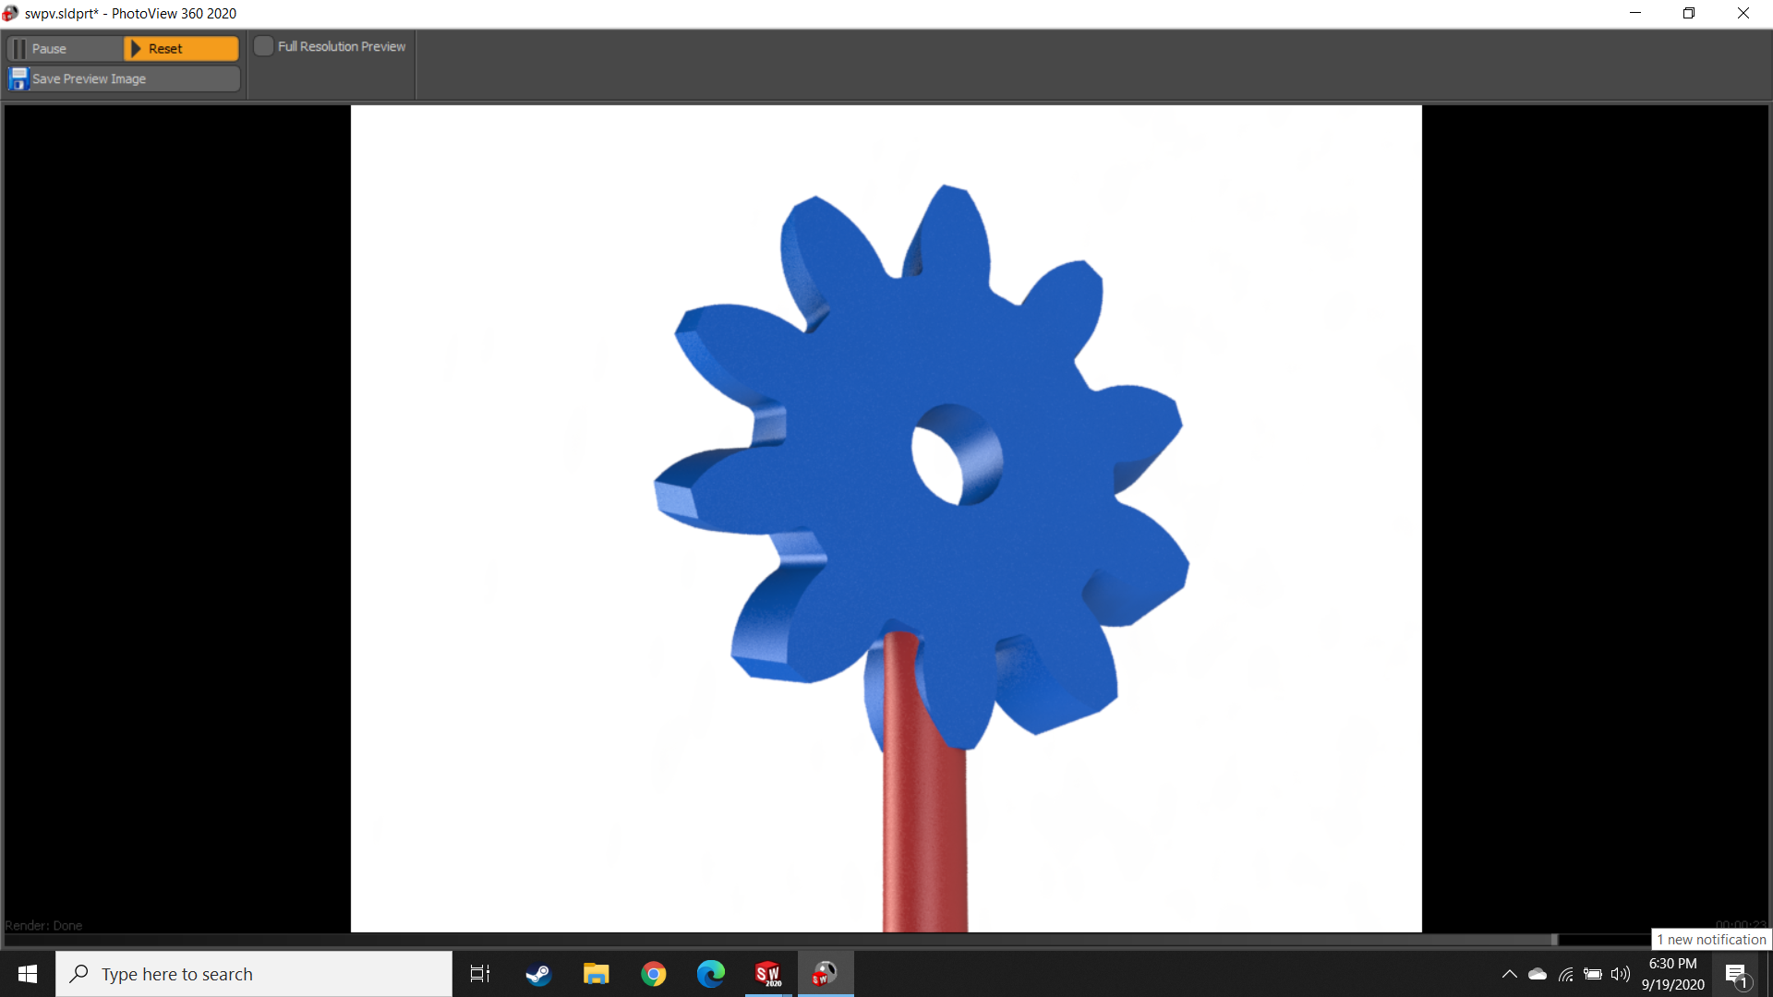

Bad sprue:

sprue interferes with desired

geometry of casted component

Good sprue:

sprue does not interfere with desired

geometry and can be easily removed

1. Secure the sprued model to the tree. Keep the sprue for the model as short as possible. The sprued model can be attached with “sticky wax” or by using the hot needle again. Put a fillet of wax where the model sprue and the tree meet. When spruing multiple models, start from the top of the tree and work toward the base. Keep the models and sprues a minimum of 3 mm apart from each other. Periodically check for at least 10 mm clearance between the models and the flask wall and always be sure there is enough room for at least 15 mm of investment material above the top of the mold tree (see figure)

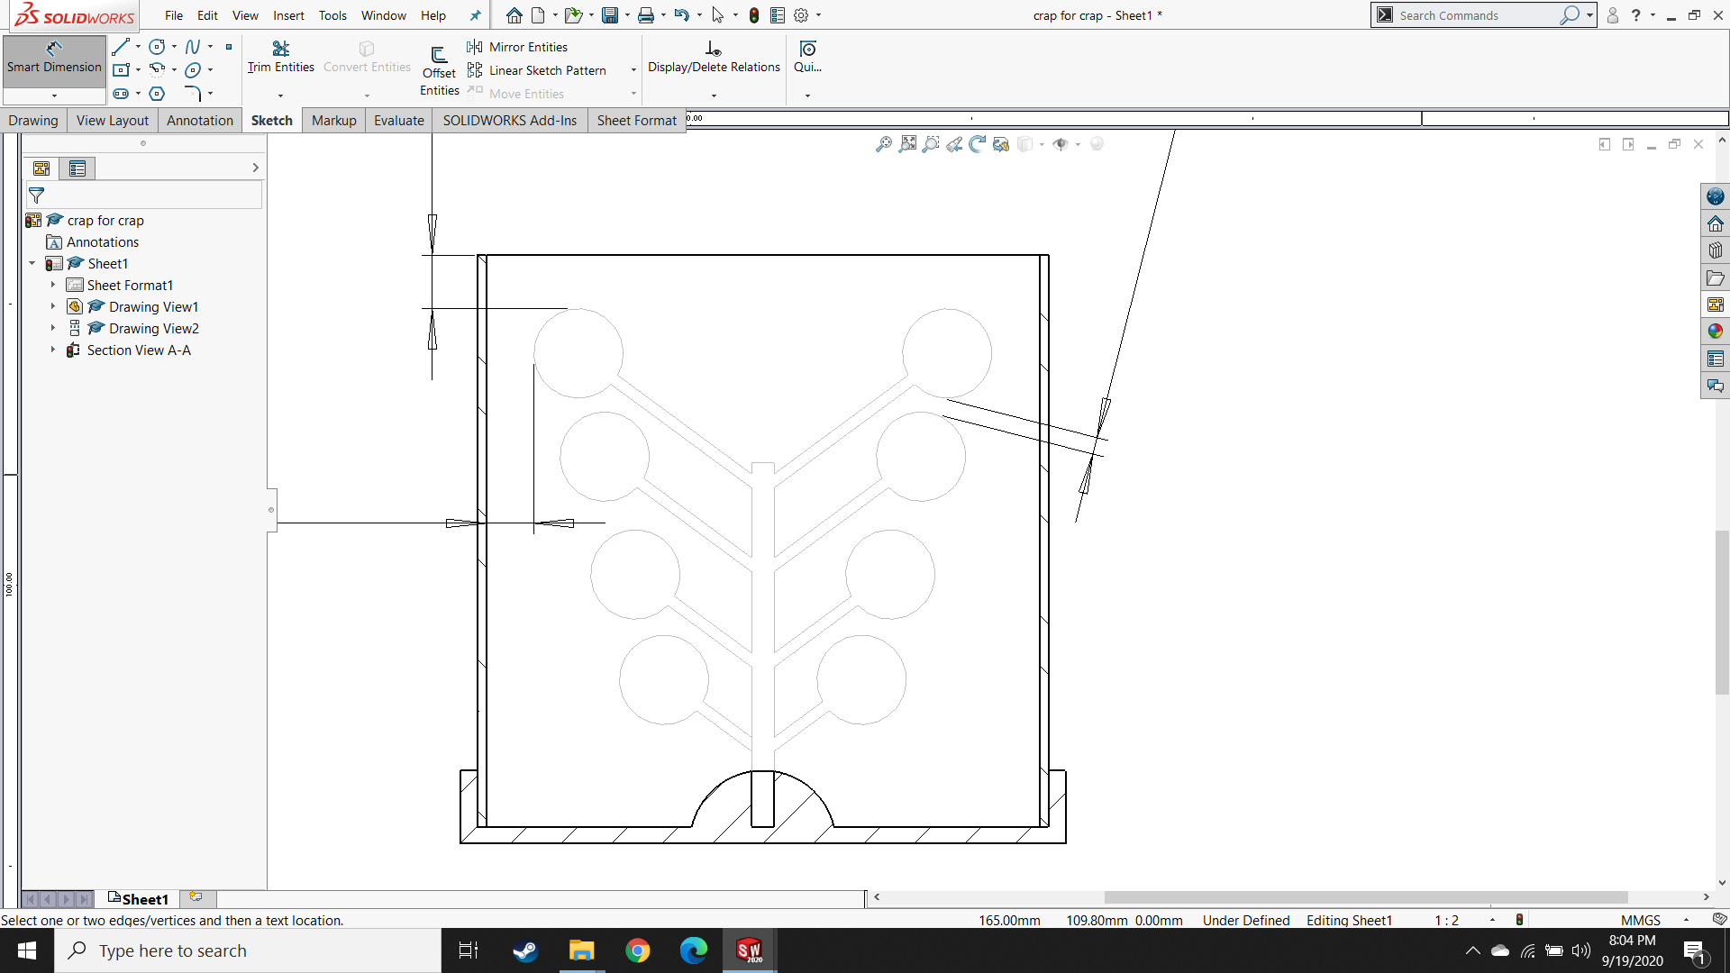

$$≥3 mm$$

$$≥15 mm$$

$$≥10 mm$$

Mold Tree

Sprue Base

Casting Flask

Since casting is time-consuming, there is pressure to cast as many parts at once as is possible. However, if the resulting mold cavity is too large, the mold will have insufficient structural integrity and the casting will fail.

1. Now weigh the fully sprued base. Subtract the weight of the sprue base recorded in step 2 and you have the weight of your models and sprues. Weigh out the appropriate amount of casting metal while keeping in mind that the maximum mass of casting metal allowable for the casting machine is 255 g. Once the metal is weighed out, set it aside until casting. The quantity $Q$ of metal that will be needed is:

$$Q=W•G_{W}•G_{M}+15.55 g ≤255 g$$

with

$W$: Weight of models and sprues in grams

$G_{W}$: Specific gravity of wax or other model medium

$G_{M}$: Specific gravity of metal being casted

$15.55 g$: Additional material added to fill “button” = 10 pennyweights

Note: Use metal that hasn’t been melted since leaving the refinery or metal that has only been melted once (such as old buttons and sprues), plus at least 50% by weight of new metal. Cast sprues and buttons can be recycled twice for casting material.

1. Put the flask and sprued base back together and check clearances a final time. Wrap upper lip of flask with wide masking or cellophane tape and set aside until you are ready to pour the investment material.

(Photo coming soon)

1. Instructions and proper proportions for mixing the investment material are included with the investment. Always add water to the rubber mixing-bowl first, and THEN add the investment powder to the water. Mix the investment for about 3 minutes until it’s just beyond the consistency of pancake batter and it has no remaining lumps.

Data for SRS CLASSIC™ Investment powder:

Powder / Water Ratio: 100/38-40  
Working Time @ 22°C Slurry Temp: 8 min.

Note: Cristobalite, an ingredient in the investment material, is a known carcinogen and may also have the potential for causing reproductive damage in humans. Furthermore, chronic inhalation of cristobalite can lead to a serious lung disease known as Silicosis. Gloves, eye protection and respiratory protection are required while handling the investment material in its powdered form. See MSDS for more information.

Note: The working time of the investment material is 8 minutes and it will spend about half of that in the vacuum chamber. This means there isn’t much time for pouring and there is essentially no time for mistakes. Proper attention must be paid during steps 8 – 11!

Note: Tap water should work but reverse osmosis water works better. If tap water is used, let it stand for at least one hour to allow the air to dissipate and the temperature to stabilize between 21 and 27 °C. Warmer water will accelerate the setting time of the investment.

1. Once the investment is mixed, place it on the vacuum machine. Put the bell jar over the bowl and turn on the vacuum. The investment will boil and turn frothy. Here, the purpose of the tape that was applied to the flask in step 7 becomes apparent. Vacuum for approximately 60 seconds

(Photo coming soon)

1. While tilting the flask to ensure maximum coverage of the model, slowly pour the investment into the flask until it is full. Rotate and tap the flask to decrease the likelihood of cavities and bubbles. For very intricate models, it is a good idea to paint the investment into the details with a paintbrush before pouring.

Note: If you don’t have enough mixed investment to fill a flask completely, dump it out and mix more. Do not use more than one pour to fill a flask.

1. Vacuum the filled flask the same way as the mixing bowl in step 9, but this time for 2 minutes. Once the vacuuming is complete, the flask can be set-aside on a flat surface and the 8-minute deadline for working with the investment material is over.
2. Let the filled flask set for 90 minutes and then remove the tape and sprue base by gently twisting it. Let it set for at least another 30 minutes.
3. The flask is now technically ready for burnout, but BEFORE burnout begins, the casting arm of the centrifugal casting machine must be balanced using the appropriate counterweight and spacer. The appropriate flask support spacer should also be placed on the slider bars to ensure the flask will remain level during casting.

Note: this step is difficult and dangerous to do with a hot flask so make sure it is done before the flask goes into the kiln!

**Burnout**

Burnout is the process through which all traces of the wax are eliminated from the kiln, but it also gradually removes the chemical moisture from the investment material and brings the temperature of the mold up to the proper level to receive the molten metal. This part of the procedure is time consuming and can damage the kiln if not done properly, so attention is necessary.

1. Before putting the flask into the kiln, make sure the bottom of the kiln is protected by a steel tray or by ceramic tiles with grooves to catch and hold the wax until it vaporizes. Do NOT let the wax melt directly onto the bottom of the kiln!
2. Put the flask into the cold kiln and follow the burnout schedule provided with the investment material. The burnout schedule for SRS CLASSIC™ Investment powder is as follows:

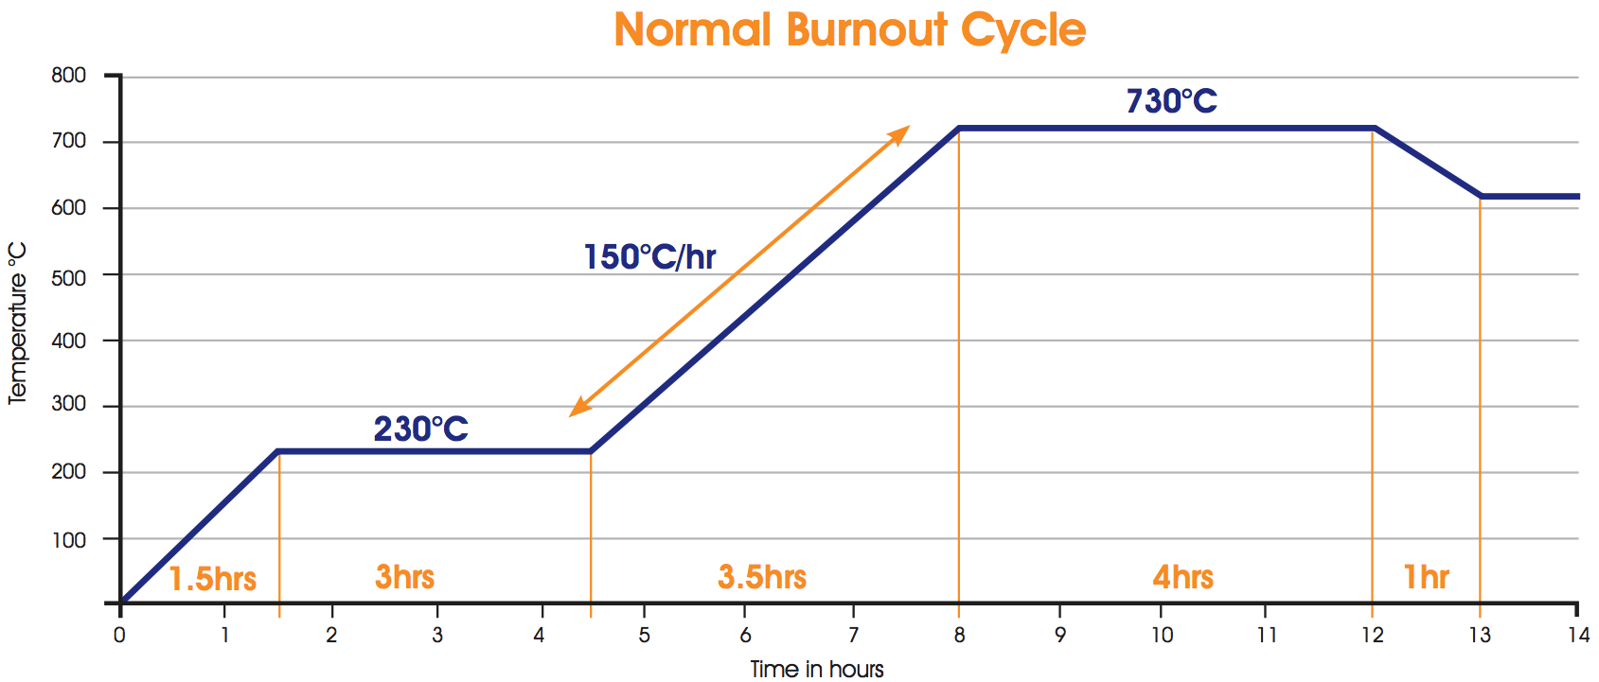

150°C below melting

temp of metal

Note: For the first 1.5 hours, the sprue should be pointing downward to allow wax to escape. Then, flip the flask every couple hours for the rest of the burnout cycle.

1. Do NOT remove the flask from the kiln to cast until it has been held at the casting temperature (150°C below melting temp of metal) for a minimum of 1 hour. If held for less than 1 hour, the core of the flask will be at a higher temperature than the readout on the kiln says and this can result in metal-mold reaction (failed casting).
2. When you are ready to begin casting, turn off the kiln. This way you won’t have to think about it in a few minutes when you remove the hot flask.

**Casting**

Before beginning, visually inspect the casting machine for damage or corrosion that may impact its functionality. Make sure the machine is clean (with nothing stacked on top or inside of the enclosure) and free of debris. Make sure moving parts rotate or slide easily and make sure that bolted connections are tight. Securely clamp or bolt the casting machine to the workbench and, with the power supply OFF, plug the power supply into the wall. With the lid of the enclosure OPEN, turn on the power supply and make sure it is set to the appropriate settings for voltage and current and then turn it off again until you are ready to cast.

1. Light the torch with the rosebud tip while following the torch’s SOP and taking all relevant safety precautions.
2. With the articulated arm of the casting machine bent to the 90° position. Add some borax flux powder to the crucible and heat the crucible until flux starts to glaze (about 30 seconds) and then add the casting metal weighed out in step 6.

(Photo coming soon)

1. Continue heating the casting metal while moving the torch around and occasionally stirring/ flipping the chunks with a carbon or ceramic stirring rod.
2. When the casting metal is nearly melted, set the torch safely aside. Take the hot flask from the kiln using steel tongs and place it into the flask cradle of the casting machine. Make sure the flask is aligned in the appropriate hole in the flask cradle in the back, and resting on the appropriate flask support spacer (chosen in step 13) in the front. Then slide the crucible up to the flask opening.

(Photo coming soon)

1. With the lid of the enclosure still open, turn on the power supply. Now the machine is “armed” so to speak. Simply closing the lid will now trigger the motor to rotate.
2. Continue heating the casting metal with the torch while stirring regularly and checking for lumps. Slide any impurities to the side of the crucible farthest from the flask mouth. Do NOT boil the metal. If the melt begins to boil, add a bit of flux and back off with the torch until the melt cools down some.
3. When the metal is liquid, make sure once again that the machine is free of all debris, fingers or tools; remove the torch and immediately close the lid of the enclosure to activate the rotation of the motor. Let the motor run for 2 minutes and then turn off the power supply. Do NOT open the lid of the enclosure until the casting arm has stopped rotating.
4. The casting flask and crucible are still very hot. Do NOT touch the flask or any part of the machine. Let the flask sit in the casting machine until the button cools down to a dull red color.

(Photo coming soon)

1. Using the iron tongs once again, remove the flask from the casting machine and quench it in the bucket of water, sloshing it back and forth. The water will remove the investment from the casting, but wait to retrieve the casting from the bucket, as it will still be hot.
2. You now have an ugly chunk of metal covered with investment and black oxidation. Scrub the remaining investment material off with a toothbrush, cut the sprues off of the model(s) and finish the piece(s) by pickling, soldering, filing, and polishing.

(Photo coming soon)

**Melting Temperatures and Specific Gravities of Common Casting Metals**

|  |  |  |
| --- | --- | --- |
| **Metal / Alloy** | **Melting Range $T_{sol}$– $T_{liq}$ °C** | **Specific Gravity** |
| Aluminum   |  | | --- | | Pure Aluminum | | Aluminum Alloy | | Aluminum Bronze | | |  | | --- | | 660 | | 463 – 671 | | 600 – 655 | | |  | | --- | | 2.55 | | 2.8 | | 7.7 | |
| Babbitt | 249 | 7.27 |
| Beryllium Copper | 865 – 955 | 8.25 |
| Bismuth | 271 | 9.79 |
| Brass   |  | | --- | | Red Brass | | Yellow Brass | | |  | | --- | | 990 – 1025 | | 905 – 932 | | |  | | --- | | 8.7 | | 8.4 | |
| Cadmium | 321 |  |
| Copper | 1084 | 8.95 |
| Gold   |  | | --- | | 18K yellow Gold | | 18K red Gold | | 18K Ni white Gold | | Fine Gold | | |  | | --- | | 900 – 930 | | 890 – 900 | | 910 – 940 | | 1064 | | |  | | --- | | 17.2 | | 17.18 | | 19.25 | | 19.35 | |
| Lead | 327.5 | 11.34 |
| Magnesium   |  | | --- | | Pure Magnesium | | Magnesium Alloy | | |  | | --- | | 650 | | 349 – 649 | | |  | | --- | | 1.738 | | 1.74 | |
| Manganese Bronze | 865 – 890 | 7.44 |
| Selenium | 217 | 4.28 |
| Silver   |  | | --- | | Fine Silver | | 930 Silver | | Sterling Silver | | |  | | --- | | 962 | | 780 – 900 | | 893 | | |  | | --- | | 10.6 | | 10.4 | | 10.5 | |
| Tin | 232 | 7.5 |

**References**

Campbell, J. (2015, 2011). *Complete casting handbook: Metal casting processes, metallurgy, techniques and design* (2nd ed.). Waltham, MA: Elsevier.

Fischer-Bühner, J. (2007). *Advances in the Prevention of Investment Casting Defects Assisted by Computer Simulation*. Schwaaäbisch Gmünd, Germany: The Research Institute for Precious Metals (FEM).

International Gem Society. (2020). Centrifugal and Vacuum Casting For Jewelry: A Step-By-Step Guide. Retrieved September 27, 2020, from https://www.gemsociety.org/article/lost-wax-casting/

Metal Melting Ranges. (2020, August 17). Retrieved September 27, 2020, from https://www.steelforge.com/literature/metal-melting-ranges/

READE Certifications. (2020). Specific Gravity Table for Metals, Minerals & Ceramics. Retrieved September 27, 2020, from https://www.reade.com/reade-resources/reference-educational/reade-reference-chart-particle-property-briefings/25-specific-gravity-table-metals-minerals-ceramics-substance

## SAFE OPERATING PROCEDURE

|  |  |  |  |  |
| --- | --- | --- | --- | --- |
|  |  | | |  |
| Erstellt am:  20.10.2020  Erstellt von:  **Ocean Tech Lab** |  | **Logo Hochschule Rhein-Waal** |
| **Institution: Hochschule Rhein Waal** | | |
| **Machine / Device** | | |
| **Workplace / -area:** | Centrifugal Casting Machine |  |
| **Job type:** |  |
| **Risks for Personnel and Environment** | | |
| File:D-W003 Warnung vor giftigen Stoffen ty.svg | * Injury due to clothing or hair getting entangled in spinning casting arm * Eye or body injury due to ejected materials * Hand injury due to fingers in enclosure while casting arm is spinning * Heat injury due to molten materials or heated casting flask * Spinning molten material can be a fire hazard * Gaseous metal inhalation hazard if casting metal is boiled * Work pieces, crucible and flask will be very hot – risk of burns * Other people could be endangered if enclosure is opened while casting arm is spinning |  |
| **Risk Minimization Procedures** | | |
|  | * Follow instructions in casting procedure manual * Wear eye-protection and heat resistant gloves * As appropriate for the material, wear respiratory protection * Before first usage, obtain appropriate training * Always cast with a partner or supervisor * Balancing of casting arm to be assisted by qualified personnel * Wear tight fitting clothing made of natural fibres while using torch * Long haired operators must wear hair nets * Warn bystanders of dangers * Inform Management immediately of breakages |  |
| **Breakdown Procedures** | | |
|  | * In case of breakdown, stop all work and inform Management * Ensure broken tools cannot be operated until repaired |  |
| **First Aid** | | |
|  | **First Aider: __Prof Megill_____________________**   * In case of accident, shut off the machine * Keep calm * Call for First Aid * Report the accident | **First Aid:  x 299**  **Ambulance:  0 - 112** |
| **Maintenance Procedures** | | |
| M33 | * Maintenance and repair are only to be undertaken by qualified personnel or companies. * Annual electrical inspections (PAT) to be completed by qualified personnel. |  |
|  | | |

Supervisor signature:

# APPENDIX B

## Motor Dimensioning

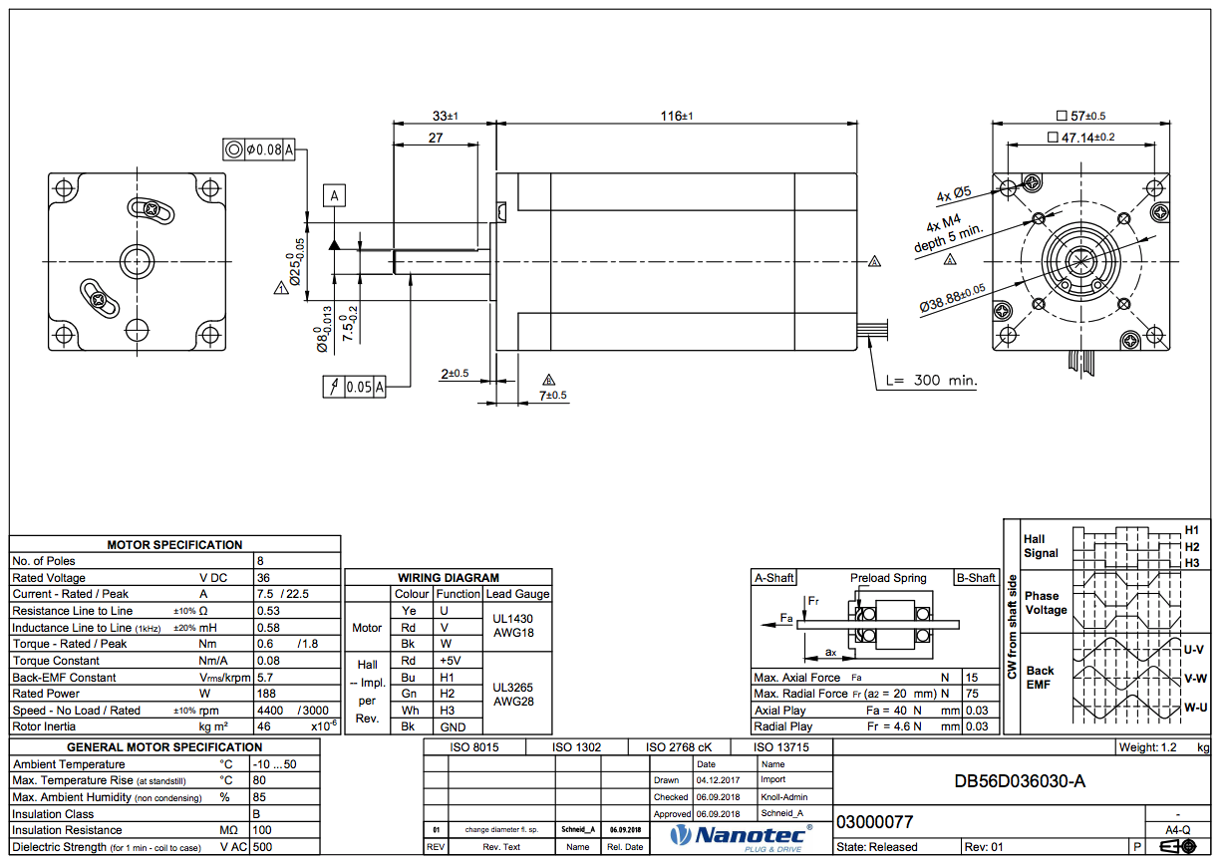

## Motor Product OverviewMacintosh HD:Users:hinkleaj:Desktop:Screen Shot 2020-10-13 at 2.26.44 PM.pngMacintosh HD:Users:hinkleaj:Desktop:Screen Shot 2020-10-13 at 2.26.57 PM.png

## Gearbox Dimensioning – Technical Information

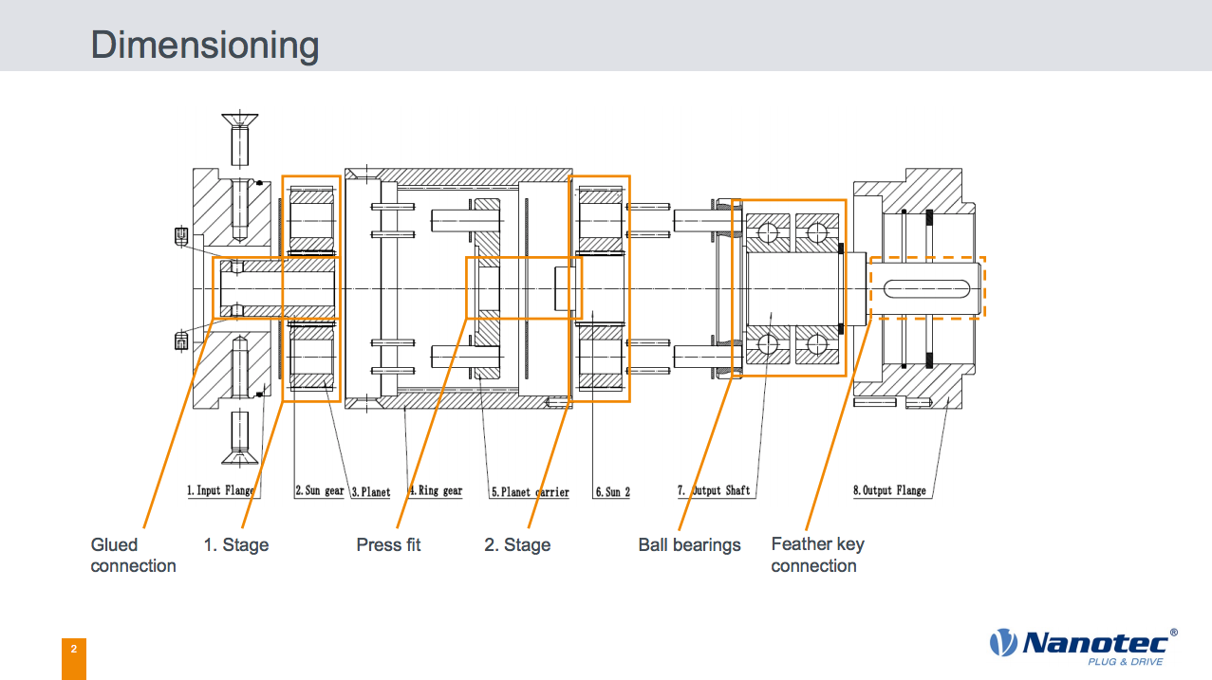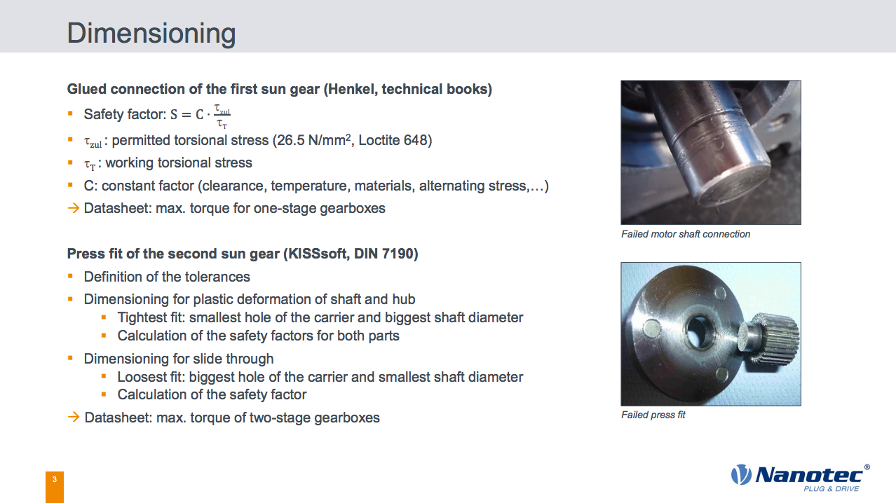

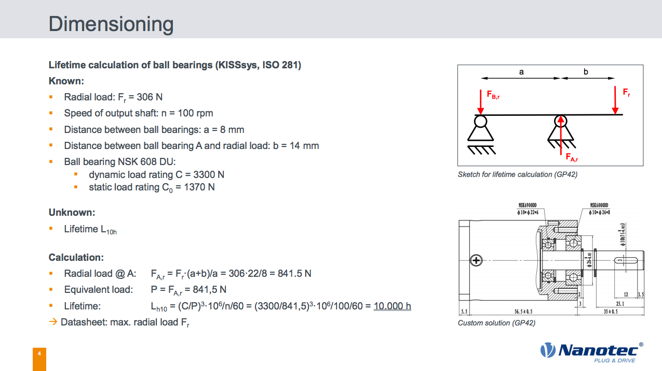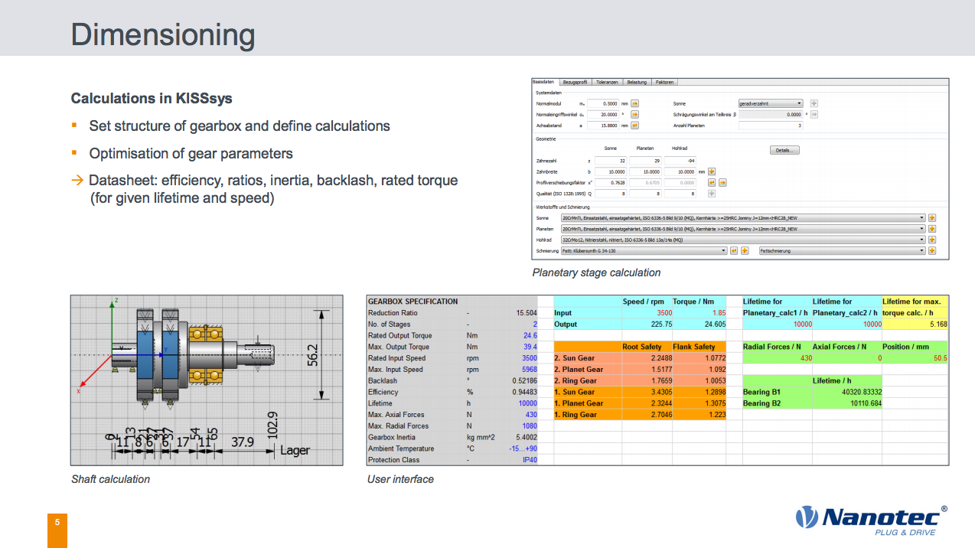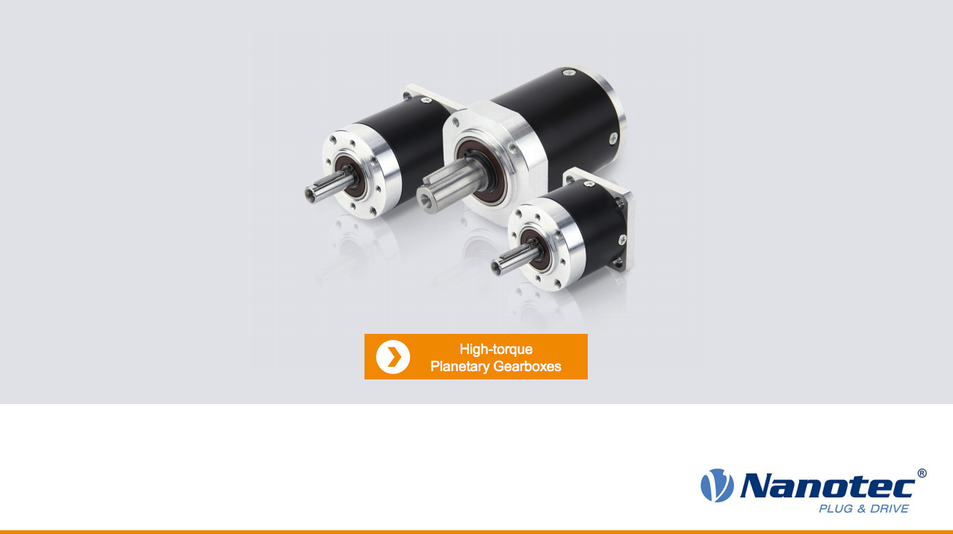

## Gearbox Product Overview

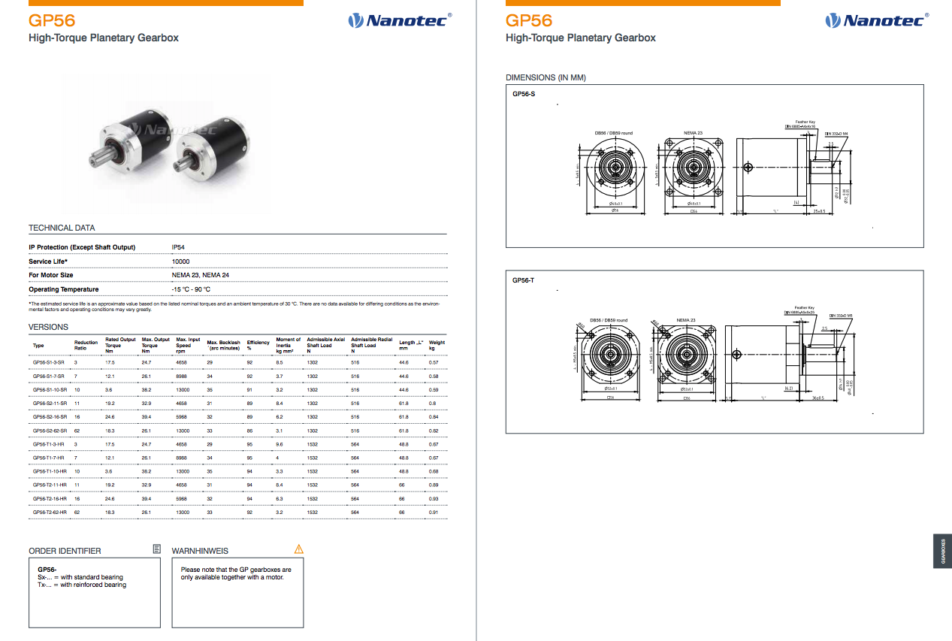

## SRS UK Classic Investment Powder Safety Data SheetMacintosh HD:Users:hinkleaj:Desktop:Screen Shot 2020-10-13 at 2.05.07 PM.pngMacintosh HD:Users:hinkleaj:Desktop:Screen Shot 2020-10-13 at 2.05.29 PM.png

## Macintosh HD:Users:hinkleaj:Desktop:Screen Shot 2020-10-13 at 2.05.48 PM.png

## Macintosh HD:Users:hinkleaj:Desktop:Screen Shot 2020-10-13 at 2.06.07 PM.png

## Cristobalite Hazardous Substance Fact SheetMacintosh HD:Users:hinkleaj:Desktop:Screen Shot 2020-10-13 at 1.54.07 PM.png

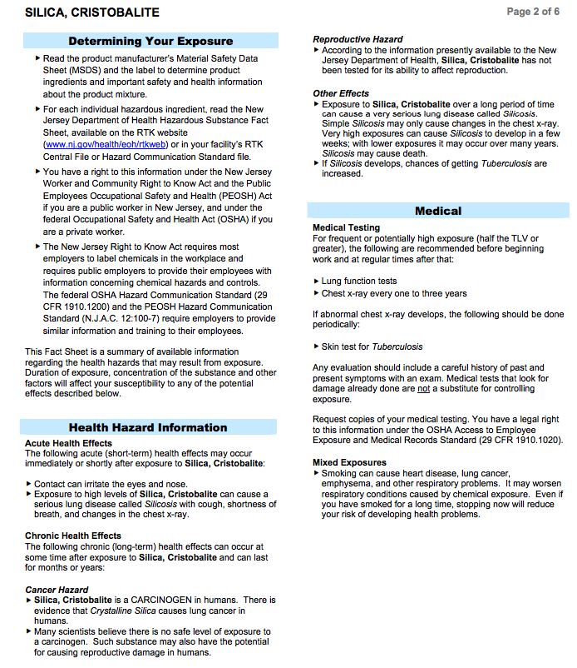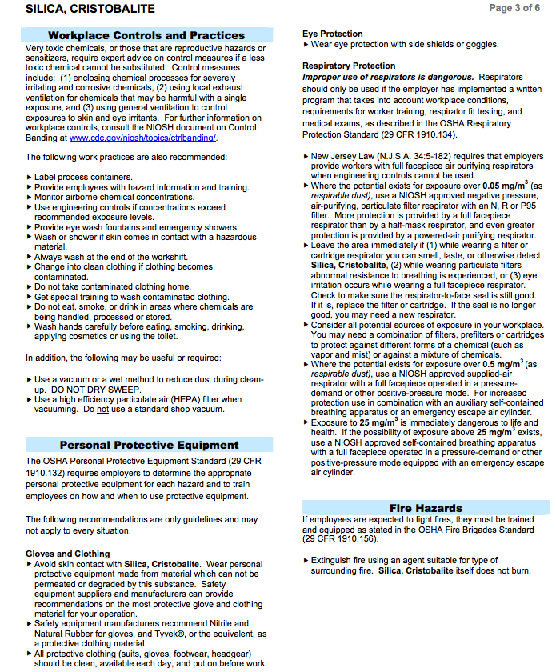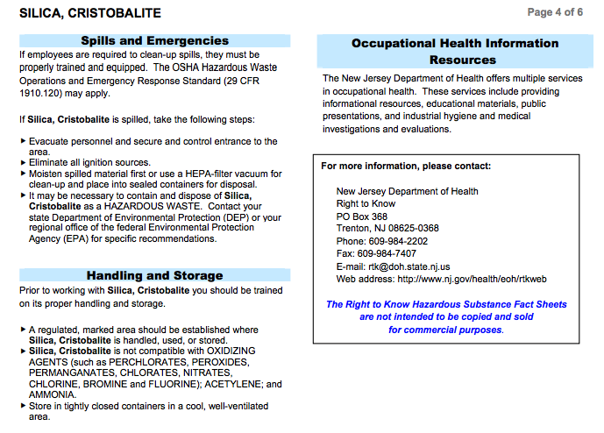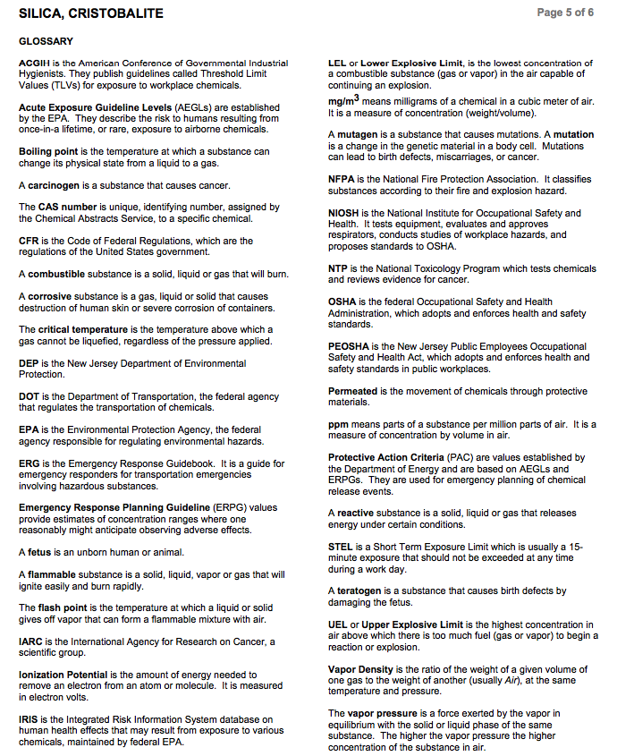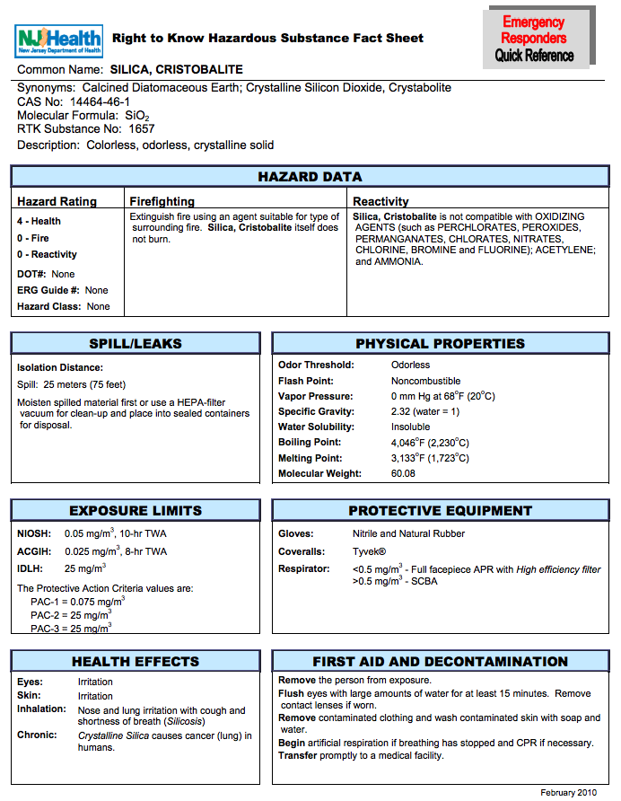

# APPENDIX C

## CAD Model accompanying this document

1. https://www.stuller.com/products/22-4620/23798/?groupId=13348
2. https://www.stuller.com/products/55-2410/15738962/?groupId=201441&recommendationSource

   =productpage& recommendationType=recommendation&recommendationId=13330
3.
4. (Samuel, A. M., Mohamed, S. S., Doty, H. W., Valtierra, S., & Samuel, F. H.)
5. (Fischer-Bühner, J.)
6. * This value was estimated by analyzing countless videos of centrifugal casting. The slowest value was chosen as representative so the error remains on the safe side.